**Make your own current balance**

**Abstract**

A current balance is made from readily available materials. The magnetic force on a wire carrying a current in a magnetic field is balanced by the gravitational force on a mass. This simple experiment enables students to apply their knowledge and check they have understood fundamental concepts. A straight forward calculation enables the magnetic susceptibility of free space to be determined.

**Introduction**

There are many forms of current balance. The simplest, for teaching the basic concept of the force on a wire carrying a current in a magnetic field, uses a solenoid to produce a uniform magnetic field and a single loop of wire to carry a current at 90° to the magnetic field, see *figure 1*.

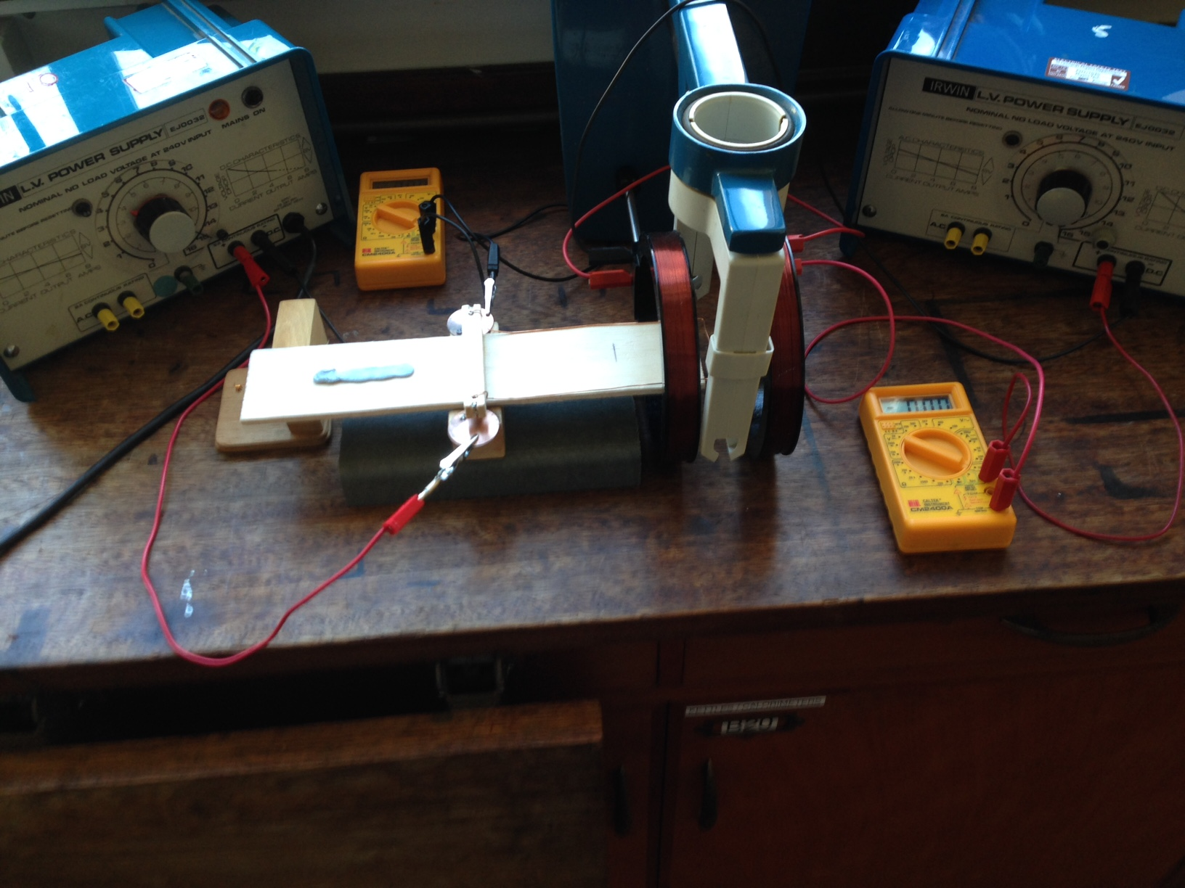

**Figure 1** A general view of the apparatus

*BI*wire*lwire*

mg

**Figure 2** The forces acting on the balance

The magnetic force (*F*) acting on a wire of length (*lwire*) carrying a current (*Iwire*) at 90° to a magnetic field of magnetic flux density (*B*) is given by: *F=BIwirelwire* (*equation 1*)

The magnetic flux density (*B*) is uniform in the central region between the two coils and is given by *B=8μo NIcoil/(5(√5) rcoil)*, where *μo*is the magnetic susceptibility of free space, *N* is the number of turns in the coil, rcoil is the radius of the coil and *I*coil is the current flowing through the coils. Substituting for *B* in *equation 1* gives an expression for the magnetic force on the wire in terms of quantities that are easily measureable apart from *μo*:

*F=(8μo NIcoil/(5(√5) rcoil)* ) *Iwire lwire*

The magnetic force is balanced by the gravitational force resulting from a mass placed on the opposite end of the lever forming the current balance, the same distance as the wire is from the pivot point, see **figure 2**.

**Apparatus construction details**

The lever was made from a piece of Balsa wood 30 cm in length and 5 cm in width. A piece of Balsa wood 7 cm in length and of 1 cm square cross section was glued with its centre on the pivot line so 1 cm extended on each side of the lever. Two holes were made with a drill 0.5 cm from each end of the 7 cm length of wood. A slot was cut through from each end of the wood so a metal insert from a cable connector tightly fitted into each hole to give good stability. The pivot was made using optical pins. A 1 cm length was cut off the pointed end of an optical pin. The blunt end of the pin was placed in the bottom side of the cable connector and using one of the locking screws was held firmly in place, see *figure 3*. This was done on the other side too.

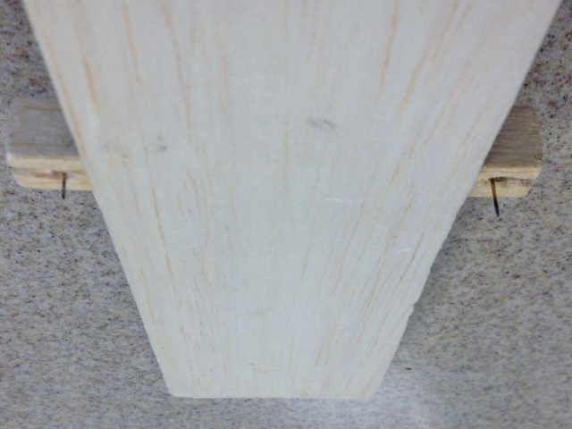

**Figure 3** Construction of the pivot

A 40 cm length of 22 gauge enamelled copper wire was bent round one side of the lever. A centimetre at each end of the wire was bared. One bare end of the wire was inserted into the other side of the cable connector on one side of the lever and held securely in place by the locking screw. This was repeated for the other end of the wire on the opposite side of the lever, see *figure 4*

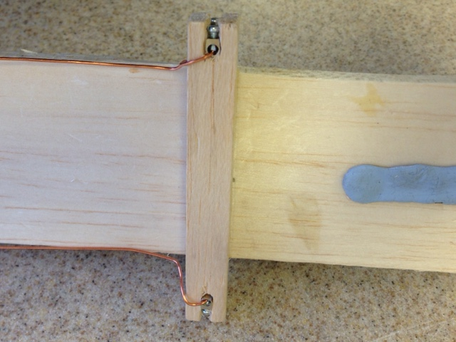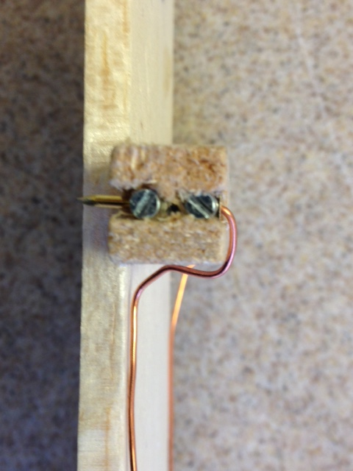

**Figure 4** Attaching the wire to the balance

Connection to the external circuit is made by resting the pin heads on a piece of copper. To locate the pins the copper is punched in the correct positions so each pin can be located correctly.

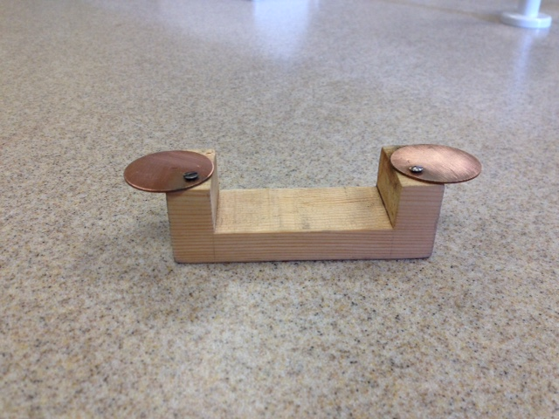

**Figure 5** The mount for the balance

The copper discs are mounted on a U shaped piece of wood that enables the balance to pivot freely, see *figure 5*.

It is important to have the piece of wood holding the pins fixed to the top of the Balsa wood as this keeps the centre of mass low aiding stability.

The copper discs are firmly screwed to the two ends of a U shaped piece of wood as shown in figure 5. The copper discs overlap the ends of the U to enable connection to be made to the external circuit using crocodile clips. The dimensions for the mount are shown in *figure 6*.

Copper discs frommagnetic mafrom

3 cm

**Figure 6** Diagram of the mount

6.5 cm

3.0 cm

10.5 cm

Place the balance in position with the pins located in a grove on each side and using some easily adjustable mass, such as a piece of plasticene, adjust the mass till the balance balances. Keeping the balance in this position is very difficult but having a support under the end of the balance on the opposite end to the wire, so the balance can rest on it, enables the balance position to be held.

The magnetic field is provided by a pair of Helmholtz coils. The length of wire at 90 degrees to the magnetic field must be positioned at the centre of the coils. Slot the end of the balance with the wire attached in between the Helmholtz coils, as shown in *figure 7*.

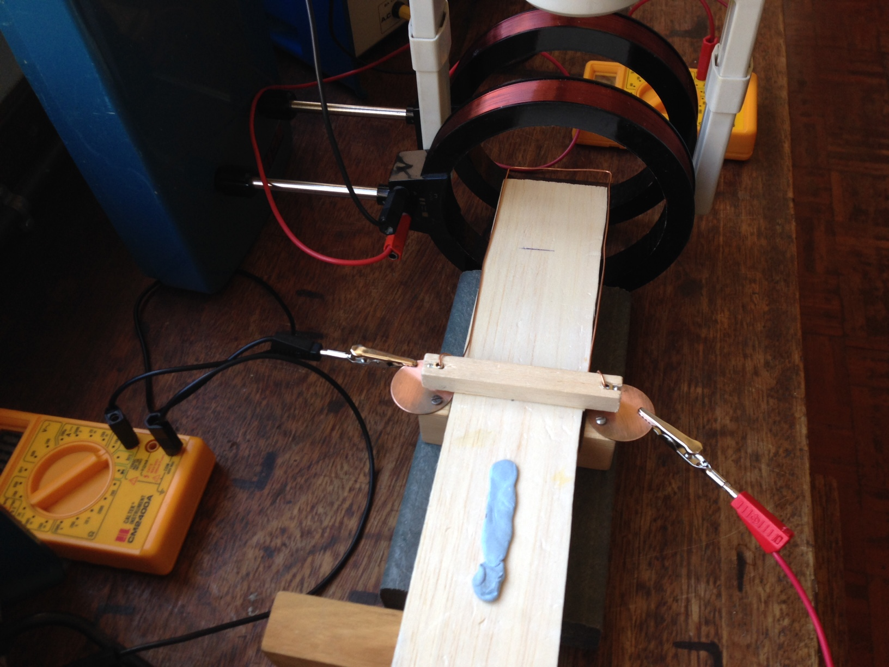

**Figure 7** Position the wire at the centre of the solenoid

Connect up the circuit as shown in *figure 8*. The current through the coil is recorded by an ammeter in series with the variable low voltage power supply and the coil. The current through the wire is recorded by an ammeter in series with a separate variable voltage low voltage power supply and the wire.

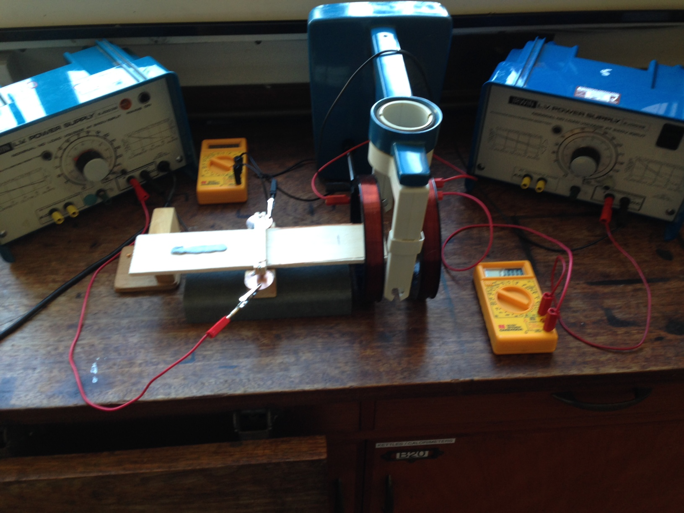

**Figure 8** Experimental set up

The mass is varied by placing riders of mass 0.01 g on the hook the opposite end of the balance to the wire. To get 0.01 g masses use 28 swg copper wire and check 0.50 m has a mass of 0.50 g. Sellotape the wire to a piece of graph paper and cut the wire up into 1 cm lengths of mass 0.01 g, see figure 9.

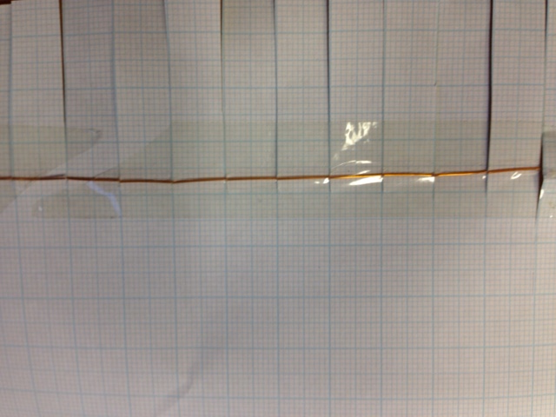

**Figure 9** Cutting the wire to make the 0.01 g masses

|  |  |
| --- | --- |
| Mass placed on rider (g) ±0.001g | Current through wire (A) ±0.1A |
| 0.010 | 3.0 |
| 0.050 | 4.8 |
| 0.100 | 6.8 |

A typical set of results are shown in *figure 10*.

**Figure 10** A typical set of results

These data give a value for μo  of 1.0x10-6 Hm-1 ±0.3x10-6 Hm-1

The accepted value for μo is 1.26x10-6 Hm-1.