
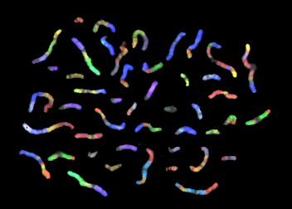

A metaphase spread of ‘FISH’ painted chromosomes from:
http://www.genecrc.org/site/ko/ko5c1a.htm

5 – 14 Biotechnology:
The role of chromosomes and genes
in inheritance
Teacher’s Guide
April 2005

