This is a metaphase spread of Trisomy 18

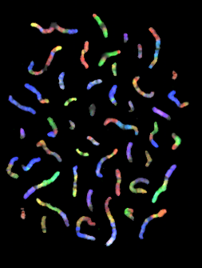

http://www.genecrc.org/
http://www.genecrc.org/site/ko/ko5c.htm#
(Source material no longer available online)
This photograph is taken from The Gene Issues Website

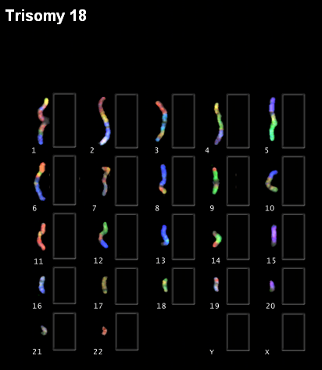
Match the chromosomes by colour!
http://www.genecrc.org/
http://www.genecrc.org/site/ko/ko5c.htm#
(Source material no longer available online)
This is taken from The Gene Issues Website

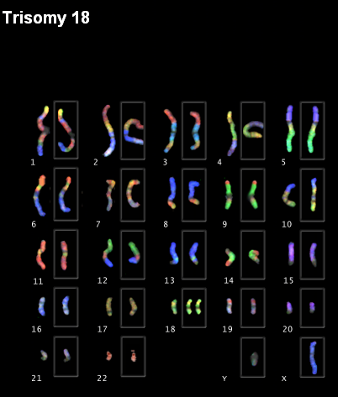
This is taken from The Gene Issues Website

This is taken from The Gene Issues Website
http://www.genecrc.org/
http://www.genecrc.org/site/ko/ko5c.htm#
(Source material no longer available online)
This is taken from The Gene Issues Website
http://www.genecrc.org/
http://www.genecrc.org/site/ko/ko5c.htm#
(Source material no longer available online)

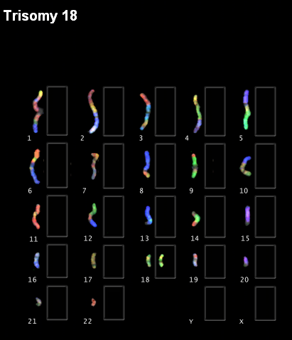

This is taken from The Gene Issues Website
http://www.genecrc.org/
http://www.genecrc.org/site/ko/ko5c.htm#
(Source material no longer available online)

This is taken from The Gene Issues Website

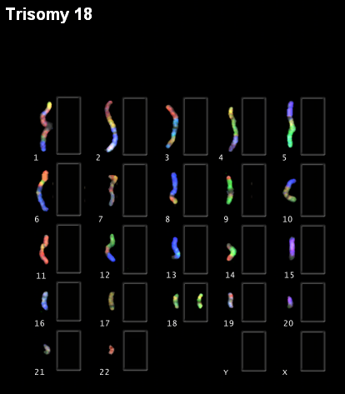
This is taken from The Gene Issues Website
http://www.genecrc.org/
http://www.genecrc.org/site/ko/ko5c.htm#
(Source material no longer available online)

