This is a metaphase spread of a Normal Male

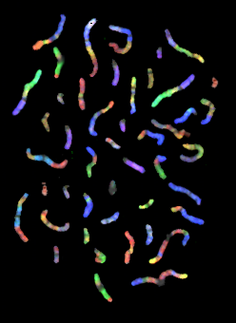

This photograph is taken from The Gene Issues Website
http://www.genecrc.org/
http://www.genecrc.org/site/ko/ko5c.htm#
(Source material no longer available online)

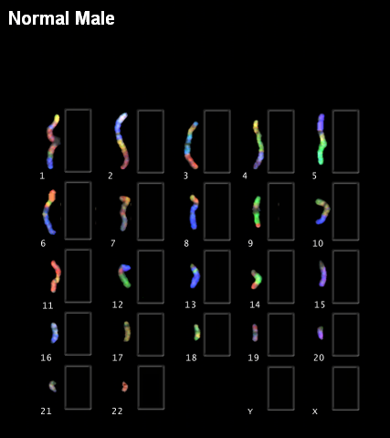
Match the chromosomes by colour!
http://www.genecrc.org/
http://www.genecrc.org/site/ko/ko5c.htm#
(Source material no longer available online)
This is taken from The Gene Issues Website

This is taken from The Gene Issues Website
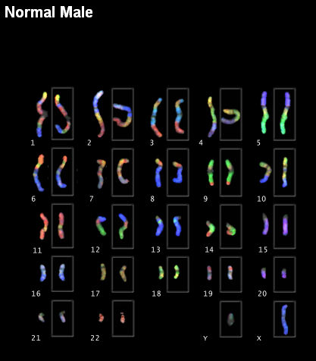
http://www.genecrc.org/
http://www.genecrc.org/site/ko/ko5c.htm#
(Source material no longer available online)

This is taken from The Gene Issues Website
http://www.genecrc.org/
http://www.genecrc.org/site/ko/ko5c.htm#
(Source material no longer available online)

