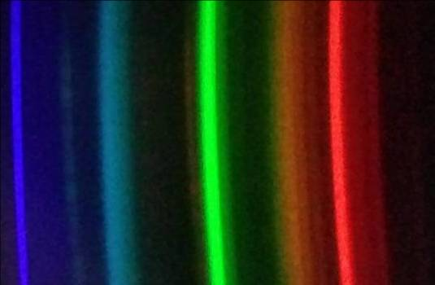


Chemistry workshops and investigations
Make a DVD smartphone spectrometer
To make one of these smartphone spectroscopes, each person/group will need:
A Blank DVDr (or part of) | Scissors
Template printed on black card | Sticky tape or glue
Scalpel or craft knife | Methylated spirits and cotton wool (or a clean, soft cloth)
Black electrical tape | Phone or tablet

To use the template:
Cut along the solid lines. Use a scalpel/craft knife to cut as narrow a slit as you can in the front flap.
Fold along the dotted./dashed lines (up or down according to the instructions).
Tape your diffraction grating over the square cut-out in the ‘door’ – on the inside of it.
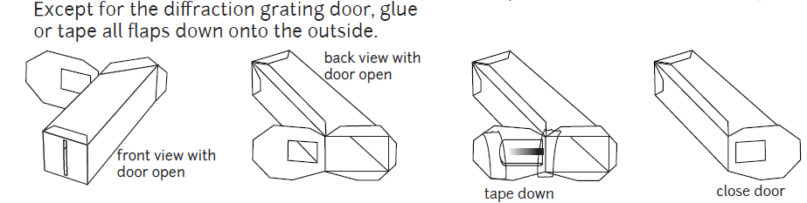

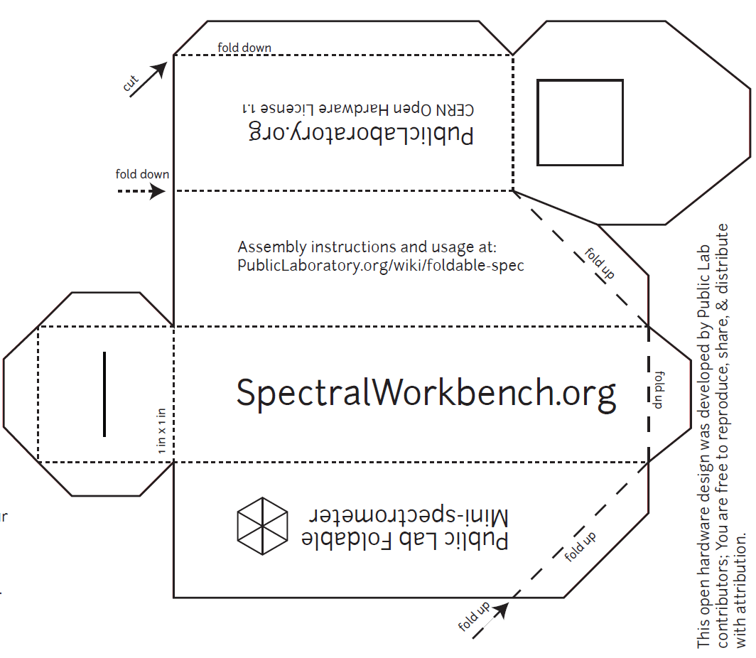
Template – print out on black card

1) Preparing the diffraction grating.
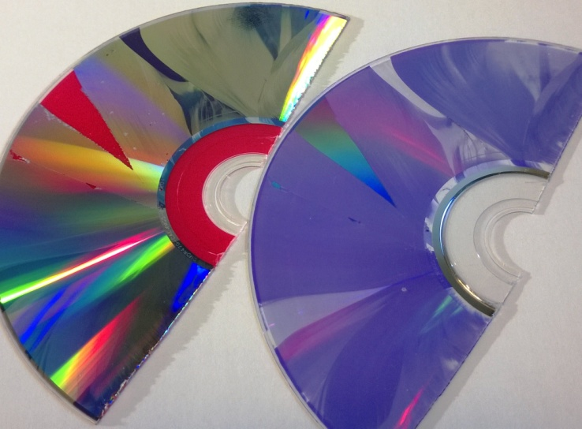
You will need a recordable DVD (DVD-R).
Figure 1: DVD layers
Cut the DVD-R into halves or quarters with a pair of scissors and then you should be able to get a fingernail in and separate it into two layers: the metallic layer with the label on and a clear plastic layer with a purple sheen. (Figure 1)
You need the clear layer. Try to handle the surface as little as possible to avoid marking it.
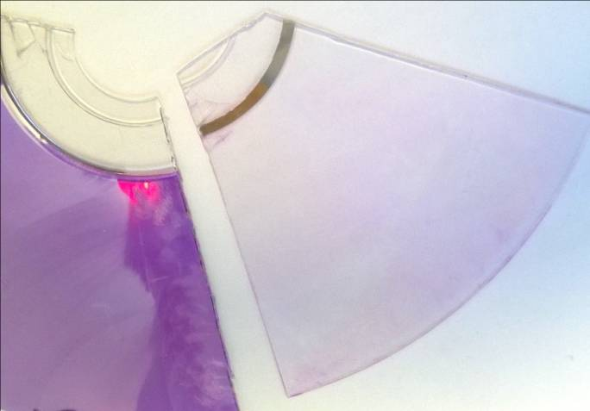
Figure 2: Cleaning the dye off
You can remove the purple colouring using some ethanol (methylated spirit works well) and cotton wool. (Figure 2) but be very careful with this as it is easy to rub off the lines needed for the diffraction grating. It’s best to leave it alone.
Cut a piece from the edge of the now clear plastic, approximately 1cm x 1cm. This is your diffraction grating.

2) Getting and preparing the template
You can find the template on the publiclab website (but a copy is on the back page of this document) It refers to printing on 11” x 8” paper but A4 seems to work fine. (http://publiclab.org/sites/default/files/8.5x11mini-spec3.8.pdf)
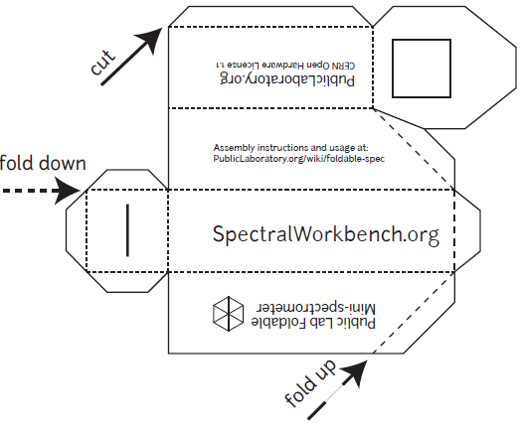
You need to print this out onto black card: card so it is stiff enough and black to reduce internal reflection. You might think printing black lines onto black card is a daft thing to do but it is still possible to see the design clearly enough to cut it out.
Figure 3: The template (not actual size)
Cut round the outside, scissors are probably easiest.
Use a scalpel or sharp craft knife to cut out the square (top right of the diagram) where the grating goes. Then use the scalpel/knife to cut a narrow slit (lower left of the diagram) - the narrower the better.

3) Assembling the spectrometer
Use tape or glue to fix your 1 cm x 1 cm piece of diffraction grating on the inside of the ‘door’, over the square hole you cut out for it. The lines need to be horizontal so make sure that the edge of the DVD-R is at the top or bottom rather than to one side. Then fold the device as shown in the diagram and tape or glue it shut (tape is probably easier and black electrical tape is best).
You will now have a rectangular box, approximately 10 cm long with a slit at one end (Figure 4) and a slope at the other end with a window containing the diffraction grating (Figure 5)
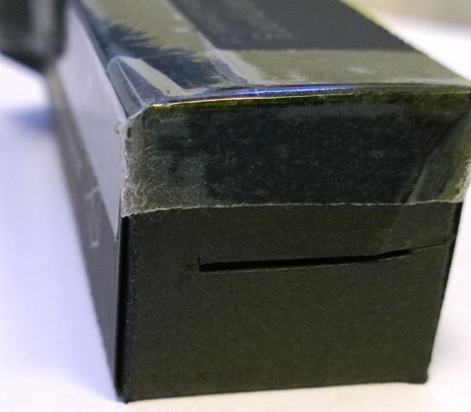
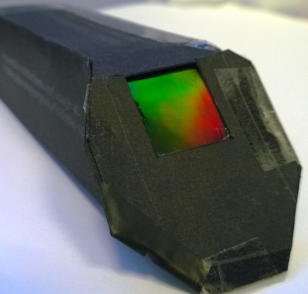
Figure 4: The slit
Figure 5: The diffraction grating

Cuvette adaptor

To make a cuvette adaptor, each person/group will need:
A spectroscope (made as above) | Scissors
Template printed on black card | Sticky tape or glue
Scalpel or craft knife | Black electrical tape
A cuvette

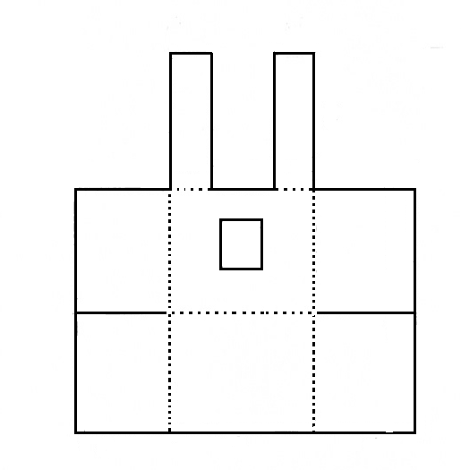
To fit a cuvette to the front of the spectroscope.
Figure 11: Cuvette adaptor template

Print the template (Figure 11) on black card.

Cut out and fold.

Solid lines are cuts, dashed lines are folds (all folds are upwards)

Use black electrical tape to hold the structure together.

Fit the adaptor over the front of a spectroscope (as shown in Figure 12).
It is a lot easier if you place an empty cuvette in to make sure the fit is correct.

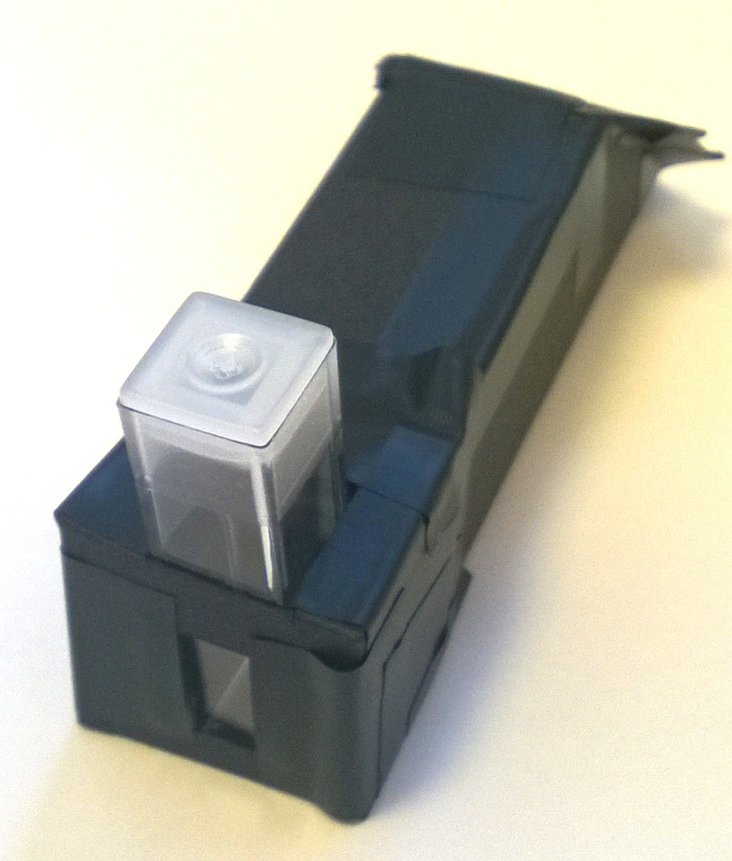
Secure it in place with more electrical tape
Figure 12: Cuvette adaptor fitted


SSERC Risk Assessment (revised version November 2009)
(based on HSE ‘5 steps to risk assessment’)
2 Pitreavie Court, South Pitreavie Business Park, Dunfermline KY11 8UB
tel : 01383 626070 fax : 01383 842793
e-mail : sts@sserc.org.uk web : www.sserc.org.uk

Activity assessed | Making a DVD Spectroscope
Date of assessment | 7/28/2026
Date of review (Step 5)
School
Department

Step 1 | Step 2 | Step 3 |  | Step 4
List Significant hazards here: | Who might be harmed and how? | What are you already doing? | What further action is needed? | Action by whom? | Action by when? | Done
Being cut during construction | Pupil using shark knife/scalpel | Follow normal procedures for using sharp implements.
Possible damage to eyes if looking directly at too bright a light source | Pupil using spectrometer | Unlikely as spectrometer is attached to phone rather than being looked through.  Warn pupils not to point it at or look directly at the sun or any other bright source

Description of activity:

A template is cut from black card and folded into shape. A piece from a DVD-r is cut out and used as a diffraction grating. The assembled device is fixed over the lens of a mobile phone camera.

Additional comments:

Attribution
This work is based on a work by Public Lab (www.publiclab.org ) The original work and this derivation is licenced under a Creative Commons Attribution-ShareAlike 3.0 Unported licence, CC BY-SA 3.0. (http://creativecommons.org/licenses/by-sa/3.0/ )

