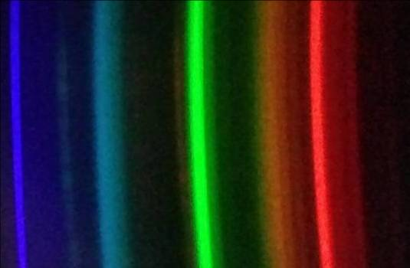


Chemistry workshops and investigations
Make a DVD smartphone spectrometer
Background
Spectroscopy is an important analytical tool in several areas of science. In the classroom, however, spectroscopy is not used as much as we would like due to the relatively high cost of the equipment.
A diffraction grating is an optical device with a structure which splits light into several beams travelling in different directions. They can do so either by reflection or transmission. The directions of these beams depends on the spacing of the grating and the wavelength of the light. If you shine white light on a diffraction grating, the grating will cause the white light to spread out into a spectrum.
In a CD or DVD, the tracks containing the data spiral in to the centre, resulting in an array of parallel lines which can work as a diffraction grating. This is what produces the array of colours you see when you look at the reflections in a CD or DVD. (Figure 1)
You will need
Blank DVDr | Scissors
Template printed on black card | Sticky tape or glue
Scalpel or craft knife | Methylated spirits and cotton wool (or a clean, soft cloth)
Black electrical tape | Phone or tablet

Making the spectroscope
1) Preparing the diffraction grating.
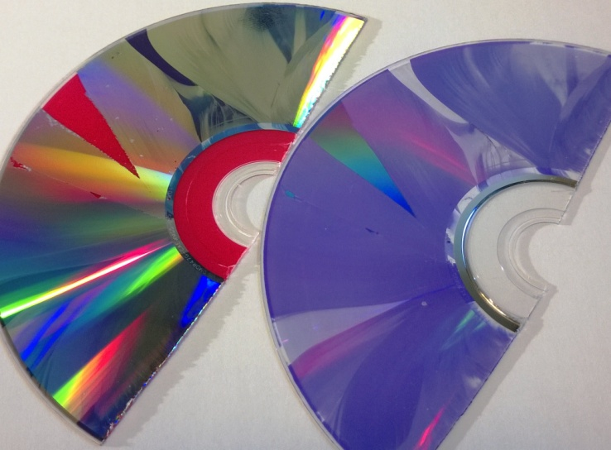
You will need a recordable DVD (DVD-R).
Cut the DVD-R into halves or quarters with a pair of scissors and then you should be able to get a fingernail in and separate it into two layers: the metallic layer with the label on and a clear plastic layer with a purple sheen. (Figure 1)
You need the clear layer. Try to handle the surface as little as possible to avoid marking it.
Figure 1: DVD layers
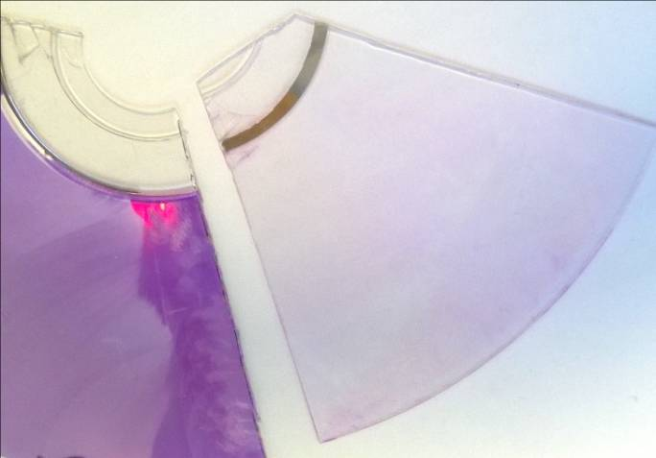
You can remove the purple colouring using some ethanol (methylated spirit works well) and cotton wool. (Figure 2) but be very careful with this as it is easy to rub off the lines needed for the diffraction grating. It’s best to leave it alone.
Cut a piece from the edge of the now clear plastic, approximately 1cm x 1cm. This is your diffraction grating.
Figure 2: Cleaning the dye
2) Getting and preparing the template
You can find the template on the publiclab website (but a copy is on the back page of this document) It refers to printing on 11” x 8” paper but A4 seems to work fine. (http://publiclab.org/sites/default/files/8.5x11mini-spec3.8.pdf)
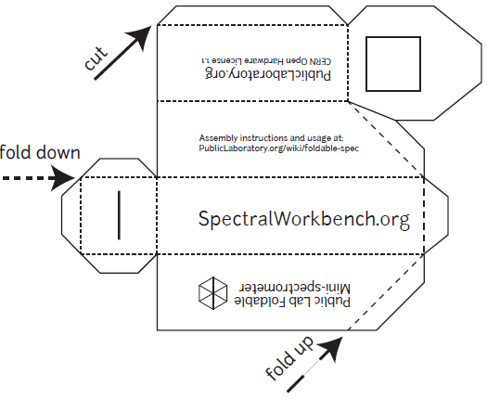
You need to print this out onto black card: card so it is stiff enough and black to reduce internal reflection. You might think printing black lines onto black card is a daft thing to do but it is still possible to see the design clearly enough to cut it out.
Cut round the outside, scissors are probably easiest.
Use a scalpel or sharp craft knife to cut out the square (top right of the diagram) where the grating goes. Then use the scalpel/knife to cut a narrow slit (lower left of the diagram) - the narrower the better.
Figure 3: The template (not actual size)
3) Assembling the spectrometer
Use tape or glue to fix your 1 cm x 1 cm piece of diffraction grating on the inside of the ‘door’, over the square hole you cut out for it. The lines need to be horizontal so make sure that the edge of the DVD-R is at the top or bottom rather than to one side. Then fold the device as shown in the diagram and tape or glue it shut (tape is probably easier and black electrical tape is best).
You will now have a rectangular box, approximately 10 cm long with a slit at one end (Figure 4) and a slope at the other end with a window containing the diffraction grating (Figure 5)
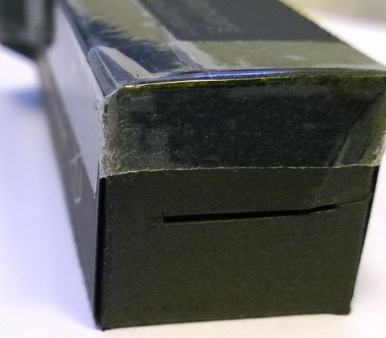
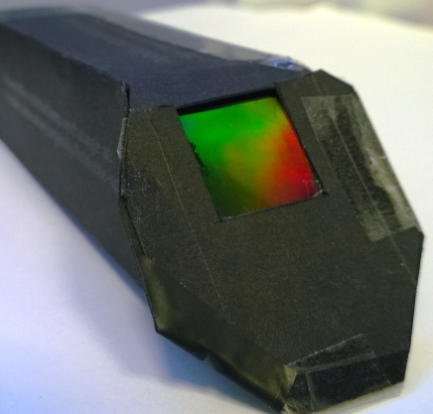
Figure 4: The slit
Figure 5: The diffraction grating

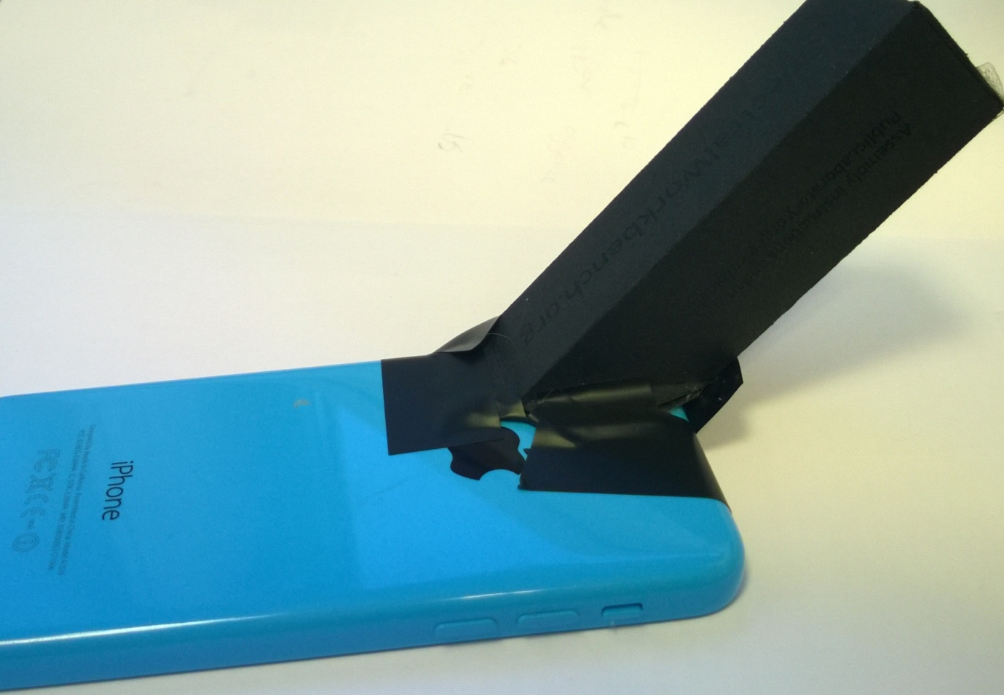
4) Attaching the spectrometer to your phone
You can simply do this using tape (again, black electrical tape is best). Launch the camera app. Place the ‘window’ with the diffraction grating against the lens, check that you are getting a pattern and then tape it in place. This is a bit tricky with an iPhone as the camera lens is stuck away in the top left hand corner. It is possible, however, to get it in place with a bit of care.
Figure 6: Spectrometer attached to an iPhone

(For more than a one off use, it is worthwhile making a mount if your camera lens is awkwardly placed. This can be done relatively easily using Corriflute or similar material).
Once in place, launch the camera app (if you closed it) and then you can point it at various light sources and get photographs of their spectra. (Figures 7, 8 & 9)
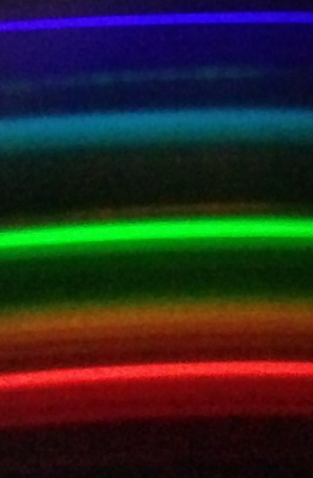
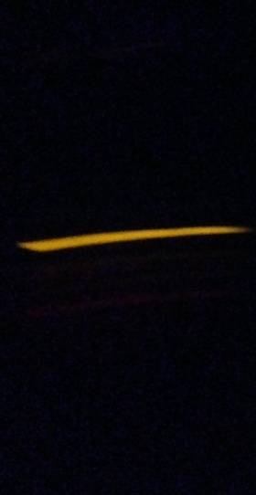
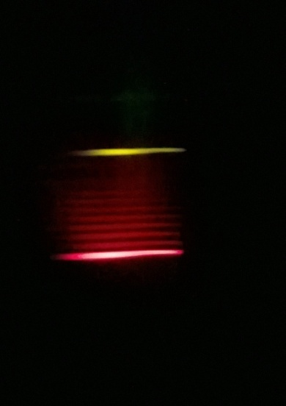
Figure 7: spectrum of a compact fluorescent lamp
Figure8: spectrum from a sodium flame test
Figure 9: spectrum from a strontium flame test

5) Tips
Make sure the flash is switched off on your phone.
If you are getting light leakage, use more black electrical tape to block these off.
Pointing directly at a light source can lead to problems: The images can be excessively bright but you are also more prone to internal light leakage.
Exposure can be tricky so try several shots at different settings. Too bright and the software might have trouble analysing it, too dark and there will be too much background noise for a good spectrum.
Improving your images
One of the problems is that the spectrum is only a relatively small portion of the screen. This can give extraneous noise when you analyse it.
You could zoom in on the camera but there are a couple of problems with this:
1) you might accidentally alter the zoom between shots.
2) Most (if not all) camera apps re-set when they close so if your phone switches off between shots you have lost the zoom setting.
This is a problem because the software uses the exact positioning of the bands within the image to work out its wavelength.
You can solve this by cropping the photographs afterwards. As long as you do it carefully.
Using Microsoft Windows Picture Manager.
1) Open the reference file
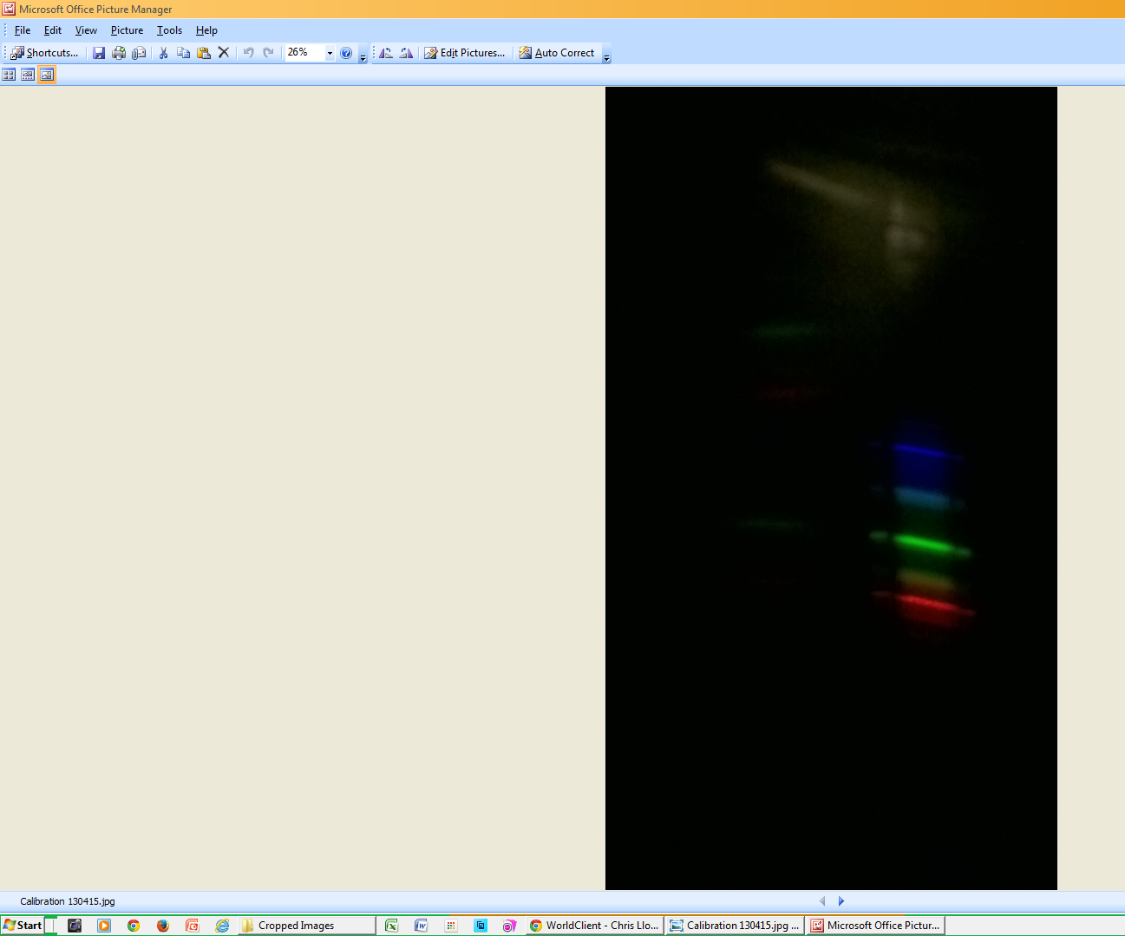
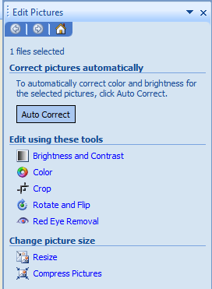
2) Select the ‘Edit Picture’ option and then crop.

3) Move the cropping handles to give you a good spectrum.
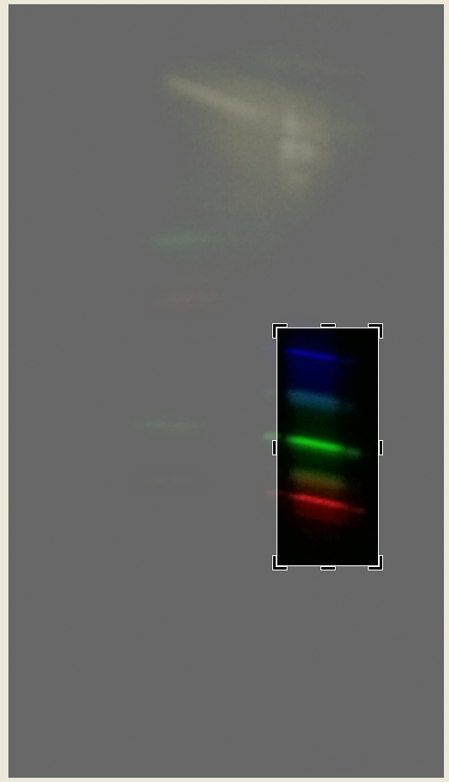
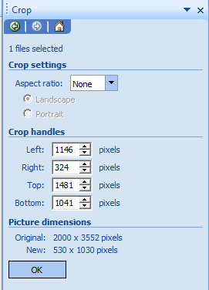
4) You will notice on the right of the image in the section labelled ‘crop handles’ there are 4 numbers. These tell you the exact positioning of the cropping lines. Make a note of them.

5) Open up your next spectrum image, as before go to ‘edit picture’ and ‘crop’.
6) This time type the numbers you wrote down into the boxes.
7) When you press OK, the image will be cropped to exactly the same section as the previous one and so can be accurately compared.
8) Repeat this with your other images.
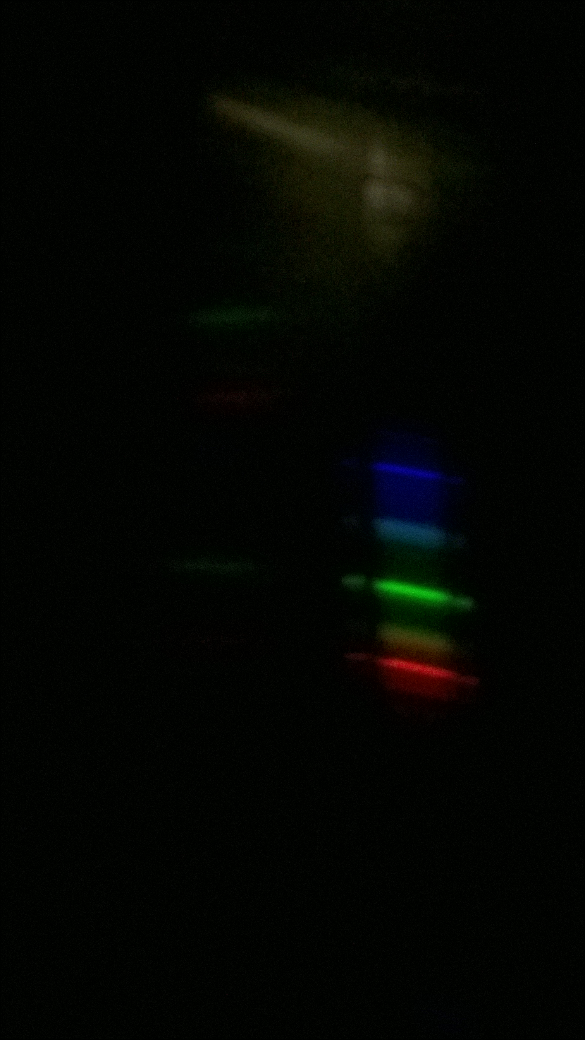
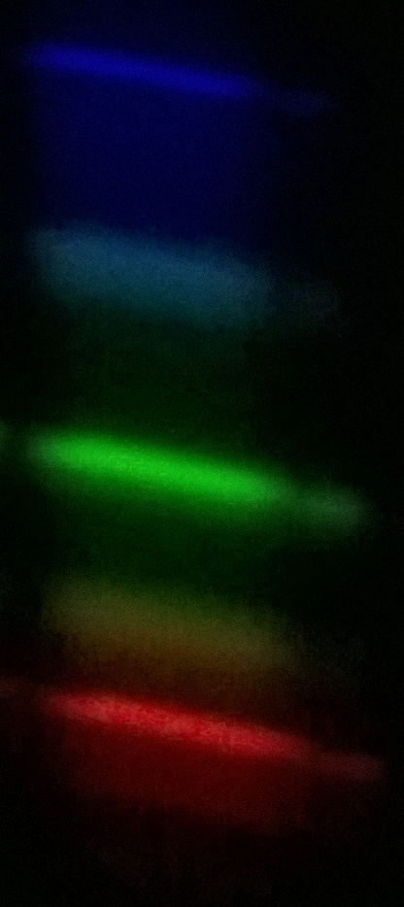

Before After
Attribution
This work is based on a work by Public Lab (www.publiclab.org ) The original work and this derivation is licenced under a Creative Commons Attribution-ShareAlike 3.0 Unported licence, CC BY-SA 3.0. (http://creativecommons.org/licenses/by-sa/3.0/ )

