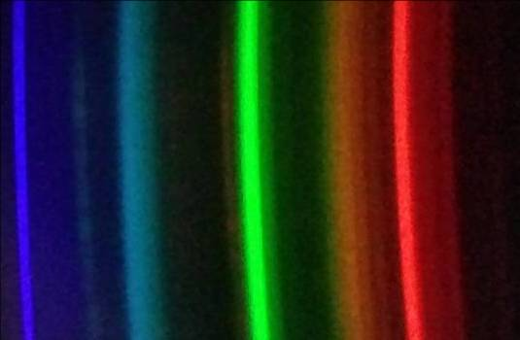


Chemistry workshops and investigations
Analysing Spectra with Spectral Workbench
Background
Previous documents showed you how to make a simple spectrometer attachment that will fit onto your mobile phone. This allows you to take pictures of spectra.
That is all very well but just having a picture of a rainbow-like image is not all that useful. In order to do proper science with it, you need some way of analysing the image to get a graph showing how intensity varies with wavelength.
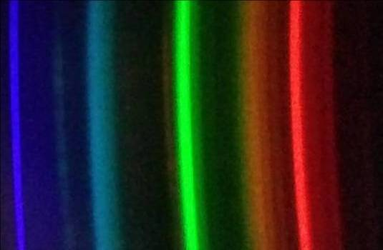
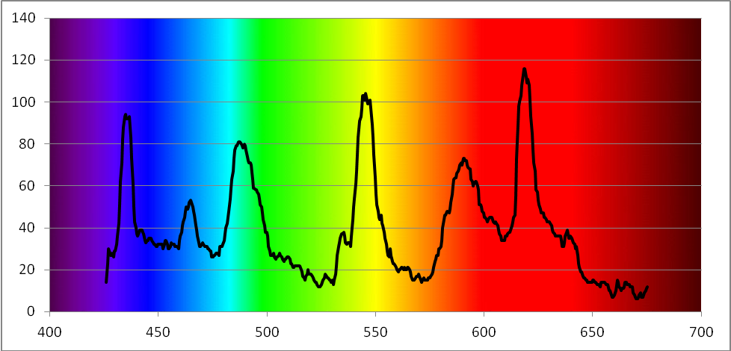

Analysing the spectrum
This can be tricky but it is easier than it was.
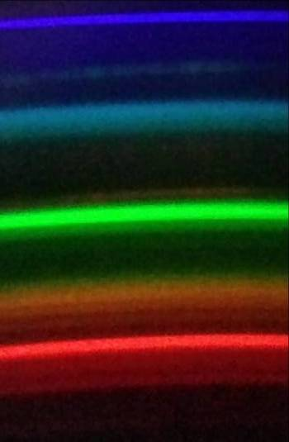
In order to analyse the spectrum and actually get a graph of it, you need to have some reference points. Fortunately, we have these in the form of the spectrum of a fluorescent tube (ideally a compact fluorescent lamp). Usefully, fluorescent lamps have some notable spectral lines that can be used for calibration
Blue – 436 nm
Green – 546 nm
Red – 611 nm

So the first thing to do is to take a photograph of your fluorescent source.
If it's too bright, and that is quite likely if you are pointing it at the source, point it at a piece of white paper or wall which is brightly illuminated by the bulb.
In order for your reference to be valid, make sure you use the same spectroscope/phone assembly each time and do not zoom in on any of the photographs. Each time you re-attach the spectroscope, you will have to take another reference photo of a fluorescent source.
The easiest way to analyse your spectrum is to use the Spectral Workbench website (http://spectralworkbench.org/) . This is part of the Public Lab project (and the source of the spectrometer design). You need to register (for free) with Public Lab but that is all.
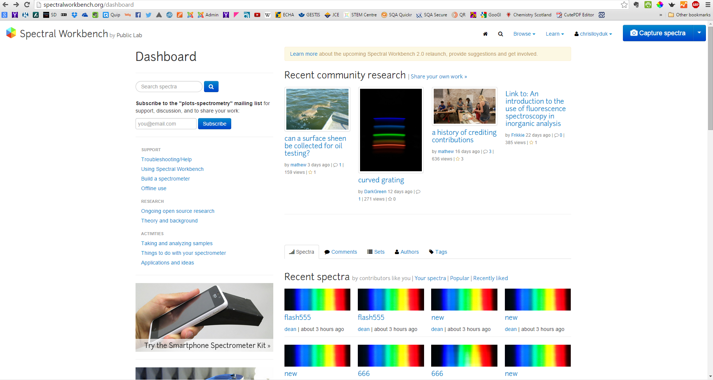
Annoyingly, even if you have logged into the Public Lab website, you still need to log in to Spectral workbench.

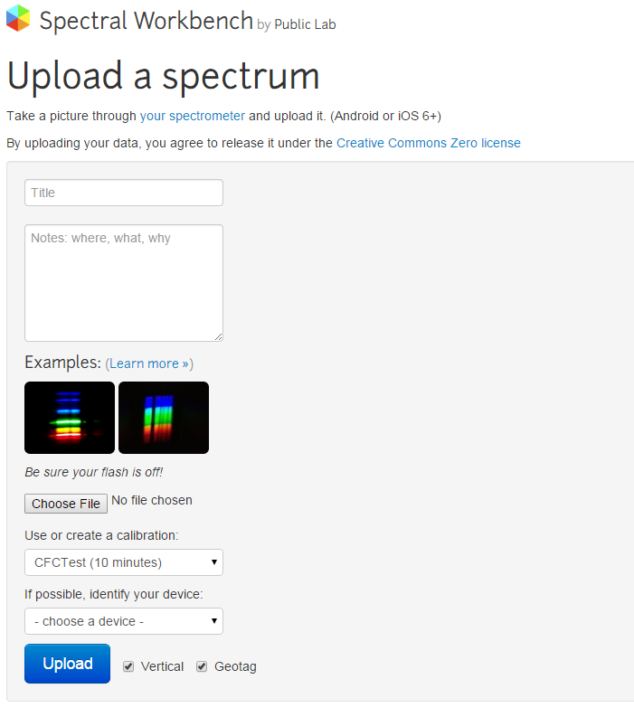
Once in, you will need to upload your image.
Click on ‘Capture Spectra’ (the blue button at the top right, circled in red) and the drop down menu gives you the option to upload from file. Selecting this gives you this screen.

There is a tick box saying ‘vertical’ but as far as I can tell this makes no difference to how the software analyses your picture.
Enter a name and any other data you need and click the ‘upload button.
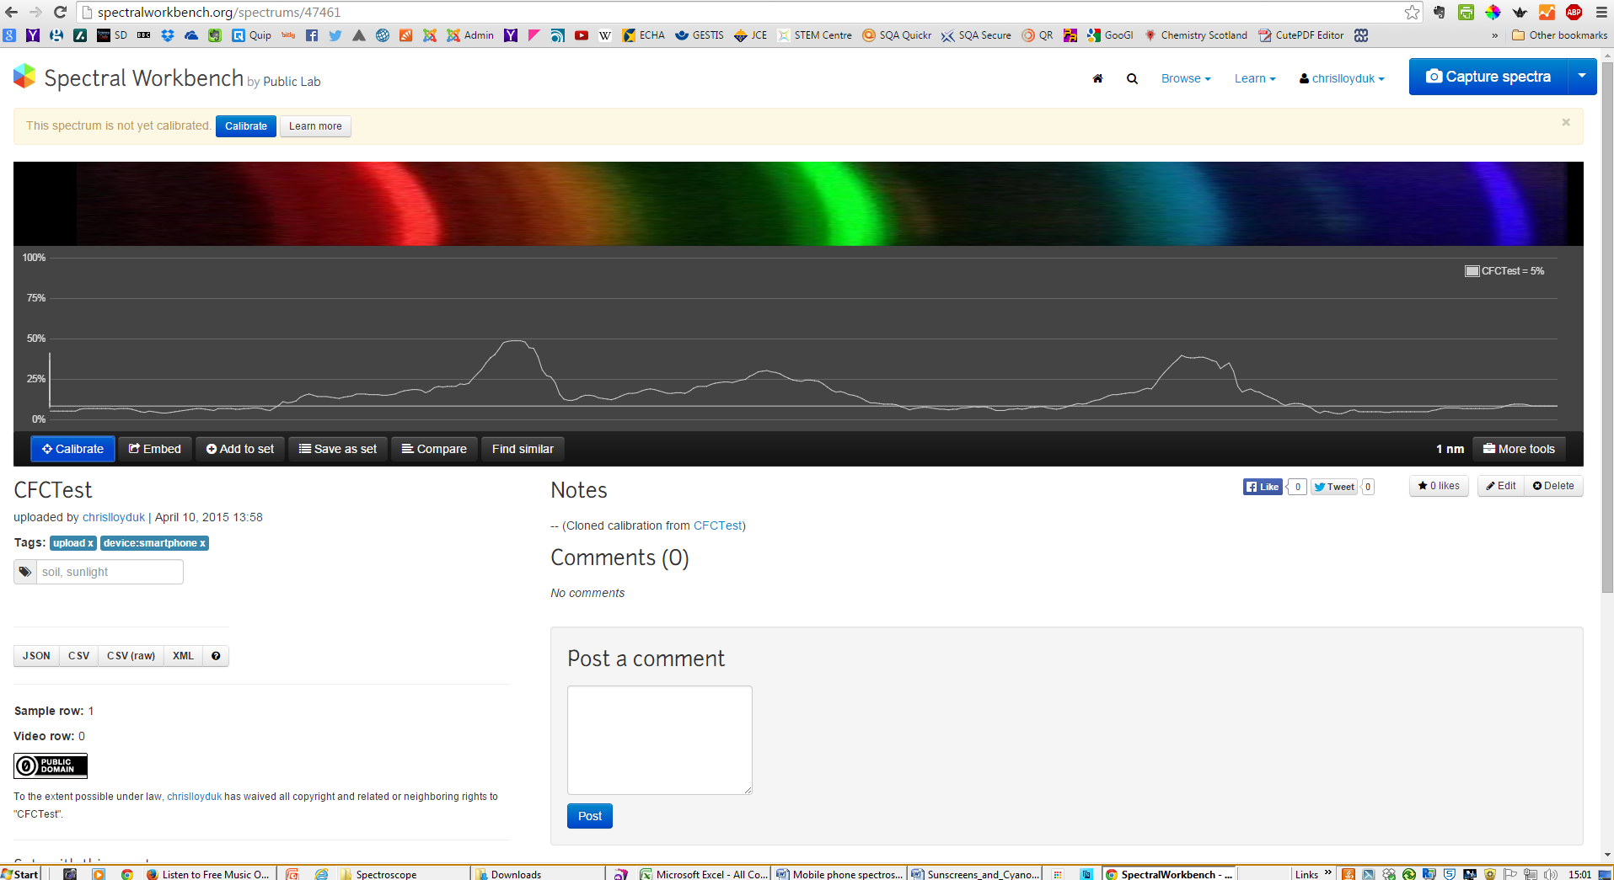
After a few seconds, your spectrum will appear – as shown below.

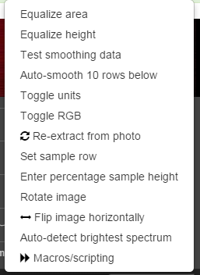
If you see a series of horizontal coloured lines rather than a spectrum similar to that above, click on the ‘more tools’ button. (Circled in red) That brings up the menu on the left.
Click on ‘rotate image’ and you should soon see something vaguely like the one above.
Another point you need to be aware of is that the analysis software only works if the blue lines are at the left.
If, like in the illustration above, they are on the right, you need to click on ‘Flip image horizontally’.

Now you have your spectrum loaded, you need to set it to be your reference sample.
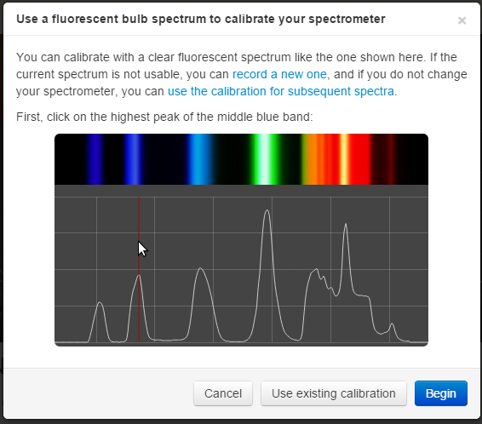
Click on ‘Calibrate’ (the blue button on the left below the spectrum and you will see this screen appear.
Click ‘begin’ and then, as it says’ find the brightest part of the appropriate blue band and click.
That brings the screen back, this time telling you to find the brightest part of the green band.
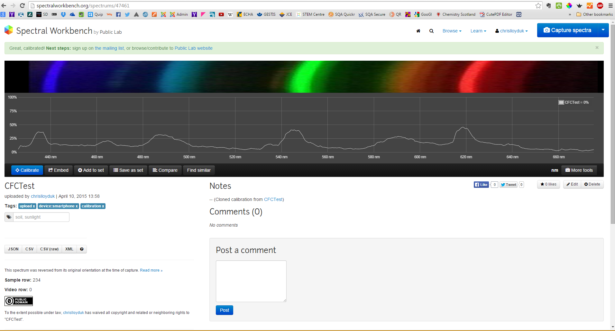
Click on this and after a few seconds your spectrum will reappear with the wavelengths along the bottom.

It is quite possible at this stage that the graph along the bottom will look rather unimpressive. This is likely due to the line being sampled across your spectrum not being in the best place. To fix this, click on the ‘more tools’ button again and this time select ‘auto-detect brightest spectrum’.
There will again be a short delay and your spectrum should come up with a much better sample.
If you want to get a graph you can print, or otherwise manipulate (to look a bit more impressive), you can export the data. .csv is the best format to choose as it will open directly in Excel.
Here is an excel version of the same graph: still with the wavelength along the bottom. (I just used a picture of a spectrum as a background to make it look prettier!)

Now you have your calibration graph, things are much simpler.
Upload another image (rotating and flipping it as before if you need to) and the software will automatically interpret it using your reference spectrum.
So the graph will appear with the wavelengths along the bottom. The same will be true of all the other spectra you photographed in this session. Here is one of a white LED (Section shown only).
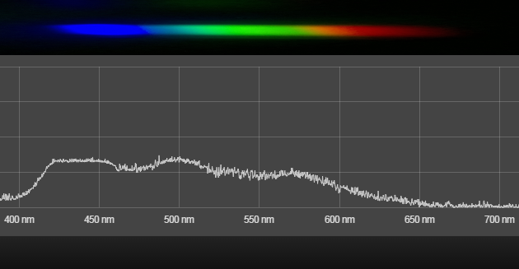

Using Excel to get better graphs.
When you open up your csv file (it automatically opens in Excel) you will notice a couple of things.
1) There are two columns: column 1 is the wavelength in nm, column 2 is a reading of intensity in arbitrary units)
2) There are a lot of points. The file gives you readings at about 4-5 per nm.
To plot a graph of the readings, first insert a row at the top and enter the column headings; ‘wavelength’ and the name of your source.
Then select both columns and on the insert tab, go to Scatter.
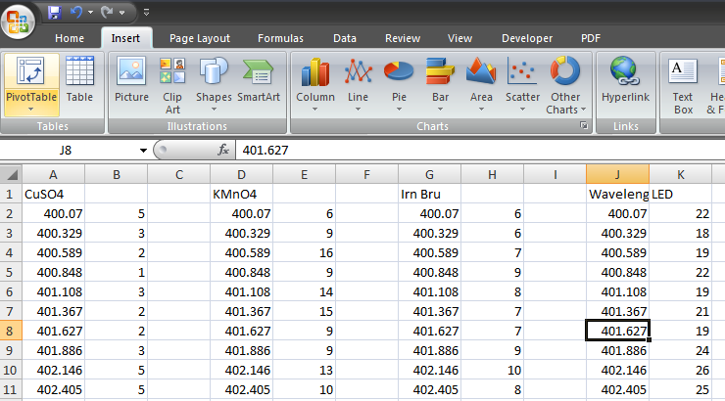
From here, select the option for smoothed lines.
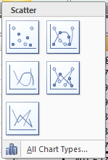

You will get something like this.
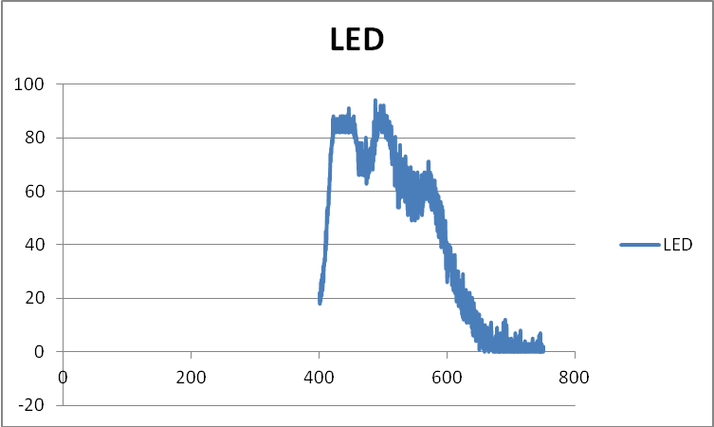
It still does not look right. By default, Excel starts both axes at 0. You want your x-axis to run from about 400 to 700 (You decide exactly by looking at your data.
Right click on the x-axis and select format horizontal axis. On this screen, set the minimum and maximum values. Your graph will immediately seem much better.
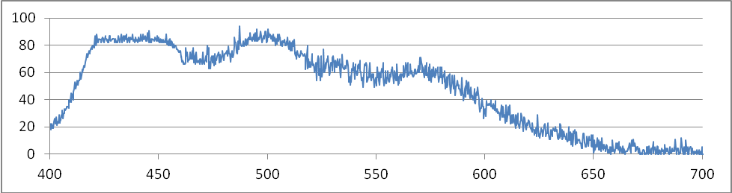
Smoothing
You can see, however, that the graph is a bit ‘rough’. There is quite a lot of variability in the data. To make the graph better, you can smooth the data.
A well-known statistical technique is called 3-median smoothing. Basically, you replace every point with the median value of the point itself and that above and below it.
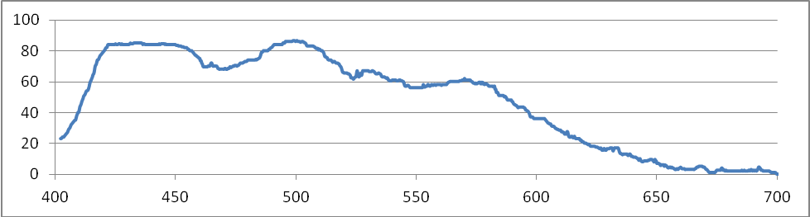
Given that we have such a lot of points, however, you can get a more satisfactory effect by taking the median of 10 points above and below (20-median smoothing). Here is the graph above smoothed in this way.

The excel formula is =median(select range of cells) so the first one here was in Row 12 and went ‘=median(B2:B21)’
This was then copied down the column.

Here is a graph of three substances, taken using the cuvette adaptor.
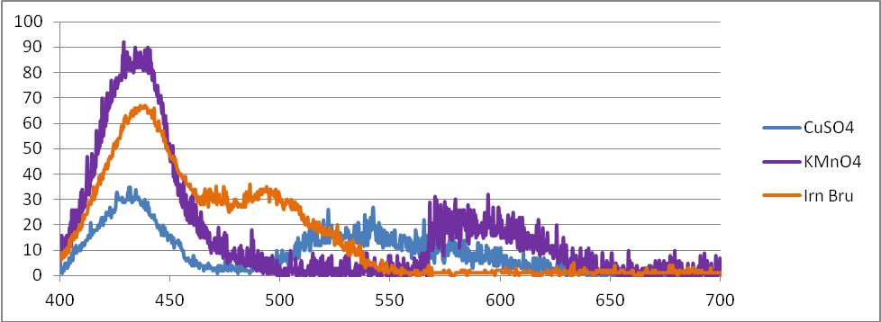
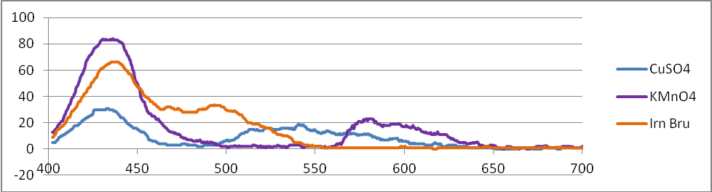
And here is the same data with the smoothing applied

Attribution
This work is based on a work by Public Lab (www.publiclab.org ) The original work and this derivation is licenced under a Creative Commons Attribution-ShareAlike 3.0 Unported licence, CC BY-SA 3.0. (http://creativecommons.org/licenses/by-sa/3.0/ )

