Chemical Investigations
Testing for Starch and Sugars in Food
Pupil Guide
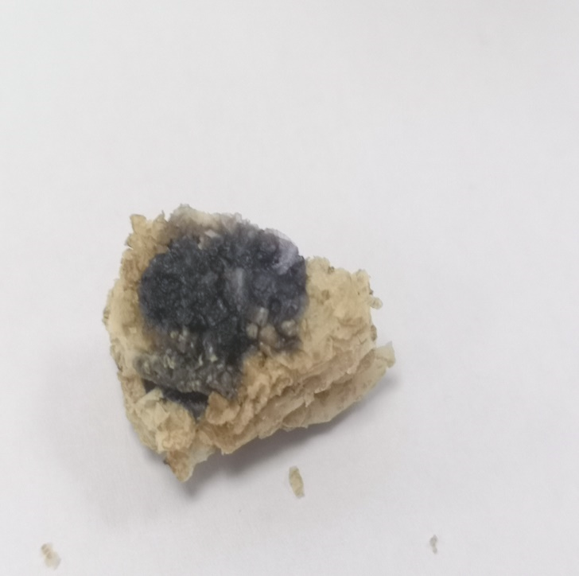


Testing for Starch and Sugars in Food
UNIT 3 PPA 3
INTRODUCTION
Starch and sugars are important substances in the food we eat. They are called carbohydrates and our bodies use them to produce energy.
We can test for starch by adding iodine solution to a sample of food. If the iodine solution changes from brown to a blue/black colour then the food sample has starch in it.
We can use Benedict's test to find out if a food contains sugars. When the food sample is heated in blue Benedict's solution and an orange/red solid is formed then we know the food sample must have a sugar in it. However, if an orange/red solid is not formed we cannot say for sure that the food sample does not contain a sugar. Some sugars such as sucrose do not form an orange/red solid when they are heated in Benedict's solution.
The aim of this experiment is to test for starch and sugars in some food samples.
You will need
Dimple tray | Large beaker
Test tubes and rack | Tripod & gauze
Bunsen burner and heating mat | Benedict’s solution
Iodine solution | samples of milk, bread, potato and egg white

Safety
No particular precautions are needed.
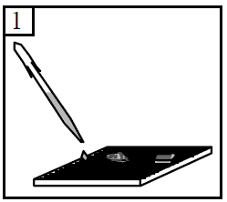
Procedure (what you do)
- Add samples of milk, bread, potato and egg white to separate dimples in the tray.

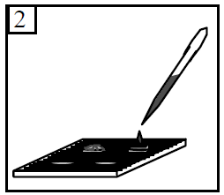
- To each of the food samples add a few drops of iodine solution.

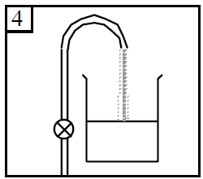
- Watch what happens to the iodine solution and record your results by writing them down in the table on your 'assessment' sheet.

- Fill the large glass beaker half full with water.

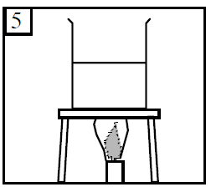
- Put the beaker of water on the tripod.
Light the Bunsen burner, put it under the tripod and heat the water until it boils.
Remove the Bunsen burner from below the beaker.
Or boil some water in a kettle and pour it into the beaker.
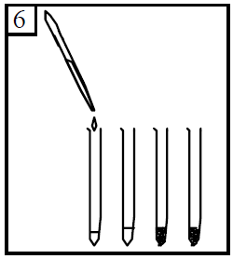
- Add some milk to one test tube and egg white to another test tube to a depth of about 1 cm.
Take a sample of bread and break it up into crumbs. Add the breadcrumbs to a third test tube.
Break up a sample of potato into tiny pieces and add them to a fourth test tube.
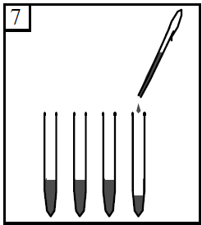

- To each of these four test tubes add Benedict's solution to give a total depth of about 3 cm.

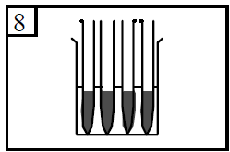
- Place the test tubes in the hot water and watch what happens to the Benedict's solution.
Record your results in the table.

Results sheet
What was the aim of the experiment?

Procedure
How did you test for starch in the food samples?

How did you test for sugars in the food samples?

Results
Complete the following table:
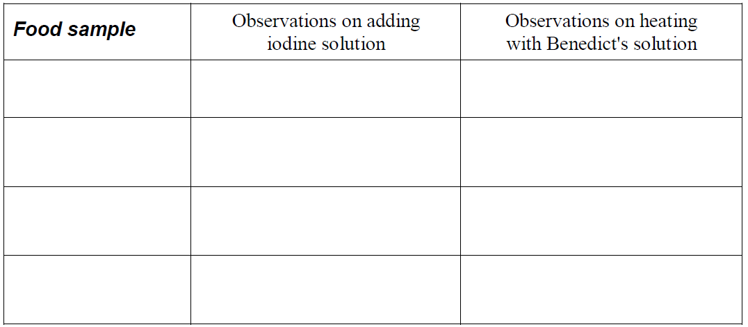
Conclusion
Complete the following table:
