|  |
| --- |
| Chemical Investigations |
| Factors which affect Lathering of Soap |
| Pupil Guide |

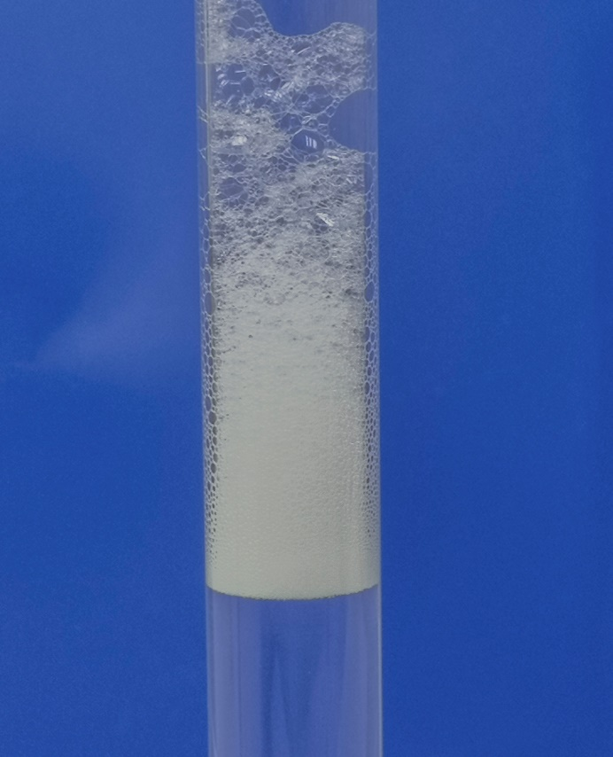

Factors Affecting lathering of Soap

*UNIT 2 PPA 3*

**INTRODUCTION**

It is difficult to clean things in water alone because substances like oil and grease do not dissolve in water. This is why we have to add detergents to the water. Detergents break down grease and oil into very tiny drops which then mix with the water and can be washed away.

Most detergents produce a lather or foam when they are shaken with water.

The aim of this experiment is to investigate a factor which might affect the amount of lather produced when detergents are shaken with water.

Some of the factors we could investigate are:

* the type of detergent
* the volume of detergent
* the temperature of the water
* the amount of shaking
* the volume of water

To make the investigation fair we can only change one factor during the experiments. All the other factors must be kept the same.

From the first two factors in the list, choose one you would like to investigate.

If you choose the first one go to the section with the heading 'type of detergent'. If you choose the second factor go to the section with the heading 'volume of detergent'.

**You will need**

|  |  |
| --- | --- |
| test tubes with stoppers & rack | ruler |
| syringe | timer |
| Beaker | Solutions of: washing powder/liquid, dishwasher powder, washing-up liquid |

**Safety**

While the concentrated detergents can be irritating, the dilute solutions are of no significant hazard.

**Procedure (what you do)**

**A Type of detergent**

1. Add dilute hydrochloric acid to the beaker until it is half full.
2. Diagram

   Description automatically generatedUsing the syringe measure out 3 cm3 of water into a test tube.

1. Add two drops of automatic washing powder solution to the water and stopper the tube.

1. With your thumb on the stopper shake the test tube hard for 15 seconds.

1. Let the solution settle for 15 seconds and then use the ruler to measure the height of the foam.
2. Record your result by writing it down in the table.
3. Repeat the experiment first with the solution of the non-automatic washing powder and then with the solution of the dishwasher powder. Remember to do each one twice to get duplicate results.

**B Volume of detergent**

1. Add dilute hydrochloric acid to the beaker until it is half full.
2. Diagram

   Description automatically generatedUsing the syringe measure out 3 cm3 of water into a test tube.
3. A picture containing text

   Description automatically generatedAdd one drop of the solution of washing-up liquid to the water and stopper the tube.

1. With your thumb on the stopper shake the test tube hard for 15 seconds.

1. Let the solution settle for 15 seconds and then use the ruler to measure the height of the foam.

Record your result by writing it down in the table.

1. To obtain a duplicate result repeat steps 2 to 5 with one drop of the solution of washing-up liquid.

Remember to measure and record the height of the foam.

1. Repeat the experiment first with two drops of the solution of washing-up liquid and then with three drops of the same solution. Remember to do each one twice to get duplicate results.

**Results sheet**

*What was the aim of the experiment? (Remember to say which factor you were investigating)*

**Procedure**

*Which factors were kept the same in the experiment? (Give at least four)*

*How did you get some idea of the amount of lather formed?*

*Complete the following table:*

*† To work out the average height of the foam add results 1 and 2 together and divide this*

*number by 2.*

**Conclusion**

*What did you find out from this experiment?*