

|  |
| --- |
| Chemical Experiments |
| Diffusion of gases |

Diffusion is the process whereby atoms or molecules are transferred from regions of relatively high concentration to regions of relatively low concentration.

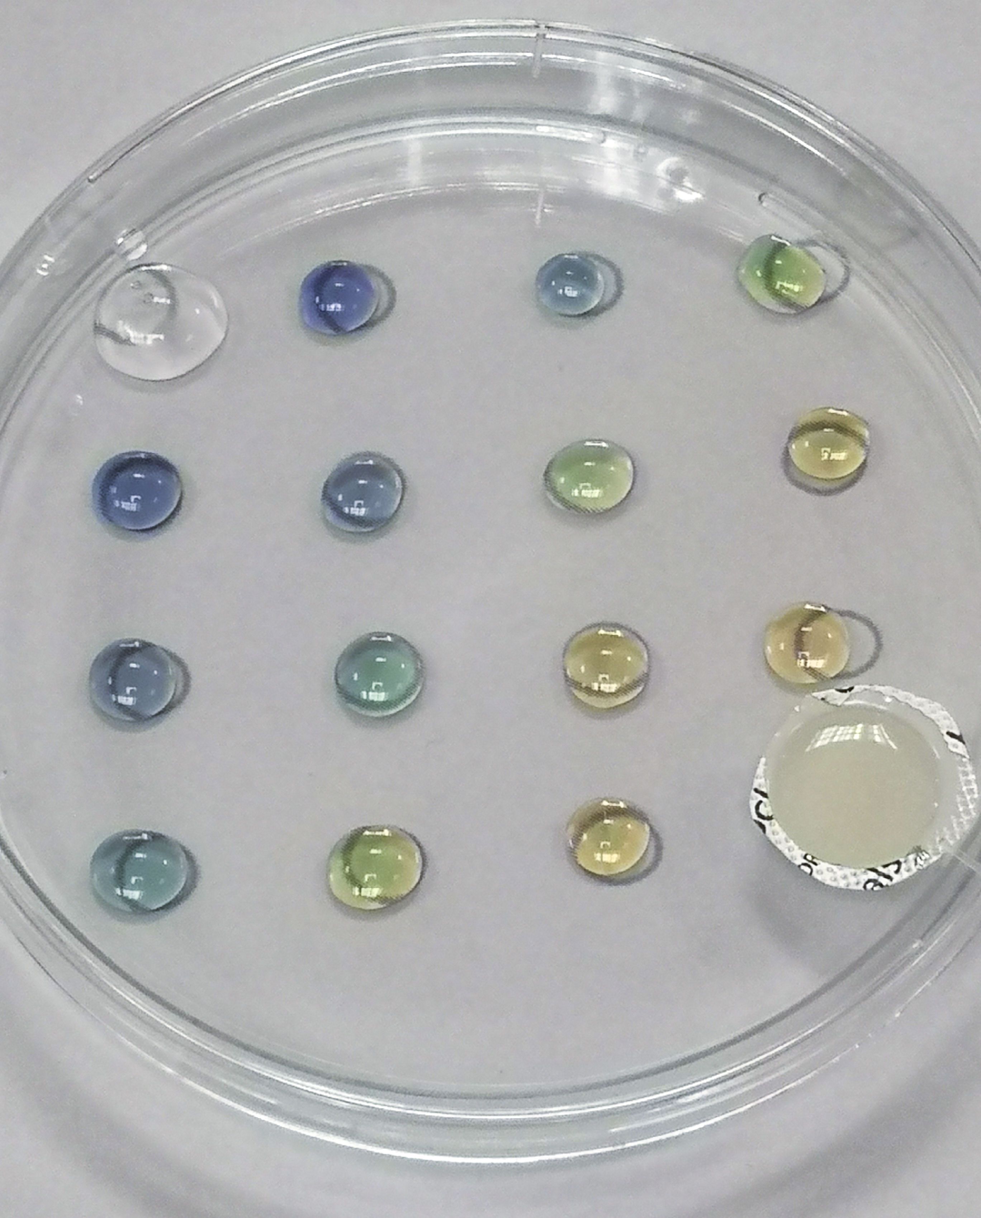

**Curriculum for Excellence**

By contributing to experiments and investigations, I can develop my understanding of models of matter and can apply this to changes of state and the energy involved as they occur in nature. **SCN 3-05a**

I have developed my understanding of the kinetic model of a gas. I can describe the qualitative relationships between pressure, volume and temperature of gases. **SCN 4-05a**

You have already seen that this process happens quite slowly in liquids.

Here we have a few experiments showing it taking place considerably faster in gases. The reactions takes place in a Petri dish. As well as protecting you from the toxic gases, it blocks air currents that could interfere with the natural diffusion process.

**Experiment 1**

**Diffusion of ammonia or sulphur dioxide**

We use universal indicator here to indicate the progress of these alkaline and acidic gases

**You will need**

|  |  |
| --- | --- |
| Ammonia 1-2 mol l-1 | Anhydrous calcium chloride |
| OR 0.3g Sodium sulphite** | 1-2 mol l-1 hydrochloric acid |
| Section from small blister pack |  |
| Universal indicator in distilled water* | Forceps |
| Pasteur pipettes (or dropping bottles) | Petri Dish |
| Instruction sheet |  |

* The reaction shows up better if

* For the ammonia, you acidify it with a drop of HCl before – just enough to turn it red
* For the SO2 you make it alkaline with a drop of NaOH – just enough to turn it blue/purple.

** Alternatively, you can just put a drop of concentrated HCl here.

**Preparation**

1. Place the petri dish on top of the sheet, covering the circle.
2. To each of the white circles add 1 drop the dilute indicator solution

**To Do**

1. To the grey circle add 3-4 drops of ammonia solution and then a piece of calcium chloride.

OR

1. Place a small blister pack where the grey circle is and add 0.3g of sodium sulphite and then 10 drops to 2 molar HCl
2. Replace the lid immediately and watch what happens.

**Results**

1. **Ammonia** - The anhydrous calcium chloride, dissolves exothermically in the water. This raises the temperature and as a result some of the ammonia gas comes out of solution.

It spreads across the petri dishes changing the colour of the indicator drops from red through green to blue.

1. Sulphur dioxide – The acid reacts with the sodium sulphite to release sulphur dioxide.
2. It spreads across the petri dishes changing the colour of the indicator drops from blue through green to red/orange.

**Experiment 2**

**Diffusion of ammonia AND sulphur dioxide**

We use universal indicator here to indicate the progress of these alkaline and acidic gases

**You will need**

|  |  |
| --- | --- |
| Ammonia 1-2 mol l-1 | Anhydrous calcium chloride |
| 0.3g Sodium sulphite | 1-2 mol l-1 hydrochloric acid |
| Section from small blister pack |  |
| Universal indicator in tap water* | Forceps |
| Pasteur pipettes (or dropping bottles) | Petri Dish |
| Instruction sheet |  |

* Tap water is used as distilled water is often slightly acidic from dissolved CO2. This way you can (usually) be sure it is green.

**Preparation**

1. Place the petri dish on top of the sheet, covering the circle.
2. To each of the white circles add 1 drop the dilute indicator solution

**To Do**

1. Place a small blister pack where the grey circle is and add 0.3g of sodium sulphite and then 10 drops to 2 molar HCl
2. In the circle diagonally opposite this add 3-4 drops of ammonia solution and then a piece of calcium chloride.
3. Replace the lid immediately and watch what happens.

It is best to add the ammonia and sodium sulphite first then the HCl and calcium chloride in rapid succession.

**Results**

1. **Ammonia** – As before the anhydrous calcium chloride, dissolves exothermically in the water. This raises the temperature and as a result some of the ammonia gas comes out of solution.

It spreads across the petri dishes changing the colour of the indicator drops from red through green to blue.

1. Sulphur dioxide – Likewise, once again, the acid reacts with the sodium sulphite to release sulphur dioxide.

It spreads across the petri dishes changing the colour of the indicator drops from blue through green to red/orange.

But this time the two gases meet. The end result is that those on the side nearest the acid turn orange and those near the ammonia turn purple. See below left.

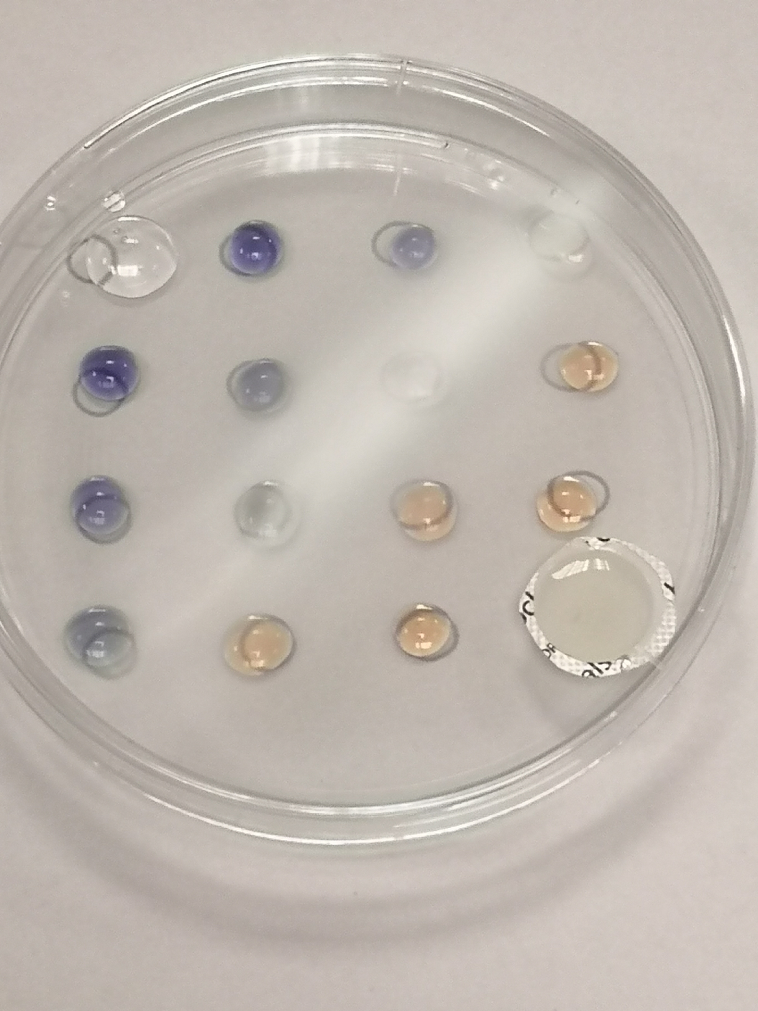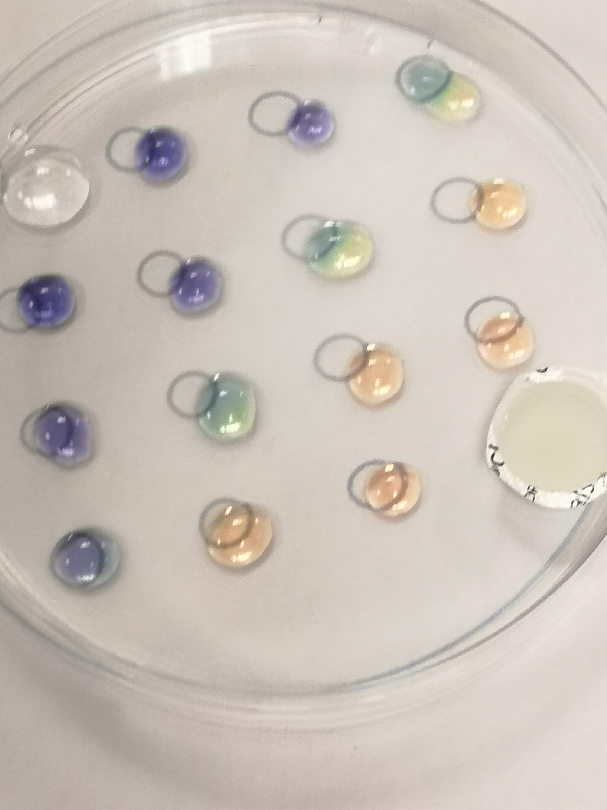

If you leave it longer, you will see a line of white appearing. Where the ammonia and SO2 meet, they form a solid – probably a mixture of ammonium sulphites.

**Experiment 3**

**Diffusion of Chlorine**

This experiment taken from the excellent book by Bob Worley and Dave Paterson[1] visualises the movement of chlorine using the displacement of iodine from potassium iodide as visualised but the blue/black starch iodide complex.

**You will need**

|  |  |
| --- | --- |
| Potassium iodide (0.1 mol l-1) | Starch (1%) |
| Solution of domestic thin bleach (50%) | Hydrochloric acid (1 mol l-1) |
| Pasteur pipettes (or dropping bottles) | Petri Dish |
| Instruction sheet | Poly pocket |

**Preparation**

1. Put the sheet in a poly pocket.
2. Place the petri dish on top of the sheet, covering the circle.
3. To each of the white circles add
   1. 1 drop of potassium iodide solution
   2. 1 drop of starch solution.

**To Do**

1. To the grey circle add 2 drops of bleach solution and then 2 drops of acid.
2. Replace the lid immediately and watch what happens.

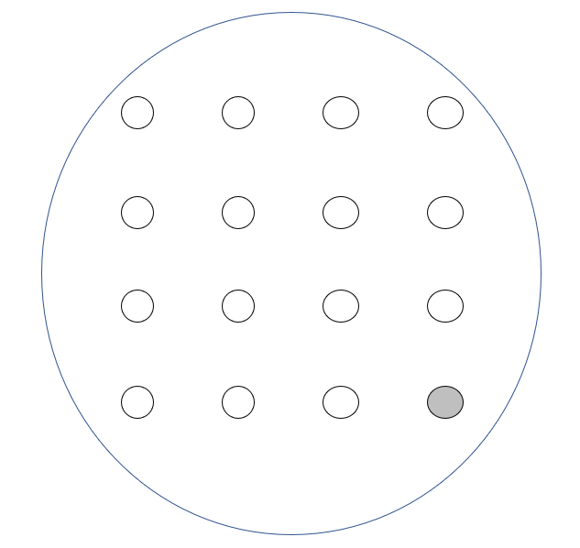

1 Drop each of starch and KI

**Results**

2 Drops each of bleach and HCl

Contained within the Petri dish, the concentration of chlorine builds up, produced by the reaction between the sodium chlorate I and hydrochloric acid.

NaOCl + 2 HCl 🡪 NaCl + Cl2 + H2O

The chlorine, being more reactive, displaces the iodine from iodide in a classic displacement reaction.

Cl2 + 2KI 🡪 I2 + 2KCl

In time it would be possible to see a yellow colour appearing. However, in the presence of and iodide ions, iodine forms triiodide (I3-) ions

I2 + I- 🡪 I3-

In turn, the I3- ions combine with starch to form an intensely coloured blue-black complex.

I3- + starch 🡪 starch-I3- (complex)

As the chlorine gas diffuses across the petri dish, a ‘wave’ of dark starch-triiodide colour appears.

1. Understanding Chemistry through microscale practical work – ASE 2022