

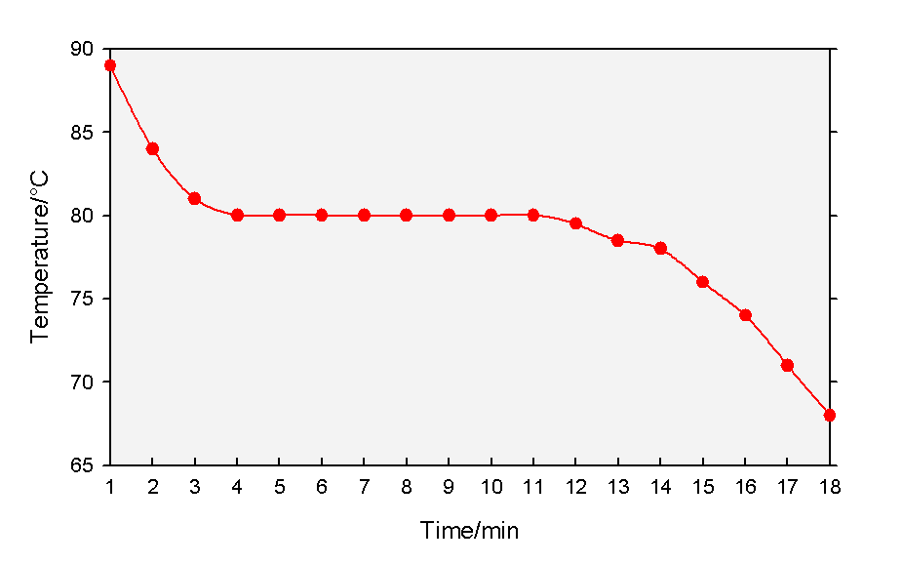

|  |
| --- |
| PupilExperiment |
| Cooling curves |
| Pupil Guide |

##### Introduction

A cooling curve is a line graph that represents how the temperature of a substance changes as it changes state on cooling – usually from liquid to solid though sometimes from gas to liquid.

The graph below shows a cooling curve for naphthalene and illustrates the key point of the cooling curve, the pause at the melting/freezing point due to the latent heat of melting.



Naphthalene is rarely used now as it is (slightly) carcinogenic so today we are using phenyl salicylate (salol)

This works well enough but does exhibit the phenomenon of supercooling – remaining liquid even though it is below the freezing point.

### You will need

|  |  |
| --- | --- |
| Eye protection | Beaker (250 cm3) |
| Phenyl salicylate (salol)* | Boiling tube |
| Thermometer (0–100˚C) | Timer |
| Bunsen burner | Clamp, stand and boss |
| Tripod & Gauze |  |

* Enough to ¼ fill a boiling tube.

### Method

1. 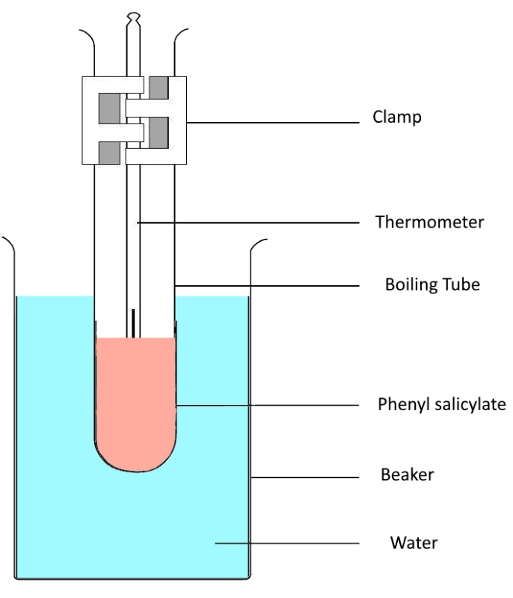Put about 150 cm3 water into the beaker and place on a gauze on a tripod over a Bunsen burner.
2. Add a few anti-bump granules
3. Fill the boiling tube about ¼ full with phenyl salicylate.
4. Insert a thermometer (0 – 110°C)*
5. Fix the boiling tube in a clamp and lower it into the beaker so it is close to but not quite touching the bottom.
6. Heat the beaker until the water just starts to boil. Keep it boiling, gently.
7. Once the phenyl salicylate is entirely melted:
   1. Switch off the Bunsen burner
   2. Lift the test tube out of the water by lifting the clamp
   3. Start the timer,
   4. Take your first temperature reading (start the datalogger if you are using one)
8. Record the temperature of the phenyl salicylate every minute as it cools down.
9. Note in your results table the temperature at which you see the phenyl salicylate begin to solidify. (Literature value is around 45°C but it may be lower due to supercooling).**
10. Once solidification begins, stop stirring but continue to take readings.
11. Continue to take readings until you can see the phenyl salicylate is clearly cooling again.

### Notes & Hints

* You can also use a datalogger in which case insert the temperature probe instead.

** Alternatively your teacher may tell you to it to cool to around 40-41° and then add a grain or two of solid phenyl salicylate to initiate solidification. This causes a release of heat taking the temperature up to the melting point.

### Health & safety

Phenyl salicylate is a skin/eye and respiratory irritant. Wear eye protection.

If you have sensitive skin you **may** need gloves but there is no general need – any spillage is unlikely and as long as it is washed off straight away there should be no issues.