

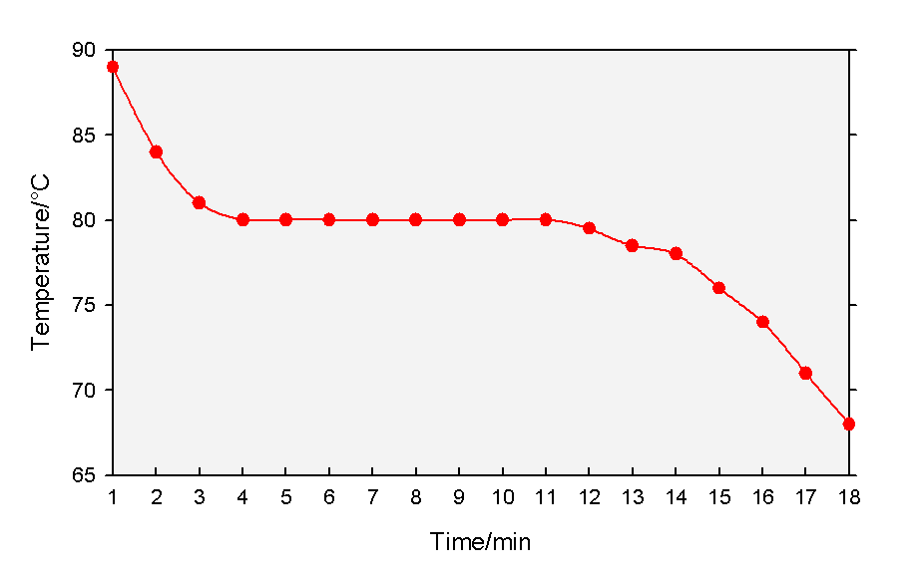

|  |
| --- |
| PupilExperiment |
| Cooling curves |
| Teacher/Technician Guide |

**Curriculum Links**

**CfE**

By contributing to experiments and investigations, I can develop my understanding of models of matter and can apply this to changes of state and the energy involved as they occur in nature. SCN 3-05a

##### Introduction

A cooling curve is a line graph that represents how the temperature of a substance changes as it changes state on cooling – usually from liquid to solid though sometimes from gas to liquid.

The graph below shows a cooling curve for naphthalene and illustrates the key point of the cooling curve, the pause at the melting/freezing point due to the latent heat of melting.



Naphthalene will still give the best results but it is hazardous so is best used either as a demonstration or perhaps by Higher/Advanced Higher classes and in small amounts.

1,4 dichlorobenzene is sometimes suggested but as it is as hazardous as naphthalene there is no real advantage to be gained by using it.

Some safer alternatives are long chain alkanols and alkanoic acids, e.g.

* hexadecan-1-ol,
* hexadecanoic acid (palmitic acid),
* octadecan-1-ol,
* octadecanoic acid (stearic acid) or
* phenyl salicylate (salol)

Most of these, however, are complicated by strong intermolecular bonding and the cooling rate is much slower than naphthalene.

Phenyl salicylate is safe but has the problem that it is prone to significant supercooling – however, if this phenomenon is incorporated into the teaching then it ceases to be a major problem.

Accordingly, the method that follows uses octadecanoic acid with phenyl salicylate as an extension.

### You will need

|  |  |
| --- | --- |
| Eye protection | Beaker (250 cm3) |
| Octadecanoic acid* (stearic acid) | Boiling tube |
| Thermometer (0–100˚C) | Stop clock |
| Bunsen burner | Clamp, stand and boss |
| Tripod & Gauze |  |

* Enough to ¼ fill a boiling tube.

### Method

1. 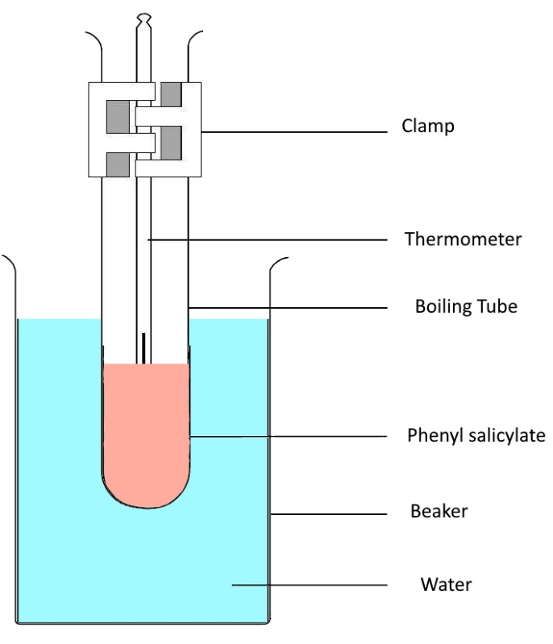Put about 150 cm3 water into the beaker and place on a gauze on a tripod over a Bunsen burner.
2. Add a few anti-bump granules
3. Fill the boiling tube about ¼ full with phenyl salicylate.
4. Insert a thermometer (0 – 110°C)*
5. Fix the boiling tube in a clamp and lower it into the beaker so it is close to but not quite touching the bottom.
6. Heat the beaker until the water just starts to boil. Keep it boiling, gently.
7. Once the octadecanoic acid is entirely melted:
   1. Switch off the Bunsen burner
   2. Lift the test tube out of the water by lifting the clamp
   3. Start the timer,
   4. Take your first temperature reading (start the datalogger if you are using one)
8. Record the temperature of the octadecanoic acid every minute as it cools down.
9. Note in your results table the temperature at which you see the octadecanoic acid begin to solidify. (Literature value is 69°C but it can vary greatly with samples of different purity).**
10. Once solidification begins, stop stirring but continue to take readings.
11. Continue to take readings until you can see the octadecanoic acid is clearly cooling again.

### Notes & Hints

* You can also use a datalogger in which case insert the temperature probe instead.

Use as pure a sample as you can – impurities may affect both the melting point and how it cools. Impure samples may exhibit a gently downslope rather than being absolutely horizontal at the freezing point – however, as long as there is a recognisable ‘shelf’ it should be OK.

### Extensions

You can use phenyl salicylate to show supercooling. After heating allow it to cool below the 45°C melting point (to around 40-41°) and then add a grain or two of solid phenyl salicylate to initiate solidification. This causes a release of heat taking the temperature up to the melting point. (It can be tied in with discussion about the sodium acetate handwarmers that use this effect).

### Health & safety

Phenyl salicylate is a skin/eye and respiratory irritant. Wear eye protection. Pupils with sensitive skin may need gloves but there is no general need – any spillage is unlikely and as long as it is washed off straight away there should be no issues.

Work in a well-ventilated laboratory to minimise the effect of any fumes: this should not be a major problem as the boiling point is 173° so even if allowed to reach the boiling point of water not an enormous amount of vapour will be released. (Avoid heating it this much – aside from any H&S issues, it will take a long time to cool down).

##### Technician Guide

### Each Group will need

|  |  |
| --- | --- |
| Eye protection | Beaker (250 cm3) |
| Octadecanoic acid (stearic acid) * | Boiling tube |
| Thermometer (0–100˚C) | Stop clock |
| Bunsen burner | Clamp, stand and boss |
| Tripod & Gauze |  |

* Enough to ¼ fill a boiling tube.

You can keep a set of boiling tubes with the octadecanoic acid (and even the thermometers) in for re-use. It can be melted and re-used many times, just being topped up as required.

Or you can melt the acid in a beaker of hot water to allow removal the thermometers and then keep the tubes as above

Alternatively, melt the acid and pour it out.