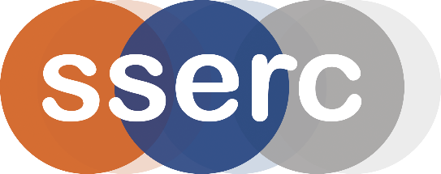
SSERC Risk Assessment (revised version March 2018)
(based on HSE’s INDG 163 ‘Risk assessment - A brief guide to controlling risks in the workplace’)

2 Pitreavie Court, South Pitreavie Business Park, Dunfermline KY11 8UU
tel : 01383 626070 e-mail : enquiries@sserc.org.uk web : www.sserc.org.uk

Activity assessed | Microelectrolysis
Date of assessment | 30th June 2020
Date of review (Step 5)
School
Department

Step 1 | Step 2 | Step 3 | Step 4
List Significant hazards here: | Who might be harmed and how? | What are you already doing?  What further action is needed? | Actions
 |  |  | by whom? |  | Due date |  | Done
Copper II chloride is harmful if swallowed (Cat 4) is a skin and respiratory irritant (Cat 2) and causes serious eye damage. | Technician by spillage while preparing solutions. | Wear gloves and goggles (EN 166 3). Avoid raising dust.
Potassium bromide and iodide are both eye irritants (Cat 2)  (both solutions are of low hazard) | Technician by spillage while preparing solutions. | Wear eye protection
Chlorine is produced in the reaction, which is toxic if inhaled (Cat 3) and a skin/eye/respiratory irritant (Cat 2) | Pupils if they inhale a large ‘whiff’ as the lid of the apparatus is removed.  Especially those with asthma. | Wear eye protection.  Ensure pupils do not lean over the apparatus as it is opened.  Be aware of those with respiratory conditions.  This procedure, being done on a micro scale, produces a very small amount of chlorine. It is safe to carry out in the open laboratory.

Description of activity:

A few drops of copper II chloride are electrolysed in a petri-dish. This traps the fumes of chlorine, which in turn displaces bromine from potassium bromide and iodine from potassium iodide. It also bleaches blue litmus paper.
Additional comments:

As long as care is taken that pupils don’t take a deep breath of the fumes as they open their apparatus, the concentration of chlorine will be well below the WEL.

