

|  |
| --- |
| Chemistry  At  Home |
| The Amazing Penny Experiment |

**The Amazing Penny Experiment**

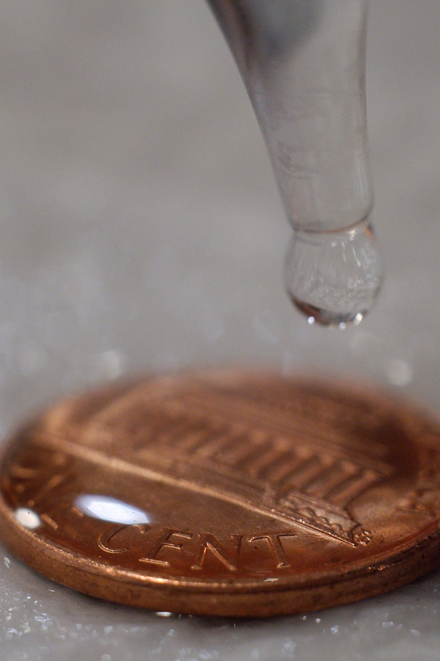

This experiment can be simply carried out for fun in order to see what happens.

There is, however, some proper chemistry at work here. The water stands ‘proud’ of the surface of the penny due to intermolecular forces called hydrogen bonds, which have a greater effect at the surface (look it up) and produce the phenomenon called ‘surface tension’.

Once you have carried out the first investigation to establish a baseline number of drops a penny can hold, you can then go further and investigate the effect of various factors on surface tension.

See **Extensions** below

You will need:

Coins



Small cup of water

Dropper of some sort

Paper Towels



Procedure:

1. Place your penny on top of a paper towel. Be sure to be working on a flat surface where your penny or surface won’t get bumped.

*The reason for the paper towel is that it will enable you to tell when the water has overflowed the penny as the towel will absorb it rapidly and show a dark patch of wetness.*

1. Fill the dropper with water.
2. Begin dropping water one drop at a time onto the head side of your penny. It’s easiest to count and get consistent size drops with your dropper held at about a 45˚ angle.
3. Continue adding drops until the water spills over the side of the penny. Record your final count on your paper.
4. Dry the desk and get a new paper towel. Repeat the experiment two more times and record your results.

**Results:**

How many drops of the water fit on the penny?

|  |  |  |  |
| --- | --- | --- | --- |
| Trial 1 | Trial 2 | Trial 3 | Average |
|  |  |  |  |

**Extensions**

Repeat the same experiment but this time use a salt solution. Make as concentrated a solution of salt in water as you can and see what happens this time.

1. Salt Water

|  |  |  |  |
| --- | --- | --- | --- |
| Trial 1 | Trial 2 | Trial 3 | Average |
|  |  |  |  |

Is there a difference between these results and those for pure water? If so, see if you can find out why.

If there is a difference, investigate if it is related to concentration. Halve the concentration of your salt solution and repeat the experiment.

1. Soapy Water

Repeat the experiment but this time gently mix a squirt of washing up liquid into your water.

|  |  |  |  |
| --- | --- | --- | --- |
| Trial 1 | Trial 2 | Trial 3 | Average |
|  |  |  |  |

Is there a difference this time? If so, again see if you can find out why.

You can investigate further – try dissolving only a single drop of washing up liquin in your cup of water. See if bathroom soap, shampoo, toothpaste, washing powder/liquid have the same effect. Is it greater or less?

1. Temperature

Repeat the experiment again but this time see what happens if you use hot water, and then cold water

Hot water – take a mug of hot water from the kettle (or the hot tap). It is best if you warm your coin a bit first – on a radiator or in hot water and dry it. The temperature will drop but it should remain significantly higher than it was before

|  |  |  |  |
| --- | --- | --- | --- |
| Trial 1 | Trial 2 | Trial 3 | Average |
|  |  |  |  |

Cold water – Cool your water with ice if possible – if not just let it cool down in the fridge. As before, get your coin cool first – but not so cold (from the freezer) that it freezes the water drops.

|  |  |  |  |
| --- | --- | --- | --- |
| Trial 1 | Trial 2 | Trial 3 | Average |
|  |  |  |  |

Does temeperature affect the surface tension? If so, again see if you can find out why.