 Making light of photosynthesis

Fun with photosynthesis 2

Teacher information
This is a hands-on practical activity whose purpose is to help pupils gain an understanding of absorption and / or release of oxygen by plants under light and dark conditions.
The activity makes use of an aquatic plant and sodium hydrogencarbonate along with apparatus readily available in school laboratories. The technique described will allow pupils to investigate oxygen evolution / uptake in plants in light and dark conditions during a single school period. By using and / or adapting the basic technique, pupils can design their own practical work / investigations.
Until recently SSERC recommended the use of Cabomba caroliniana in this activity. Cabomba is an aquatic plant, non-native to the UK which has been available from aquarium suppliers as an aquarium oxygenator. In bright light, it readily releases bubbles of oxygen gas and the rate of bubbling can be varied very easily by altering the lighting conditions. However, in 2016 Cabomba, along with various other plant species, was placed on the EU list of invasive alien species and as current stocks are used up will become increasingly difficult to source. Ultimately it will be an offence to keep, or supply Cabomba.  At SSERC we have identified another aquarium oxygenator, also non-native which, so far, is still available to buy. Egeria najas (not to be confused with Egeria densa) performs just as well as Cabomba in these simple classroom photosynthesis experiments | 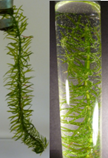
Sodium hydrogencarbonate is used to ensure an adequate supply of carbon dioxide for photosynthesis to take place.

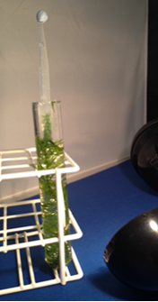
In the basic version of this practical, a sprig of E. Najas is submerged in 1% sodium hydrogencarbonate solution and irradiated with visible light. Under these conditions, the E. najas photosynthesises and releases bubbles of oxygen-rich gas. The rate at which bubbles are released can be measured. In bright light, the rate of bubbling may be too fast to count by eye.
This practical can be easily adapted so that the gas released can be collected and its volume measured. This is achieved by placing an inverted, filled pipette over the sprig of E. najas. The gas evolved displaces the liquid and its volume can be measured against the graduations of the pipette. The rate of gas evolution under different lighting conditions can be measured and conclusions drawn about the effect of light intensity on rate of photosynthesis.

Laboratory Protocol – Fun with Photosynthesis Part 2

You are provided with:
- a boiling tube containing 1.0% sodium hydrogencarbonate
- a small bench-top lamp
- Egeria najas
- scissors and tweezers
- drinking straw
- Blu-tack™
- weighing boat
- disposable pipettes (3 cm³) x 2

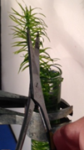
- Take a length of Egeria najas and cut it to the same length as the boiling tube. Trim the leaves from the final 3 cm of the stem and place the inverted Egeria najas inside the tube. Fill the tube with 1% sodium hydrogencarbonate solution.
- Under the surface of the liquid cut, at an angle of approximately 45º, about 1 cm of the Egeria najas and discard.  - Illuminate with the bench lamp provided. | 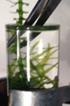
- Once a steady stream of bubbles of gas can be seen coming from the Egeria najas turn off the lamp. Note whether the rate of gas evolution changes.
- After a couple of minutes turn the lamp back on and note any changes in rate of gas evolution.
- Fill a disposable pipette (3 cm³) with sodium hydrogencarbonate from the boiling tube making sure that liquid goes into the bulb.  - Remove any air bubbles by gentle squeezing and seal the end of the pipette with Blu-tack™. | 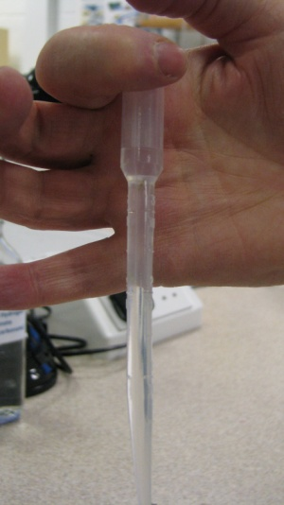 | 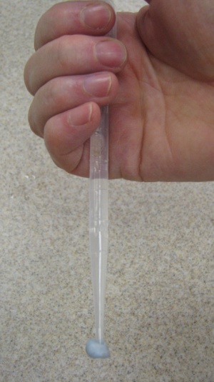

- Cut the pipette at the 3 cm³ graduation mark and allow the bulb to fall into the weighing boat.  - Using the second pipette draw up liquid from the weighing boat and top up the stem of the first pipette. | 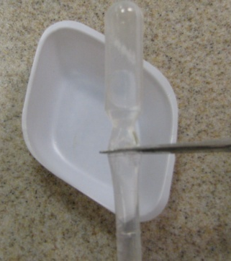 | 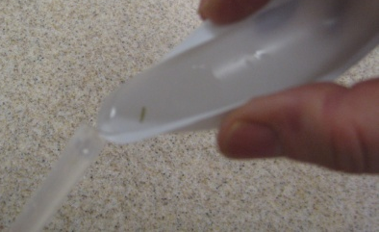
- Angle the boiling tube and quickly flip the pipette into the boiling tube containing the Egeria najas. If any air locks appear repeat steps 9 and 10.
- Place the end of the pipette over the cut end of the stem.
- Illuminate with the bench lamp provided and leave for about 30-40 minutes.

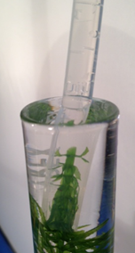
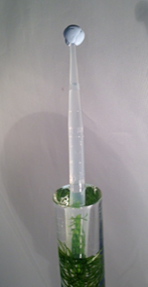
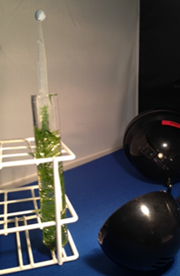

Technical information

- Materials per pair or group
  - Egeria najas (sprig at least the length of a boiling tube)
  - scissors
  - weighing boats
  - lamp
  - boiling tube
  - 100 cm³ sodium hydrogencarbonate (1%)
  - 3 cm³ plastic pipette
  - Blu-tackTM
  - timer

- Hints and tips
- Egeria najas
We have found through our work with Egeria najas that the best way to maintain the plant is to put it in a constantly aerated tank (just use a simple aquarium pump) filled with tap water located near a window. When purchasing Egeria najas it is sometimes confused with Egeria densa and species of Elodea. In comparison with Egeria densa and Elodea, Egeria najas has thin, serrated leaves and a narrow stem.
  - Lamp
- We use a 10 W desk lamp from John Lewis which works well in this experiment although other light sources available in schools may be just as effective.

  - Sodium hydrogencarbonate
We use a 1% sodium hydrogencarbonate solution for this practical work. The solution can be made up well in advance of practical and stored in the fridge. To achieve a 1% solution, add 10 g of sodium hydrogencarbonate (sodium bicarbonate) per litre of distilled water.

- Suppliers and costs December, 2018
  - Egeria najas
We source Egeria najas either from a variety of suppliers:
- The aquatic dept of our local Dobbies Garden Centre, run by Fishkeeper Scotland: https://www.fishkeeper.co.uk/
- Dunfermline website: https://www.fishkeeper.co.uk/store/fishkeeper-dunfermline
- on-line from Urmston Aquatics, 20 The Circle, Barton Road, Lostock, Manchester M32 9TR:0 http://www.urmstonaquatics.com/ Tel 0161-748-9086
The cost of Egeria najas from each of these suppliers varies:
- Fishkeeper Scotland - 4 bunches for £10, or £2.99 per bunch
- Urmston Aquatics - £2.20 per bunch but remember that there will be a delivery charge for Egeria najas ordered online. Delivery costs vary for orders in the range £2.95 up to £35.00, free > £35.00.

  - Sodium hydrogencarbonate
Sodium hydrogencarbonate can be purchased from Scientific & Chemical Supplies Ltd Product Code SO175 Sodium hydrogencarbonate, 500 g, £1.63
  - Plastic pipettes
These can be purchased from Scientific & Chemical Supplies Ltd Product Code PPT 300040, 3cm³ non-sterile pipettes (500 pk), £11.36

