 Fun with photosynthesis 1

Teacher information
This is a hands-on practical activity whose purpose is to help pupils gain an understanding of carbon dioxide uptake and / or release by plants in light and dark conditions.
The activity makes use of an aquatic plant and hydrogencarbonate indicator along with apparatus readily available in school laboratories. The methods described will allow pupils to investigate carbon dioxide exchange in plants under both light and dark conditions during a single school period. By using and / or adapting the basic technique, pupils can design their own practical work / investigations.
(Note: Before starting this practical work, pupils will need to understand the role of hydrogencarbonate indicator as a pH indicator and that carbon dioxide forms an acidic solution when dissolved in water.)

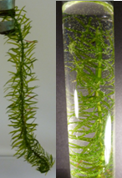
Until recently SSERC recommended the use of Cabomba caroliniana in this activity. Cabomba is an aquatic plant, non-native to the UK which has been available from aquarium suppliers as an aquarium oxygenator. In bright light it readily releases bubbles of oxygen gas and the rate of bubbling can be varied very easily by altering the lighting conditions. However, in 2016 Cabomba, along with various other plant species, was placed on the EU list of invasive alien species and as current stocks are used up will become increasingly difficult to source. Ultimately it will be an offence to keep, or supply Cabomba.
At SSERC we have identified another aquarium oxygenator, also non-native which, so far, is still available to buy. Egeria najas (not to be confused with Egeria densa) performs just as well as Cabomba in these simple classroom photosynthesis experiments.
Hydrogencarbonate indicator (HCI) is a pH indicator which can be used to measure the concentration of carbon dioxide over a range of pH values. HCI is orange/red in equilibrium with air and becomes increasingly yellow as the concentration of CO₂ increases (the solution becomes more acidic). As CO₂ concentration in solution decreases, HCI changes colour from orange –> red –> magenta –> deep purple.

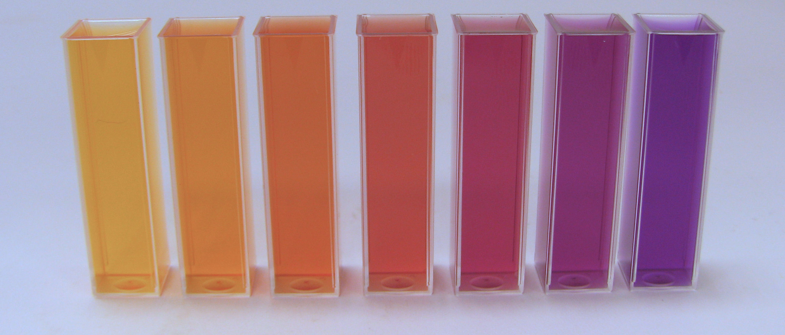
Hydrogencarbonate indicator solutions in the range pH = 6.8 (pale yellow) to pH = 9.2 (purple). pH increases in increments of 0.4 units.
In the basic practical, equal lengths (about 3 cm) of E. najas are added to each of two identical small bottles (we suggest Bijou bottles), which are then filled with equal volumes of hydrogencarbonate indicator. One bottle is then covered with a sleeve of opaque black paper and both bottles placed at an equal distance in front of the same light source. Comparison is then made of the colour of the hydrogencarbonate indicator after illumination for about 30 min. | 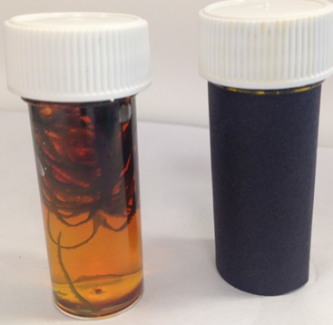
Pupils should be able to offer reasons for the colour changes. In the bottle covered with black paper, the E. najas cannot photosynthesise. It does, however, continue to respire, releasing carbon dioxide. The resulting increase in dissolved carbon dioxide concentration causes a reduction in pH and the hydrogencarbonate indicator will turn from orange to become more yellow within 30-40 minutes.  In the bottle exposed to light, the rate of photosynthesis in  E. najas is greater than the rate of respiration, causing a net decrease in the concentration of carbon dioxide dissolved in the hydrogencarbonate indicator and a corresponding increase in pH. Over a period of 30-40 minutes, colour change from orange through red to purple can be clearly observed. | 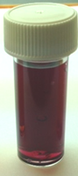 | 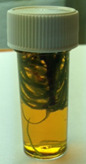
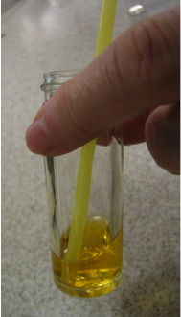
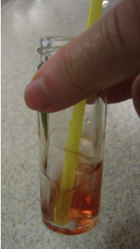
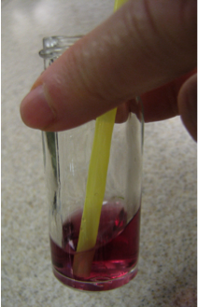
Pupils can then try to make deductions about the activity of the E. najas in light and dark conditions. One ‘nice’ activity is for them to convert the hydrogencarbonate indicator that has been turned purple by the action of E. najas back to a yellow colour. To do this, we suggest transferring the indicator into a larger container such as a Universal or small beaker and blowing (not sucking!!) through a straw into the indicator, which will turn back to yellow as the exhaled carbon dioxide dissolves and lowers the pH.

Pupils could design their own investigations into the rate of photosynthesis by, for example, varying light sources, distances from light source, using a variety of neutral density or coloured filters etc.

Laboratory Protocol – Fun with Photosynthesis 1

For this activity you will work in pairs. You are provided with
- 2 empty Bijou bottles
- A Universal bottle which contains hydrogencarbonate indicator
- An empty Universal bottle
- Tweezers
- Black paper
- Egeria najas
- Drinking straw (available separately)

- To each of the 2 empty Bijou bottles add a 3 cm length of Egeria najas.
- Fill the 2 empty Bijou bottles with the hydrogencarbonate indicator and mark the lids of your bottles with your initials.
- Place black paper over one of the Bijou bottles.
- Place both Egeria najas samples in front of the fluorescent tube and leave for about 40 min.
- Note any colour changes in the hydrogencarbonate indicator and compare with the pH colour chart below.
Hydrogencarbonate indicator solutions in the range pH = 6.8 (pale yellow) to pH = 9.2 (purple). pH increases in increments of 0.4 units.

- Pour the hydrogencarbonate indicator from the Bijou bottle which received the most light in step 4 above into the empty Universal bottle. Gently blow through a clean drinking straw into this solution (for about 30 s) - be sure to blow and not suck! Note any colour changes in the solution.
Technical information
- Materials (per group)
  - Egeria najas, ½ sprig
  - 2 Bijou bottles
  - hydrogencarbonate indicator ( ~ 20 cm³)
  - scissors
  - weighing boats / tile
  - lamp
  - black paper
  - timer
Hints and tips
- Egeria najas
We have found through our work with Egeria najas that the best way to maintain the plant is to put it in a constantly aerated tank (just use a simple aquarium pump) filled with tap water located near a window. When purchasing Egeria najas it is sometimes confused with Egeria densa and species of Elodea. In comparison with Egeria densa and Elodea, Egeria najas has thin, serrated leaves and a narrow stem.
- Hydrogencarbonate indicator
Hydrogencarbonate indicator is available to purchase from all the main scientific suppliers but it does vary in quality a great deal. HCI is normally purchased in concentrated form and has to be diluted x 10 and aerated before use.
We recommend that you prepare your own indicator.
To prepare a stock solution of hydrogencarbonate indicator:
    - dissolve 0.10 g of cresol red and 0.20 g of thymol blue in 20 cm³ ethanol
    - dissolve 0.85 g sodium hydrogencarbonate in about 200 cm³ of freshly boiled (and cooled) distilled water
    - add the cresol red / thymol blue solution produced in step 1 to the hydrogencarbonate solution produced in step 2 and dilute to 1000 cm³ with freshly boiled (and cooled) distilled water.
For use in experiments, dilute the stock solution by a factor of 10 with freshly boiled distilled water and bubble air through this diluted solution to equilibrate it with atmospheric carbon dioxide.
Note: Hydrogencarbonate indicator is very sensitive to changes in pH and so it is important that all the glassware and equipment used is rinsed out with a little of the indicator before use.
  - Lamp
We use a 10 W desk lamp from John Lewis which works well in this experiment although other light sources available in schools may be just as effective.

- Suppliers and costs
Fun with Photosynthesis Suppliers and costs December, 2018

Fun with Photosynthesis 1.

Egeria najas
We source Egeria najas from a variety of suppliers:
- The aquatic dept of our local Dobbies Garden Centre, run by Fishkeeper Scotland: https://www.fishkeeper.co.uk/
- Dunfermline website: https://www.fishkeeper.co.uk/store/fishkeeper-dunfermline
- on-line from Urmston Aquatics, 20 The Circle, Barton Road, Lostock, Manchester M32 9TR:0 http://www.urmstonaquatics.com/ Tel 0161-748-9086
The cost of Egeria najas from each of these suppliers varies:
- Fishkeeper Scotland - 4 bunches for £10, or £2.99 per bunch
- Urmston Aquatics - £2.20 per bunch but remember that there will be a delivery charge for Egeria najas ordered online. Delivery costs vary for orders in the range £2.95 up to £35.00, free > £35.00.

Hydrogencarbonate indicator
The component parts required to make up your own indicator can be purchased from Scientific & Chemical Supplies Ltd as follows:
Product Code TH025 Thymol Blue 5 g £3.69
Product Code CR005 Cresol Red 5 g £4.11
Product Code SO175 Sodium hydrogencarbonate 500 g £1.163
Product Code ET025 Ethanol (Industrial Methylated Spirit) 500 cm³ £1.37
Bijou bottles
Can be purchased from Scientific & Chemical Supplies Ltd (Industrial catalogue) Product Code DCN091010 - Sterile 7 cm³ Bijou £67.36 for a pack of 700.

Black paper
Any thick black paper that cuts out the light effectively would do for this purpose.

