The first recorded use of fingerprints was by the ancient Assyrians and Chinese. They used them to sign legal documents.

Probably the first modern study of fingerprints was made by the Czech physiologist Johannes Evangelista Purkinje. In 1823 he proposed a system of classification but it didn’t really catch on.

It was a British scientist Sir Francis Galton who proposed in the late in 19th century that fingerprints could be used for identification purposes. He wrote a detailed study of fingerprints in which he presented a new classification system using prints of all ten fingers. This is the basis of identification systems still in use.
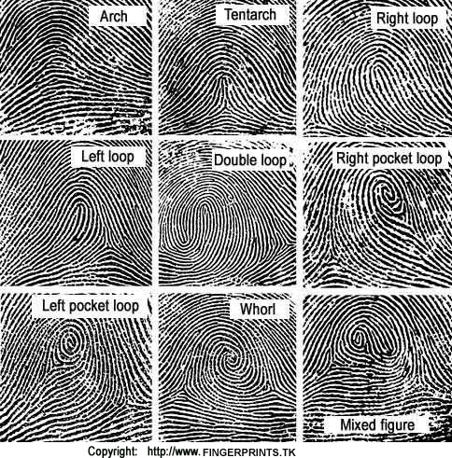
In the 1890s the police in Bengal, India, under the
British police official Sir Edward Richard Henry,
began using fingerprints to identify criminals. As
assistant commissioner of metropolitan police,
Henry established the first British fingerprint
files in London in 1901. As a result, the use of
fingerprinting as a means for identifying criminals
spread rapidly throughout Europe and the United
States, superseding the old Bertillon system of
identification by means of body measurements.

As crime-detection methods improved, police officers found that any smooth, hard surface touched by a human hand would yield fingerprints made by the oily secretion present on the skin. When these so-called latent prints were dusted with powder or chemically treated, the identifying fingerprint pattern could be seen and photographed or otherwise preserved. Today, the police can also use computers to digitally record fingerprints and to transmit them electronically to other police forces or agencies for comparison. By comparing fingerprints at the scene of a crime with the fingerprint record of suspected persons, officials can establish absolute proof of the presence or identity of a person. Or can they? There was a case recently where a police officer was accused of entering the scene of a crime and leaving her fingerprints there. She was adamant she had not been there but the fingerprint ‘experts’ insisted that fingerprints found there were hers. She was suspended and had to go to court to prove her innocence. After many, many months the court decided the fingerprints were not hers after all and she was awarded over £700,000 in compensation.

Since it is possible for innocent people to be wrongly accused of a crime based on fingerprint evidence alone, other methods of identifying people are now being looked at. What do you think these could be?

