

Chemical Demonstrations
Tomato bromine rainbow
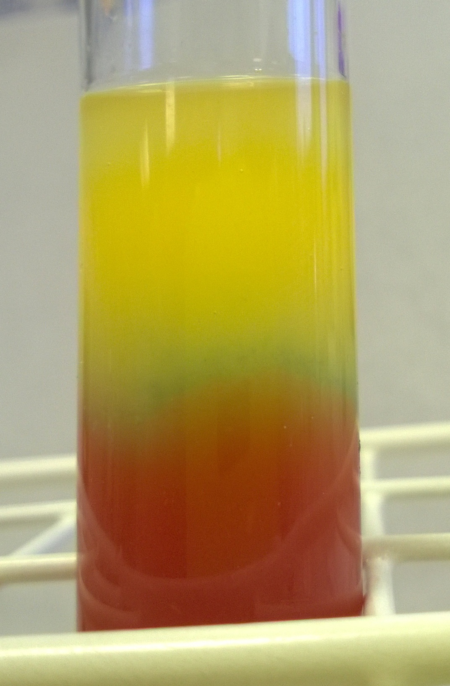
CfE Level 3
Through experimentation, I can identify indicators of chemical reactions having occurred. ...
SCN 3-19
CfE Advanced Higher –
Organic chemistry and Instrumental analysis
Spectroscopy
Absorption of visible light by organic molecules

Background
This demonstrations come from an article that appeared in the Journal of Chemical Education in December 1986.

The red colour of tomatoes is mainly due to the carotenoid, lycopene, which is a tetraterpene, having 8 isoprene units. (Though there is also some β-carotene, another, similar tetraterpene)
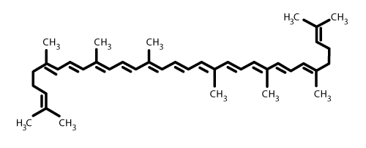
When saturated bromine water is gently stirred into tomato juice colour changes occur, and the concentration gradient created causes a rainbow effect. The reaction takes place in less than a minute and the colours persist for hours, making this demonstration fairly dramatic yet safe and easy to do.
It is the length of the conjugated system in lycopene that causes absorption in the blue region of the visible spectrum and gives them the characteristic red colour. If a double bond is attacked and removed by an agent like bromine, the length of conjugation shortens, the wavelength becomes smaller, and the absorption shifts to the ultraviolet region of the spectrum causing the compound to become colourless.
If you extract lycopene into an suitable solvent and add bromine water, that is exactly what happens.
However, in this case, you get a rainbow effect. It seems that the reaction is taking place within the lipids of the plant membranes of the tomato juice and this serves to stabilise the charge-transfer complexes. When molecules are immobilized and held in close proximity, as they are in the lipid aggregates in tomato juice,, the rate of decomposition of the complexes formed is greatly reduced. This accounts for the overwhelming predominance of the CT absorption band seen in this experiment.

What you will need
- Large measuring cylinder (the size does not matter but for a demonstration, the larger the better)
- Tomato juice
- Bromine water (saturated) (Harmful)
- 100 cm³ measuring cylinder
- Stirring rod

What you do

- Pour a measured amount of bromine water into the large cylinder.
- Measure out 10 - 15% of that volume of bromine water. (eg for 500 cm³ of tomato juice you will need 50 – 75 cm³ of bromine water.
- Carefully pour the bromine water on top of the tomato juice in the measuring cylinder – ideally pour ‘down’ a spatula or stirring rod.
- Using a stirring rod, gently mix the bromine water with the upper layers of the tomato juice.

Extensions

To show that the terpenes do not show these colours away from the other components of the tomato juice, place 10 cm³ of tomato juice and 10 cm³ of hexane in a test tube and shake to mix. The terpenes, mainly lycopene, will partition into the hexane layer.
Remove this layer into a clean test tube and add, dropwise, bromine water. You will see some fast colour changes occurring before it becomes colourless.

To show that the various colors produced in this experiment are due to increasing concentrations of bromine, you can either try this demonstration or use it as a classroom experiment for the pupils.
(The quantities here are for saturated bromine water. For lower concentrations, you will need to experiment with the quantities needed).
Place 3 cm³ of tomato juice into an array of test tubes.
Leave the first one as it is as a control.
To the following tubes add increasing amounts of bromine water. Shake them and allow to stand for a minute or two.
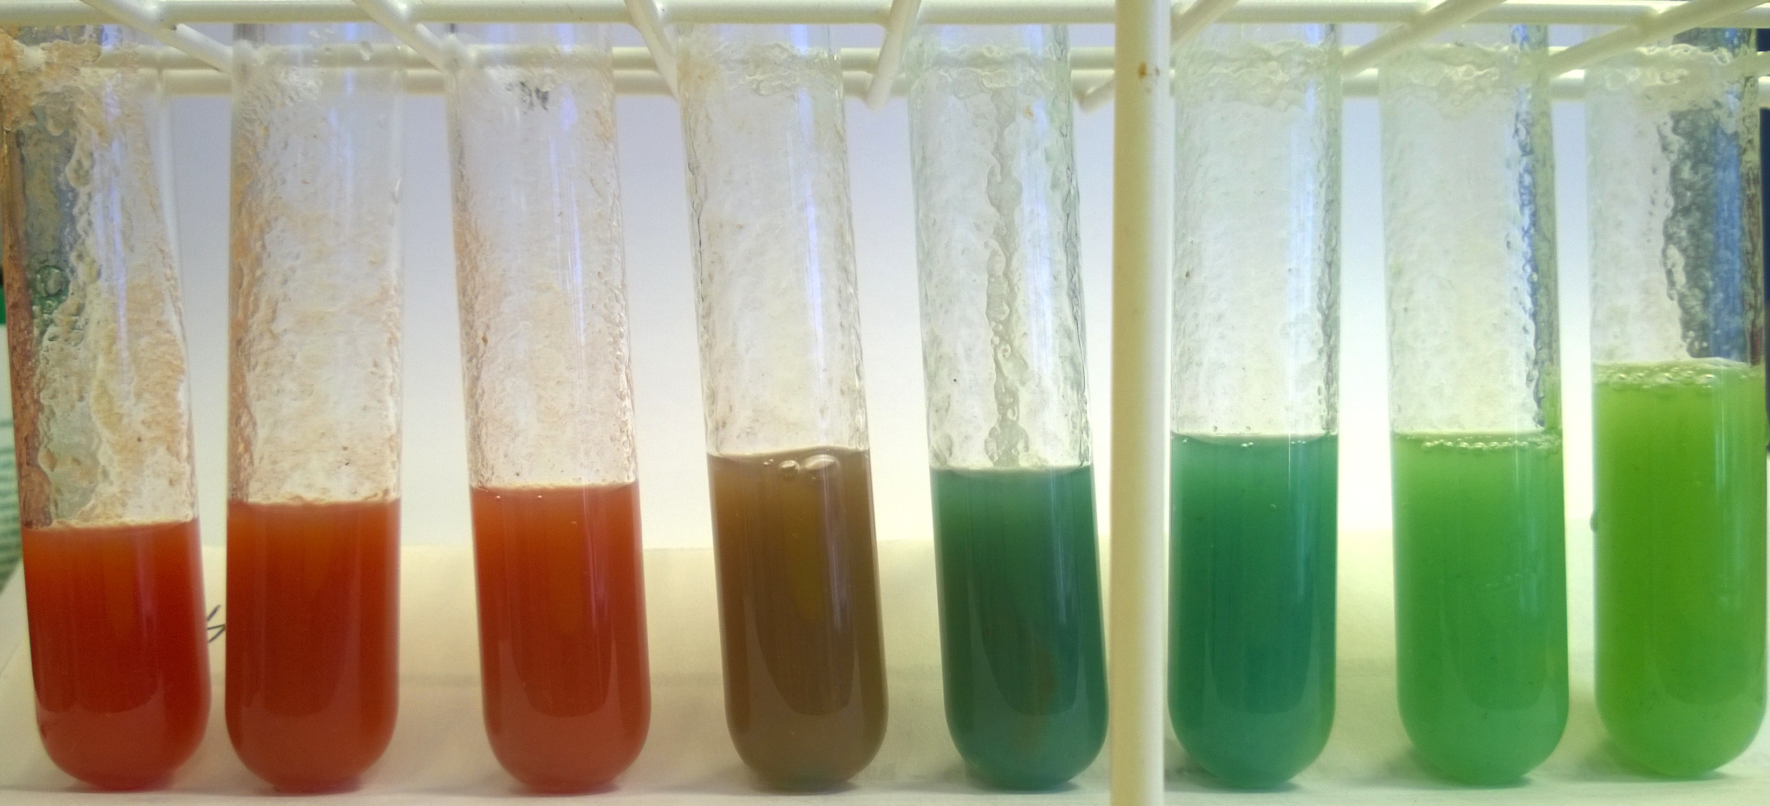
The result will be a range of colours. (See picture)

Amount of bromine water added
0 | 0.25 | 0.5 | 0.75 | 1.0 | 1.25 | 1.5 | 2.0

Safety
Carry out in a well-ventilated area
Wear eye protection. Consider wearing gloves

It is the responsibility of teachers doing this demonstration to carry out an appropriate risk assessment.

