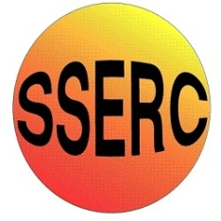
Simple Chemical Reactions
Thermometric titration

CfE Advanced Higher
Inorganic & Physical Chemistry

Introduction
The neutralisation reaction between hydrochloric acid and sodium hydroxide is exothermic. So the highest temperature is found when enough acid has been added to neutralise all of the sodium hydroxide.
After this point the temperature drops because the acid now being added is at a lower temperature than the reaction mixture.
You will need
2 M sodium hydroxide | 2 M hydrochloric acid
Polystyrene cup | Glass beaker to support the cup
25 cm³ measuring cylinder | 1 cm³ pasteur pipette
Thermometer / temperature probe

To do
- Place the polystyrene cup inside a glass beaker (for stability).
- Using the measuring cylinder, put 15 cm³ of sodium hydroxide in the polystyrene cup.
- Measure and record the temperature of the sodium hydroxide solution
- Using the pasteur pipette, add 1 cm³ of hydrochloric acid. Stir (you can use the thermometer for this) and measure the highest temperature reached.
- As soon as you have your reading (to avoid any cooling) add another 1 cm³ of acid, mix and take the temperature again.
- Keep adding acid, 1 cm³ at a time, and recording the temperature until you have added 30 cm³
- Now plot a graph of temperature against volume of acid.

What is happening?
The neutralisation reaction happening here is:
acid + alkali → salt + water
in this case
HCl_{(aq)} + NaOH_{(aq)} ⇋ NaCl_{(aq)} + H₂O_{(l)}
The point of neutralisation should occur when an equal amount of acid and alkali have been added. This is the point at which the greatest amount of heat should have been produced so should be the highest temperature.

Safety
Sodium hydroxide is corrosive. Wear goggles (BS EN166 3)

It is the responsibility of teachers doing this demonstration to carry out an appropriate risk assessment.

