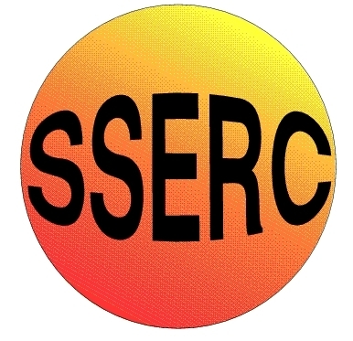
SSERC Risk Assessment (revised version November 2009)
(based on HSE ‘5 steps to risk assessment’)

2 Pitreavie Court, South Pitreavie Business Park, Dunfermline KY11 8UB
tel : 01383 626070 fax : 01383 842793
e-mail : sts@sserc.org.uk web : www.sserc.org.uk

Activity assessed | Pyrophoric iron
Date of assessment | 26/04/2014
Date of review (Step 5)
School
Department

Step 1 | Step 2 | Step 3 |  | Step 4
List Significant hazards here: | Who might be harmed and how? | What are you already doing? | What further action is needed? | Action by whom? | Action by when? | Done
Iron II sulphate is harmful if swallowed and a skin/eye irritant.  Sodium ethanedioate and iron II ethanedioate are harmful if swallowed and in contact with the skin  Carbon monoxide is toxic if inhaled (especially affecting the heart and circulatory system) and a reproductive toxin. | Technician preparing iron ethanedioate  Technician preparing iron ethanedioate. Demonstrator carrying out demonstration.  Demonstrator, (standing next to demo) Audience | Wear eye protection and gloves if required.  Wear eye protection and gloves.  Place a plug of mineral wool in the mouth of the tube when heating the iron II oxalate to ensure particles do not escape into the atmosphere.  Carry out the reaction in a well ventilated room. Do not use very large quantities or repeat many times in quick succession.

Description of activity:

Iron II oxalate is prepared by precipitating from a mixture of iron II sulphate and sodium oxalate and then dried.

The yellow powder is then heated in a boiling tube where it decomposes to produce small particles of iron and iron II oxide.

When poured onto a heat-proof mat, this powder spontaneously catches fire.

Additional comments:

