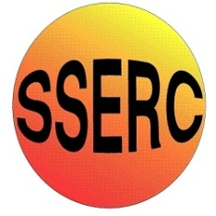
Simple Chemical Reactions
Neutralisation circles

CfE Advanced Higher
Inorganic & Physical Chemistry

Introduction
A very simple experiment to show the process of neutralisation
You will need
0.1 M sodium hydroxide | 0.1 M hydrochloric acid
1 sheet of filter paper | White tile
pencil | Universal indicator solution
2 x Pasteur pipettes

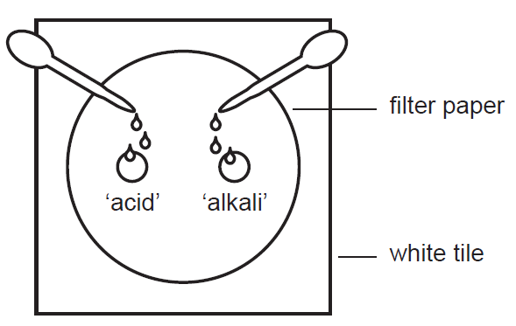
To do
- Using a pencil, draw two circles (each around 1 cm in diameter) about 2 – 3 cm apart on the filter paper
- Label one of the circles ‘acid’ and the other one ‘alkali’
- Use a Pasteur pipette to place several drops of hydrochloric acid into the ‘acid’ circle.
- Use a clean Pasteur pipette (or rinse it out) to place the same number of drops of sodium hydroxide into the ‘alkali circle
- Wait a few moments for the solutions to soak into the filter paper and meet. If they don’t meet, add more drops to both circles.
- Now add a few drops of universal indicator solution to the area where the acid and alkali have met.
- Record your observations.

The neutralisation reaction happening here is:
acid + alkali → salt + water
in this case
HCl_{(aq)} + NaOH_{(aq)} ⇋ NaCl_{(aq)} + H₂O_{(l)}
the Na⁺ and Cl⁻ ions are not involved (they are called ‘spectator’ ions)
Universal indicator is a mixture of indicators that gives a gradation of colour across the pH scale

Safety
The acid and alkali are both dilute enough to be of no significant hazard. The universal indicator is flammable so avoid sources of ignition.

It is the responsibility of teachers doing this demonstration to carry out an appropriate risk assessment.

