
Simple Chemical Reactions
Measuring an equilibrium constant

CfE Advanced Higher
Inorganic & Physical Chemistry

Introduction
Silver ions react with iron II to form metallic silver and iron III. The reaction proceeds slowly and eventually reaches an equilibrium position in which both ions are present in measurable concentrations.
The concentration of silver ions at equilibrium is measured by titration with potassium thiocyanate.
The method described is a microscale titration. You can use normal scale methods but will have to scale up the volumes used.
You will need
0.1M Iron II sulphate | 0.1M silver nitrate
0.02 potassium thiocyanate | Distilled water
3 x 1 cm³ Pasteur pipette | Microscale burette*
Small test tube with stopper or a small vial (bijou) | Small beaker (10 cm³) or another small vial)

To do
Preparation
Use a pasteur Add 2 cm³ of iron II sulphate solution to 2 cm³ of silver nitrate solution in a small test tube or bijou. Stopper it, shake well and leave overnight to reach equilibrium..
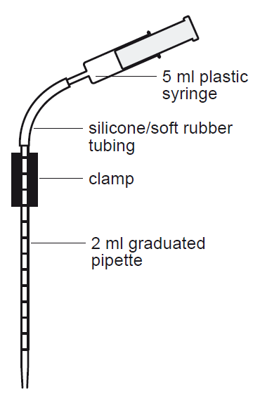
The Experiment
- Set up a microscale burette ( as shown in the diagram right)
- Fill it with potassium thiocyanate solution.
- Take the tube/bijou containing the iron I / silver mixture, handling it carefully so as not to disturb the silver precipitate.
- Use a pasteur pipette to transfer 1 cm³ of the mixture to the 10 cm³ beaker or other bijou.
- Titrate the mixture with the potassium thiocyanate untill a permanent red/brown colour appears
- Record the volume of thiocyanate added. Repeat the experiment (twice more if there is time) and calculate the average titre.

What is happening
The Ag⁺ and Fe²⁺ ions react slowly and eventually reach a position where both ions are present in measurable concentrations.
Ag⁺ _{(aq)} + Fe²⁺ _{(aq)} ⇋ Ag_{(s)} + Fe³⁺ _{(aq)}
The equilibrated mixture is then titrated with potassium thiocyanate.
Initially, the thiocyanate reacts with the remaining silver ions to form a precipitate of silver thiocyanate.
AgNO₃ _{(aq)} + KSCN _{(aq)} ⇋ AgSCN _{(s)} + KNO₃ _{(aq)}
Once all the silver ions have reacted, the thiocyanate ions start to react with the iron III ions in the mixture to form the characteristic red colour. This is the end point of the titration.

Note – this titration only works because the reaction proceeds very slowly. If it happened quickly, as most reactions do, then precipitation of silver thiocyanate would cause the reaction to continue , trying to make more of the silver thiocyanate to maintain the equilibrium until all of the silver had reacted.

The calculation
The equilibrium constant for the reaction can be calculated from this equation
Kc = [Fe³⁺_{(aq)}]
[Ag⁺_{(aq)}] x [Fe²⁺_{(aq)} ]

The concentration of Ag+ is the figure obtained from your titre. (From the equation, you can see that the thiocyanate reacts in a 1:1 ratio with the silver so the number of moles of thiocyanate used = the number of moles of silver)
Since the concentration of silver and iron II ions are equal initially, it follows that they are also equal at equilibrium (as one silver ion reacts with one iron II ion)
So the concentration of iron II is the same as the silver.
Thus both the values on the bottom line of your equation are the same.

The total concentration of iron is the total of the iron II and the iron III. This equals the initial concentration of iron, which was all iron II. (This is 0.05 M – as it was diluted 1:1 with the silver nitrate)
Subtract the value you have just obtained for the present concentration of iron II from this figure and you will be left with the value for iron III.
Put the figures into the equation and calculate the equilibrium constant.

Safety
Silver nitrate solution is damaging to the eyes, though only an irritant at this concentration) and can stain the skin. Wear eye protection (and gloves if desired).
It is the responsibility of teachers doing this demonstration to carry out an appropriate risk assessment.

