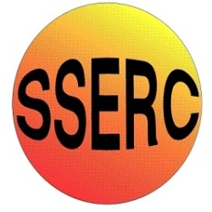
Simple Chemical Reactions
Comparing strong and weak acids

CfE Advanced Higher
Inorganic & Physical Chemistry

Introduction
Some simple investigations into the differences between strong and weak acids.
You will need
Test tubes and rack | 1 M hydrochloric acid
Marble chips | 1 M ethanoic acid
Universal indicator | Magnesium ribbon/turnings
Power supply and multimeter | Graphite electrodes

To do
1. pH of the acids
- Place a few cm³ of hydrochloric acid into a test tube, add a drop of universal indicator and record the pH.
- Repeat with ethanoic acid.
2. reaction with marble chip
- Put a 1 cm depth of hydrochloric acid into one tube and of ethanoic acid into another tube.
- Select two marble chips of the same size
- At the same time, drop one of the marble chips into each tube.
- Observe what happens in each tube
3. reaction with magnesium turnings
- Put 1 cm³ of each of the acids into two fresh tubes (or the same ones, rinsed out)
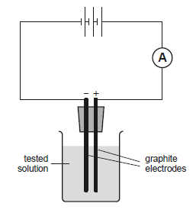
- Add a spatulaful of magnesium turnings or a piece of magnesium ribbon to each tube at the same time and record what happens.
4. Conductivity
- Use a conductivity circuit to measure the conductivity of the two acids.

What is happening?
The same number of molecules of HCl and CH₃COOH are dissolved in each 1 cm³ of the two acids but testing the pH shows that the HCl contains many times more hydrogen ions than the ethanoic acid. (Given the logarithmic scale, close to 1000x more)
As conductivity is due largely to the number of ions that can flow through the solution, a much greater current can flow through the hydrochloric acid than the ethanoic acid.
The reactions with marble chips
2HCl_{(aq)} + CaCO_{3(s)} → CaCl_{2(aq)} + H₂O_{(l)} + CO₂
2CH₃COOH_{(aq)} + CaCO_{3(s)} →Ca(CH₂COO)_{2(aq)} + H₂O_{(l)} + CO₂

And those with magnesium
2HCl_{(aq)} + Mg_{(s)} → MgCl_{2(aq)} + H_{2(g)}
2CH₃COOH_{(aq)} + Mg_{(s)} → Mg(CH₂COO)_{2(aq)} + H_{2(g)}
are reactions of the H⁺ ions and so proceed more rapidly in the hydrochloric acid where the dissociation means there is a higher concentration of hydrogen ions.

Safety
At these concentrations, the two acids are not of any significant hazard.

It is the responsibility of teachers doing this demonstration to carry out an appropriate risk assessment.

