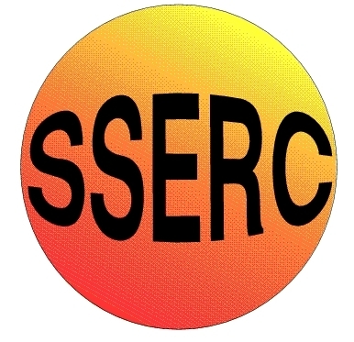
SSERC Risk Assessment (revised version November 2009)
(based on HSE ‘5 steps to risk assessment’)

2 Pitreavie Court, South Pitreavie Business Park, Dunfermline KY11 8UB
tel : 01383 626070 fax : 01383 842793
e-mail : sts@sserc.org.uk web : www.sserc.org.uk

Activity assessed | Oil from coffee grounds
Date of assessment | 24th August 2014
Date of review (Step 5)
School
Department

Step 1 | Step 2 | Step 3 |  | Step 4
List Significant hazards here: | Who might be harmed and how? | What are you already doing? | What further action is needed? | Action by whom? | Action by when? | Done
Propanone is flammable and a skin/respiratory irritant | Pupil extracting oil and evaporating propanone | Wear eye protection (and perhaps gloves). Work in a well-ventilated area.  Keep away from sources of ignition.

Description of activity:

Dried coffee grounds are shaken/stirred with 30cm³ of propanone (twice) and then filtered.

Oils from the grounds dissolve in the propanone and are then left behind when the propanone is evaporated.

Additional comments:

