
Short Experiments
Making a rubber band
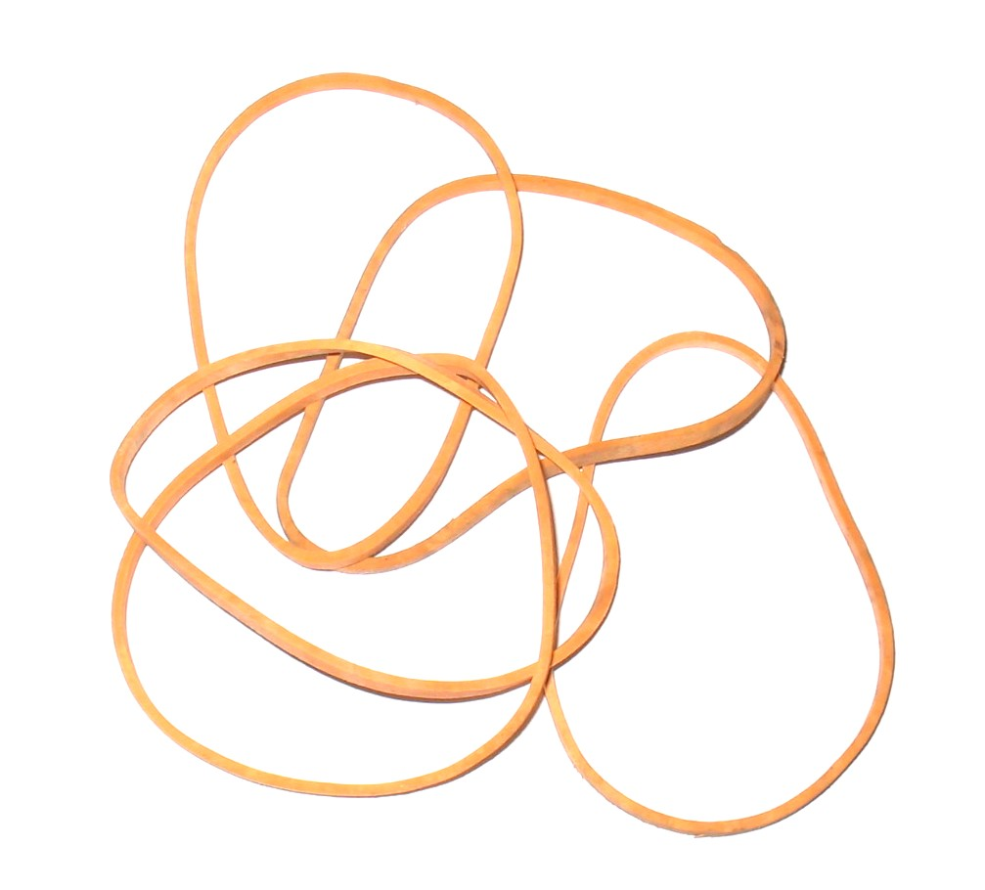

This reaction can be applied to curriculum for excellence.
SCN 3-19a
Through experimentation, I can identify indicators of chemical reactions having occurred ...
N4 – Chemistry in Society
Materials - polymers

We take rubber bands for granted but there is much more to them that something to flick across a classroom.
In this activity you will make your own rubber band from liquid rubber.
You will need.
- 1 small bottle of liquid latex (copydex glue diluted 1:1 with water is a suitable substitute)
- 1 small bottle of lemon juice (or any other dilute acid such a vinegar)
To make your rubber band
- Dip the glass rod (or blunt end of a pencil) into the latex solution – to a depth of no more than 5cm)
- Remove your rod – do not touch the rubber latex film
- Dip your rod, coated in latex, into the lemon juice, deep enough so that the latex layer is covered.
- Take it out and, if you think the layer is too thin, dip it into the latex again and back into the vinegar again.
- Rinse off the lemon juice with cold water and set your rubber band aside for 10 minutes to dry.
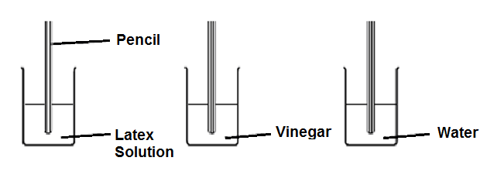
- Roll the rubber coating off the pencil carefully to form a rubber ring. Be careful as it is quite easy to break the band.

Some people have an allergic reaction to latex. If you have, wear protective gloves to avoid touching it and wear eye protection.

What is happening?
Natural rubber latex is the sap of a rubber tree Hevea brasiliensis. It is an elastic hydrocarbon polymer (i.e. it consists mainly of carbon and hydrogen).
Essentially it is a polymer of isoprene units creating polyisoprene with a molecular weight of 100,000 to 1,000,000.
If rubber latex is mixed with a weak acid such a lemon juice or vinegar it will cross-link. By simply adding the acid to a small quantity of liquid rubber latex and stirring, a solid lump of rubber will be produced.
Latex is a suspension of microscopic natural rubber particles in an aqueous medium. These particles scatter light, making the latex solution appear white and homogeneous like milk.
The surfaces of the Latex particles are charged, which creates forces of repulsion between them that keep them from coagulating. In the coagulation process acid neutralizes these charges, thereby eliminating the forces of repulsion between the particles
Thus the solid form, being composed of a huge molecular network created by cross-linking, is an example of a thermoset.
Extensions
You can use this to base an investigation on. Using weights it is possible to determine the strength and/or stretchiness of the rubber bands.
You can then see what factors affect these properties: concentration of latex/acid, types of acid, number of dips etc.
Safety
The solutions themselves are of low hazard (but be aware of possible latex allergies).

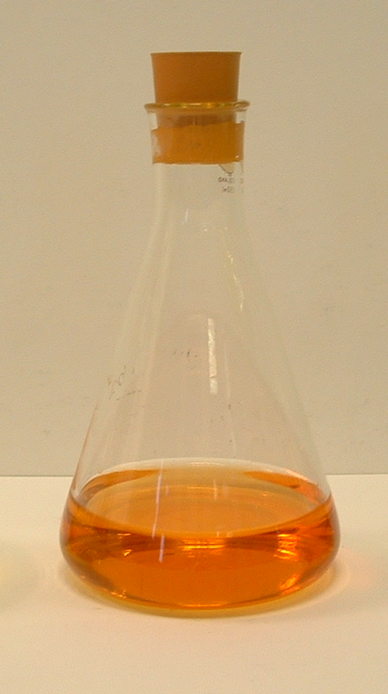
It is the responsibility of teachers doing this demonstration to carry out an appropriate risk assessment.

