
Short Experiments
Making a rubber ball
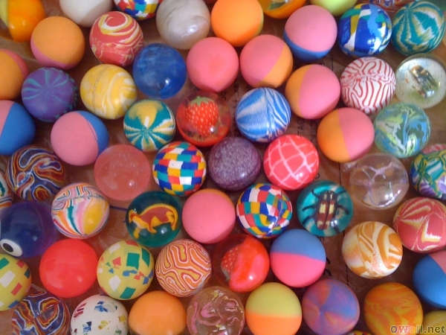

This reaction can be applied to curriculum for excellence.
SCN 3-19a
Through experimentation, I can identify indicators of chemical reactions having occurred ...
N4 – Chemistry in Society
Materials - polymers

Rubber is a natural polymer – it is the sap of the rubber tree and it bleeds out of the tree as a white liquid when the bark of the tree is cut.
This activity shows you how this simply natural polymer can be cross-linked to make it solid.
You will need.
- 1 small bottle of liquid latex (copydex glue diluted 1:1 with water is a suitable substitute)
- 1 small bottle of lemon juice (or any other dilute acid such a vinegar)
- Beaker or plastic cup
- A Stirring rod
To make your rubber ball
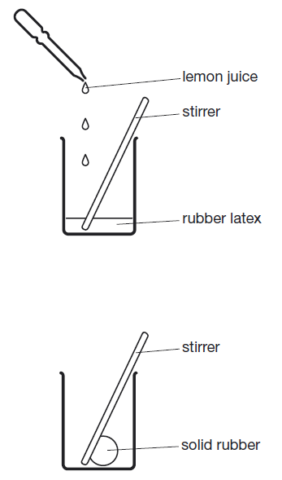
- Pour 5 cm³ rubber latex solution into small container such as a plastic cup or a small beaker.
- Add a squirt of lemon juice or vinegar.
- Stir to mix.
- Rubber will solidify and begin to stick to the stirrer.
- Keep stirring until the rubber has completely solidified and is completely stuck to the stirrer.
- Drop the solid rubber into the water and squeeze with your gloved hand to make it into a round ball shape. This isn’t easy and you have to do this quickly if you want a round ball.
- Dry the ball using a fabric cloth (not a paper towel).
- Check that the ball bounces.

Some people have an allergic reaction to latex. If you have, wear protective gloves to avoid touching it and wear eye protection.

What is happening?
Natural rubber latex is the sap of a rubber tree Hevea brasiliensis. It is an elastic hydrocarbon polymer (i.e. it consists mainly of carbon and hydrogen).
Essentially it is a polymer of isoprene units creating polyisoprene with a molecular weight of 100,000 to 1,000,000.
If rubber latex is mixed with a weak acid such a lemon juice or vinegar it will cross-link. By simply adding the acid to a small quantity of liquid rubber latex and stirring, a solid lump of rubber will be produced.
Latex is a suspension of microscopic natural rubber particles in an aqueous medium. These particles scatter light, making the latex solution appear white and homogeneous like milk.
The surfaces of the Latex particles are charged, which creates forces of repulsion between them that keep them from coagulating. In the coagulation process acid neutralizes these charges, thereby eliminating the forces of repulsion between the particles
Thus the solid form, being composed of a huge molecular network created by cross-linking, is an example of a thermoset.
Extensions
You can use this to base an investigation on. It is possible to determine the height to which the ball bounces.
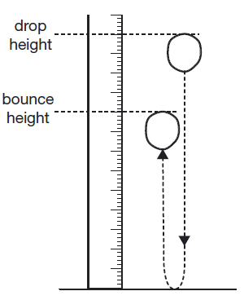
1. Support a metre rule vertically on the floor using a clamp and retort stand.
2. Try dropping the ball and see how easy it is to measure the height to which it bounces.
3. Choose a sensible drop height and use the rule to measure the height from which you will drop the ball accurately.
4. Allow the ball to fall then note height to which it bounces. You may have problems with the balls not bouncing vertically. It may be difficult to measure the bounce height accurately and you may have to try several times before you get an accurate measurement.
5. Measure the bounce height accurately 3 times and take the average.
You can then see what factors affect these properties: concentration of latex/acid, types of acid.
Safety
Some people have allergic reactions to liquid rubber latex. Wear protective gloves to avoid touching the liquid rubber, and wear eye protection.
Do not inhale the fumes, which contain ammonia.

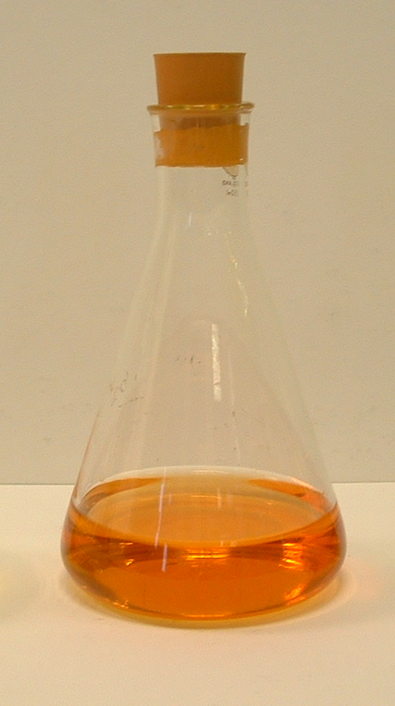
It is the responsibility of teachers doing this demonstration to carry out an appropriate risk assessment.

