
Short Experiments
Making foam rubber
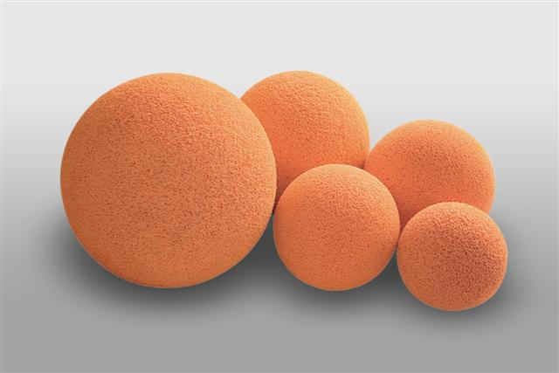

This reaction can be applied to curriculum for excellence.
SCN 3-19a
Through experimentation, I can identify indicators of chemical reactions having occurred ...
N4 – Chemistry in Society
Materials - polymers

Rubber is a natural polymer – it is the sap of the rubber tree and it bleeds out of the tree as a white liquid when the bark of the tree is cut.
Here you will make your own foam rubber and test it for ‘squashiness’ compared with ordinary rubber.
You will need.
- 1 small bottle of liquid latex (copydex glue diluted 1:1 with water is a suitable substitute)
- 1 small bottle of lemon juice (or any other dilute acid such a vinegar)
- 2 x Beaker or plastic cup (make sure at least one has a small diameter (< 5cm)
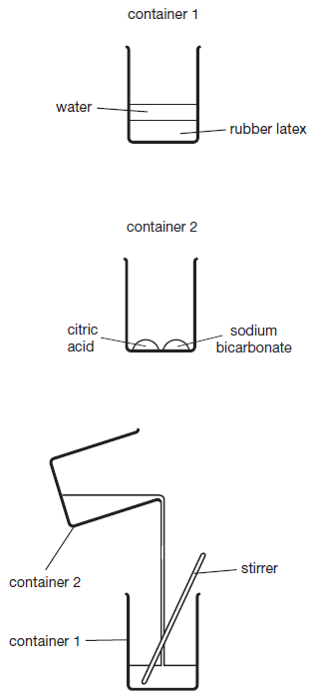
- A Stirring rod
- Sodium hydrogen carbonate
- Citric acid
To make your rubber ball
- Pour 10 cm³ rubber latex solution into small container such as a plastic cup or a small beaker.
- Add 10 cm³ of water to the latex solution.
- In another container put 1 spatula each of sodium bicarbonate powder and powdered citric acid. Mix well
- Pour the sodium bicarbonate powder/citric acid powder mix into rubber latex solution and stir quickly to mix then leave it to foam.
- When it has finished foaming, drop the foam rubber cushion into water to wash it.
- Leave the foam rubber cushion for 30 minutes to dry and harden before using it.

Some people have an allergic reaction to latex. If you have, wear protective gloves to avoid touching it and wear eye protection.

What is happening?
Natural rubber latex is the sap of a rubber tree Hevea brasiliensis. It is an elastic hydrocarbon polymer (i.e. it consists mainly of carbon and hydrogen).
Essentially it is a polymer of isoprene units creating polyisoprene with a molecular weight of 100,000 to 1,000,000.
If rubber latex is mixed with a weak acid such a lemon juice or vinegar it will cross-link. By simply adding the acid to a small quantity of liquid rubber latex and stirring, a solid lump of rubber will be produced.
Latex is a suspension of microscopic natural rubber particles in an aqueous medium. These particles scatter light, making the latex solution appear white and homogeneous like milk.
The surfaces of the Latex particles are charged, which creates forces of repulsion between them that keep them from coagulating. In the coagulation process acid neutralizes these charges, thereby eliminating the forces of repulsion between the particles
Thus the solid form, being composed of a huge molecular network created by cross-linking, is an example of a thermoset.
The difference between this and the other latex polymer activities is that the sodium hydrogen carbonate and citric acid react to produce bubbles of carbon dioxide. During the solidification, these bubbles get trapped and end up as bubbles in a solid matrix rather than just in liquid.
Safety
Some people have allergic reactions to liquid rubber latex. Wear protective gloves to avoid touching the liquid rubber, and wear eye protection.
Do not inhale the fumes, which contain ammonia.

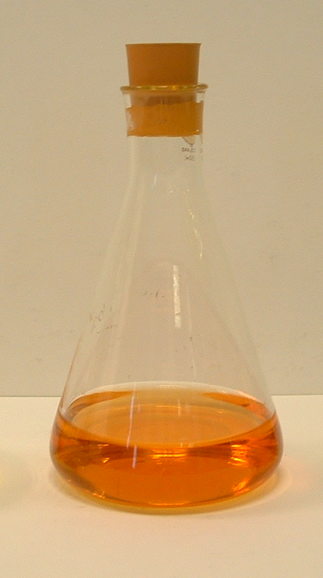
It is the responsibility of teachers doing this demonstration to carry out an appropriate risk assessment.

