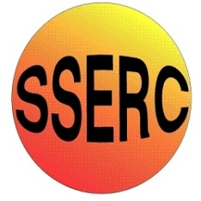

Chemical Demonstrations
Golden Rain
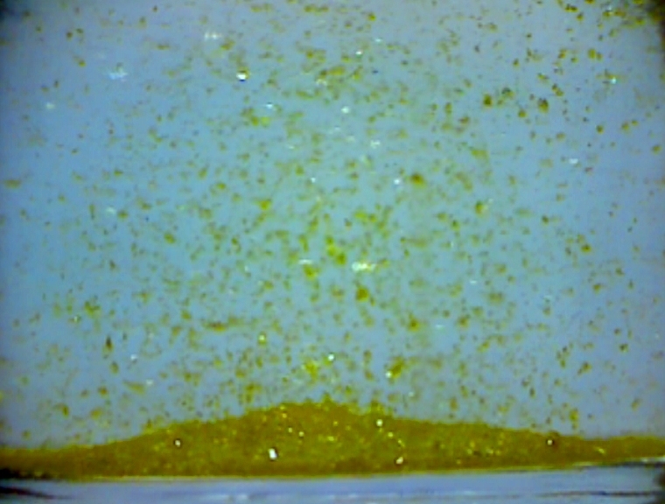
CfE – Level 3
I have taken part in practical investigations into solubility using different solvents and can apply what I have learned to solve everyday practical problems.
SCN-3-16b
National 3 – Chemical change and structure
Chemical structure
CfE Advanced Higher – Researching Chemistry - Recrystallisation

Background
This is a beautiful demonstration that is a lovely introduction to discussions about precipitation and solubility.

You will need
0.3% solution of lead nitrate (0.3 g in 100 cm³ of water) | 0.3% solution of potassium iodide (0.3 g in 100 cm³ of water)
A few drops of 1M hydrochloric acid | 250 cm³ conical flask
Dropping pipette | Kettle and large beaker for a water bath or a hotplate.

Preparation
Make up the solutions by dissolving the solids each in 100 cm³ of distilled water.
If you look at the stoichiometry, you will see that the potassium iodide is in excess: this is to maximise the chances of precipitating lead ions out of solution and reducing the possibility of washing away dissolved lead during disposal.
When you have made the solutions, add a few drops of 1M hydrochloric acid to each: this is to prevent the formation of lead carbonate which can be formed in impure water (including distilled water that has stood long enough for sufficient CO₂ to dissolve in it). Lead carbonate has a very low solubility and the haziness of its precipitate can ruin the effect.
The demonstration
- Pour one of the solutions into the other. You will immediately get a brilliant yellow precipitate of lead iodide
Pb(NO₃)_{2(aq)} + KI_{(aq)} → KNO_{3(aq)} + PbI_{(s)}
The tiny crystals of lead iodide that form swirl around in the flask and the concentration gradients as the liquids mix combine to generate a ‘pearlescent’ effect similar to that you might see in some shampoos or similar liquids.
- Now heat the solution slowly, either in a water bath or on a hotplate until the solid lead iodide has just dissolved
- Leave the solution to cool, somewhere you, and your class can see it. Ideally, shine a bright light on the beaker.

What is happening?
Whilst the lead iodide may be insoluble in water at room temperature, it’s solubility increases slightly with temperature. Put simply, when ionic compounds dissolve in water, they dissociate into their component ions. This dissociation can either give out energy (exothermic) or take in energy from the surroundings (endothermic), depending on the substance. In the case of lead iodide, it dissociates into Pb²⁺ and I– ions. This is endothermic, and so increasing the temperature of the solution will promote the dissociation of lead(II) iodide. Consequently, the solubility of lead iodide rises from 0.0756 grams per 100 cm³ of water, to a still not very impressive 0.19 grams per 100 cm³ of water.
The concentrations of the solutions are such that by the time the mixture reaches 60°C, all the lead iodide will have dissolved and the solution will be colourless again.
As the solution cools, the dropping temperature forces very pure crystals of lead iodide to precipitate back out of solution. These hexagonal crystals are larger than the very fine particles formed initially but they still take some time to meander gently to the bottom of the flask, giving the reaction mixture a shimmering, glittering effect commonly referred to as a ‘golden rain’. The effect can last for up to an hour as the crystals fall out of the solution.

Disposal
The lead iodide crystals can be kept in a closed jar/bottle as a sort of chemical ‘snow globe’.
If it is not to be kept, filter off the lead iodide and store for disposal. The filtrate will still contain some lead. Add sodium carbonate solution to precipitate out lead carbonate. Filter this off and keep for disposal.
The remaining filtrate can be washed to waste with plenty of cold running water.

Safety
It is the responsibility of teachers doing this demonstration to carry out an appropriate risk assessment.

