


Short Chemical Experiments
Azo Dyes
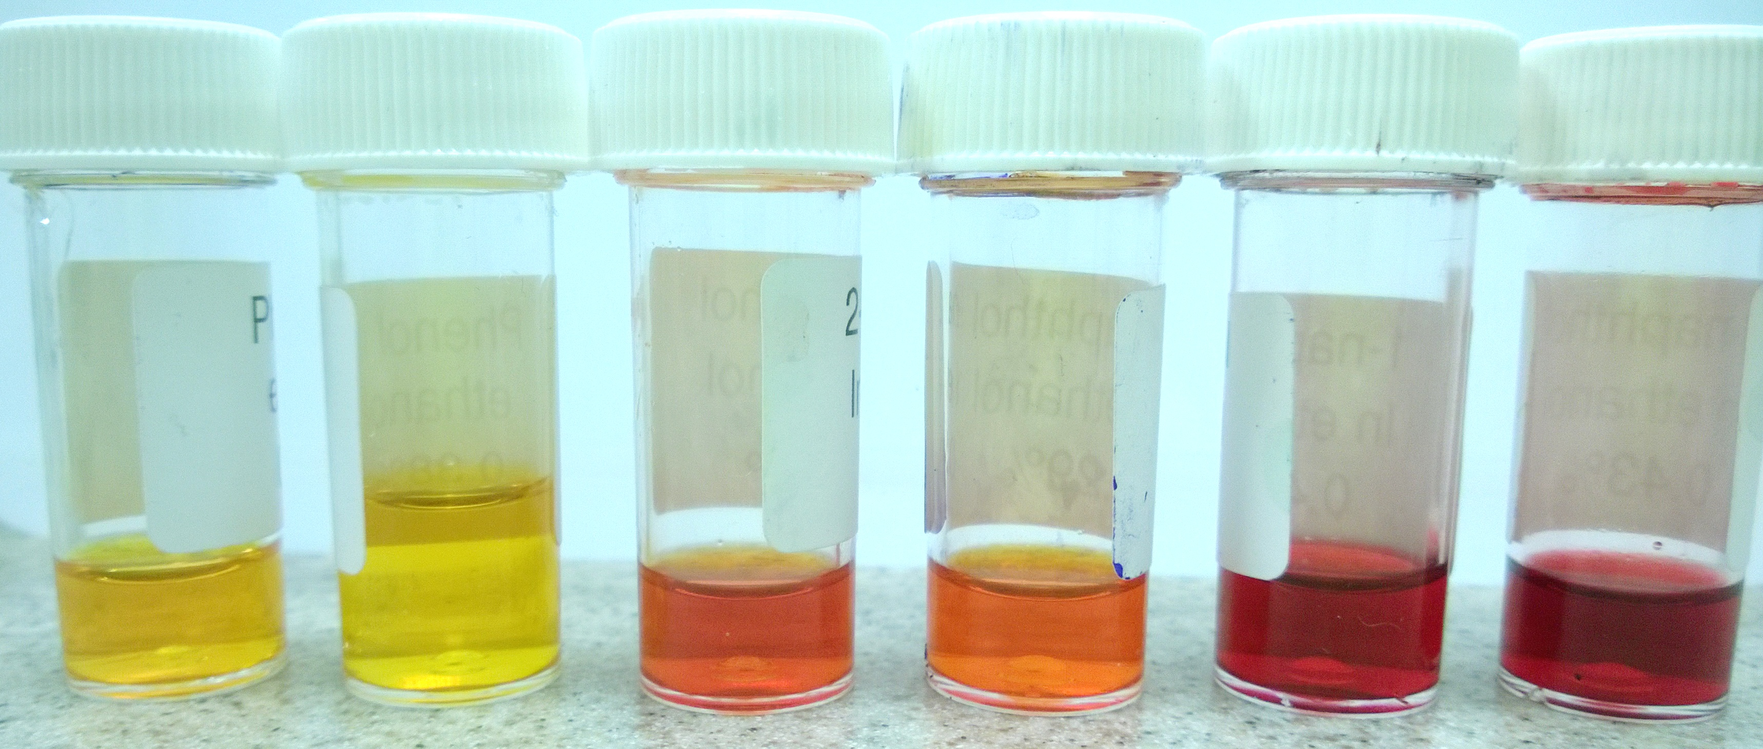
Advanced Higher (revised)

Organic Chemistry and Instrumental Analysis

Absorption of visible light by organic molecules
Azo compounds are ones containing the R-N ≡N-R’ structure.
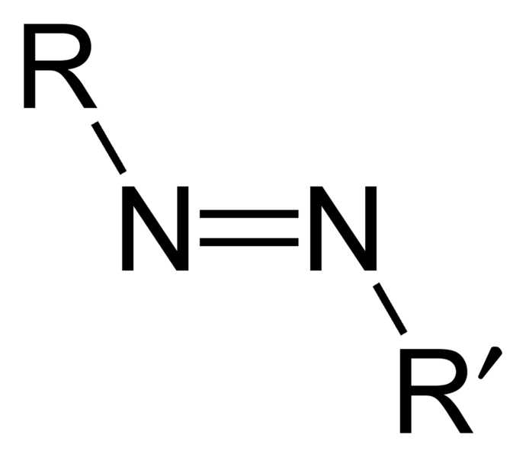
As a consequence of п-delocalization, aryl azo compounds have vivid colours, especially reds, oranges, and yellows. Therefore, they are used as dyes, and are commonly known as azo dyes.
Most azo-dye syntheses require careful cooling of the reaction mixtures but this is a simple demonstration one that can be carried out in a test tube on the bench in minutes.
You will need
sulphanilic acid (0.5% in 2M ethanoic acid)
0.04M (0.37%) phenol in ethanol (IDA) (0.377 g / 100 mL)
0.03M (0.43%) 1-naphthol in ethanol (IDA) (0.433 g / 100 mL)
0.02m (0.289%) 2-naphthol in ethanol (IDA) (0.577 g / 100 mL)
NaNO₂ (0.5% in water)
1 M NaOH

To make the Diazo reagent solution
Mix equal volumes of the 0.5 % aqueous NaNO₂ solution and the 0.5 % solution of sulphanilic acid in 2 M ethanoic acid
Make up solutions separately and then mix.

To Do
- Put 1 cm³ of the phenol/naphthol in a tube
- Add 2 drops of diazo reagent.
- Add 3 drops of 1m NaOH
Results
Coupling of diazotised sulphanilic acid with phenol and the naphthols

 | Color of the solution  (Photo 1) | after addition of NaOH  ( Photo 2)
Test tube 1 | lemon-yellow | gold-yellow
Test tube 2 | orange | orange-red
Test tube 3 | intensively orange | red-violet

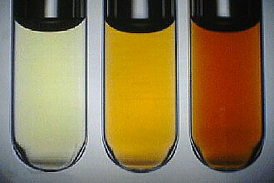  Photo 1 |  | 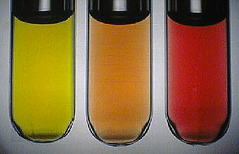  Photo 2

Using naphthalene-2-ol gives you the dye called (commercially) orange II
If N,N-dimethylphenylamine is used in place of phenol/naphthol, methyl orange solution is formed.

Health and safety
See risk assessment
The preparation of the ethanolic solution of phenol should be performed under a laboratory fume hood!
For carrying out the reactions, the scale is very small and the solutions are very dilute so a well ventilated room is sufficient. Despite the dilution, prudence would suggest that goggles and gloves should be worn.

