
Simple Chemical Reactions
Tomato chromatography

CfE Level 3
I can differentiate between pure substances and mixtures in common use and can select appropriate physical methods for separating mixtures into their components
SCN 3-16a
National 4 – Chemistry in Society
Chemical analysis

CfE Higher –
Chemistry in Society
Chemical Analysis Chromatography

Nature’s Chemistry
Fragrances

Background
The red colour of tomatoes is mainly due to the carotenoid, lycopene, which is a tetraterpene, having 8 isoprene units. (Though there is also some β-carotene, another, similar tetraterpene)
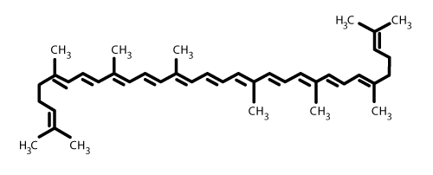

It is possible to extract these two terpenes from tomato puree and separate them using simple paper chromatography.

You will need

Test tube rack | Test tube
hexane | Propanone : PET ether (50:50 mix)
Small bottle (bijou) or another test tube and a bung | Tomato puree
1 x 3 cm³ pasteur pipette | 1 x 1 cm³ pasteur pipette
Filter paper | scissors

What you do
- Place a few g of tomato puree into your bijou (or test tube).
- Add 3 cm³ of the Propanone : PET ether solvent. Replace the lid tightly (or put the bung in the test tube) and shake vigorously.
- Let it settle for a minute or so.
- Take a capillary tube, or a very narrow Pasteur pipette and extract a little of the supernatant.
- Cut a strip of filter paper narrow enough to fit inside your test tube. Make a mark about 1cm from the bottom in pencil.
- Spot this on the line on the strip of filter paper. Dry this and then re apply several times, drying between each one.
- Put about 0.5 cm³ of hexane in the bottom of the test tube and insert the paper.
- Place the tube in a rack and leave it to run for a few minutes.
- You will see that the yellow β-carotene, being less polar, travels faster up the paper. In fact it goes with the solvent front. Behind it, rather more spread out, is the orange-red of the lycopene.


Safety
Carry out in a well-ventilated area
Wear eye protection. Consider wearing gloves

It is the responsibility of teachers doing this demonstration to carry out an appropriate risk assessment.

