
Simple Chemical Reactions
Thin-layer chromatography
of spearmint oil
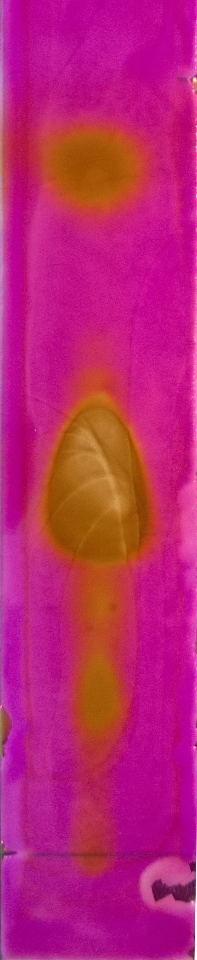
CfE Level 3
I can differentiate between pure substances and mixtures in common use and can select appropriate physical methods for separating mixtures into their components
SCN 3-16a
National 4 – Chemistry in Society
Chemical analysis

CfE Higher –
Chemistry in Society
Chemical Analysis Chromatography

Nature’s Chemistry
Fragrances

Background
Terpenes are widely found in nature. In particular, most of the scent molecules in herbs and spices are terpenes or terpenoids – mainly diterpenes. These terpenes are concentrated in the essential oils that are available in health food shops and from other supliers
This experiment shows the analysis of three terpenes in spearmint oil using thin-layer chromatography.
Spearmint oil contains at least 28 different organic compounds but there are three terpenes that are easily separable: D-limonene, L-carvone and dihydrocarveol.
After separation, the L-carvone can, if desired, be identified as it fluoresces under uv light: the other components can be identified by using a permanganate dip (Using the fact that the terpenes are oxidised by permanganate.

You will need

Test tube rack | Boiling tube & bung
Spearmint oil | Ethyl ethanoate : hexane (10:90 mix)
Capillary tube (for spotting sample) | TLC plate (2cm x 13 cm)
Permanganate developing agent (50 cm³) | forceps
Scissors (if needed to cut plate) | Pencil & ruler

Preparation
- Cut a strip of TLC plate to fit inside the test tube
- Prepare the permanganate dip:
Dissolve 6.67 g of potassium carbonate and 1 g of potassium manganate VII in 100 cm³ of distilled water. Add 1 cm³ of 2M sodium hydroxide

What you do
- Put a pencil line 1cm from the bottom of the TLC strip.
- Using the capillary tube, place a spot of the spearmint oil in the centre of the line (you want the spot to be as small as possible).
- Place a small amount of solvent in the bottom of the test tube (to about ½ cm in depth)
- Place the TLC strip in the tube so the bottom is in the solvent. Replace the bung and place the tube in the test tube rack.
- Once the solvent front has travelled a significant way up the TLC plate, remove it from the test tube and immediately mark the position of the solvent front with a pencil – before the solvent evaporates and you can’t see it.
- Allow the TLC plate to dry.
- If desired, examine the plate under uv light.
- Pour the permanganate developing agent in a shallow container (a large petri dish) and dip the TLC plate in.
- Remove the plate with the forceps, rinse with water. Allow the plate to dry (or use a hair dryer).
- Examine your plate. You will see the terpenes as brown spots (hopefully spots rather than smears) against a purple background. Make any measurements or take photographs of the plate as the colours only last an hour or two.

Safety
Carry out in a well-ventilated area

It is the responsibility of teachers doing this demonstration to carry out an appropriate risk assessment.

Reference:
Isolation of Three Components from Spearmint Oil: An Exercise in Column and Thin-Layer Chromatography
W Don R. Davies* and Todd M. Johnson Department of Chemistry, Weber State University, Ogden, UT 84408
Journal of Chemical Education • Vol. 84 No. 2 February 2007 • p318

