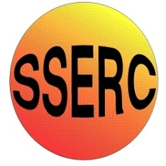
Simple Chemical Reactions
Extracting D-limonene from orange zest
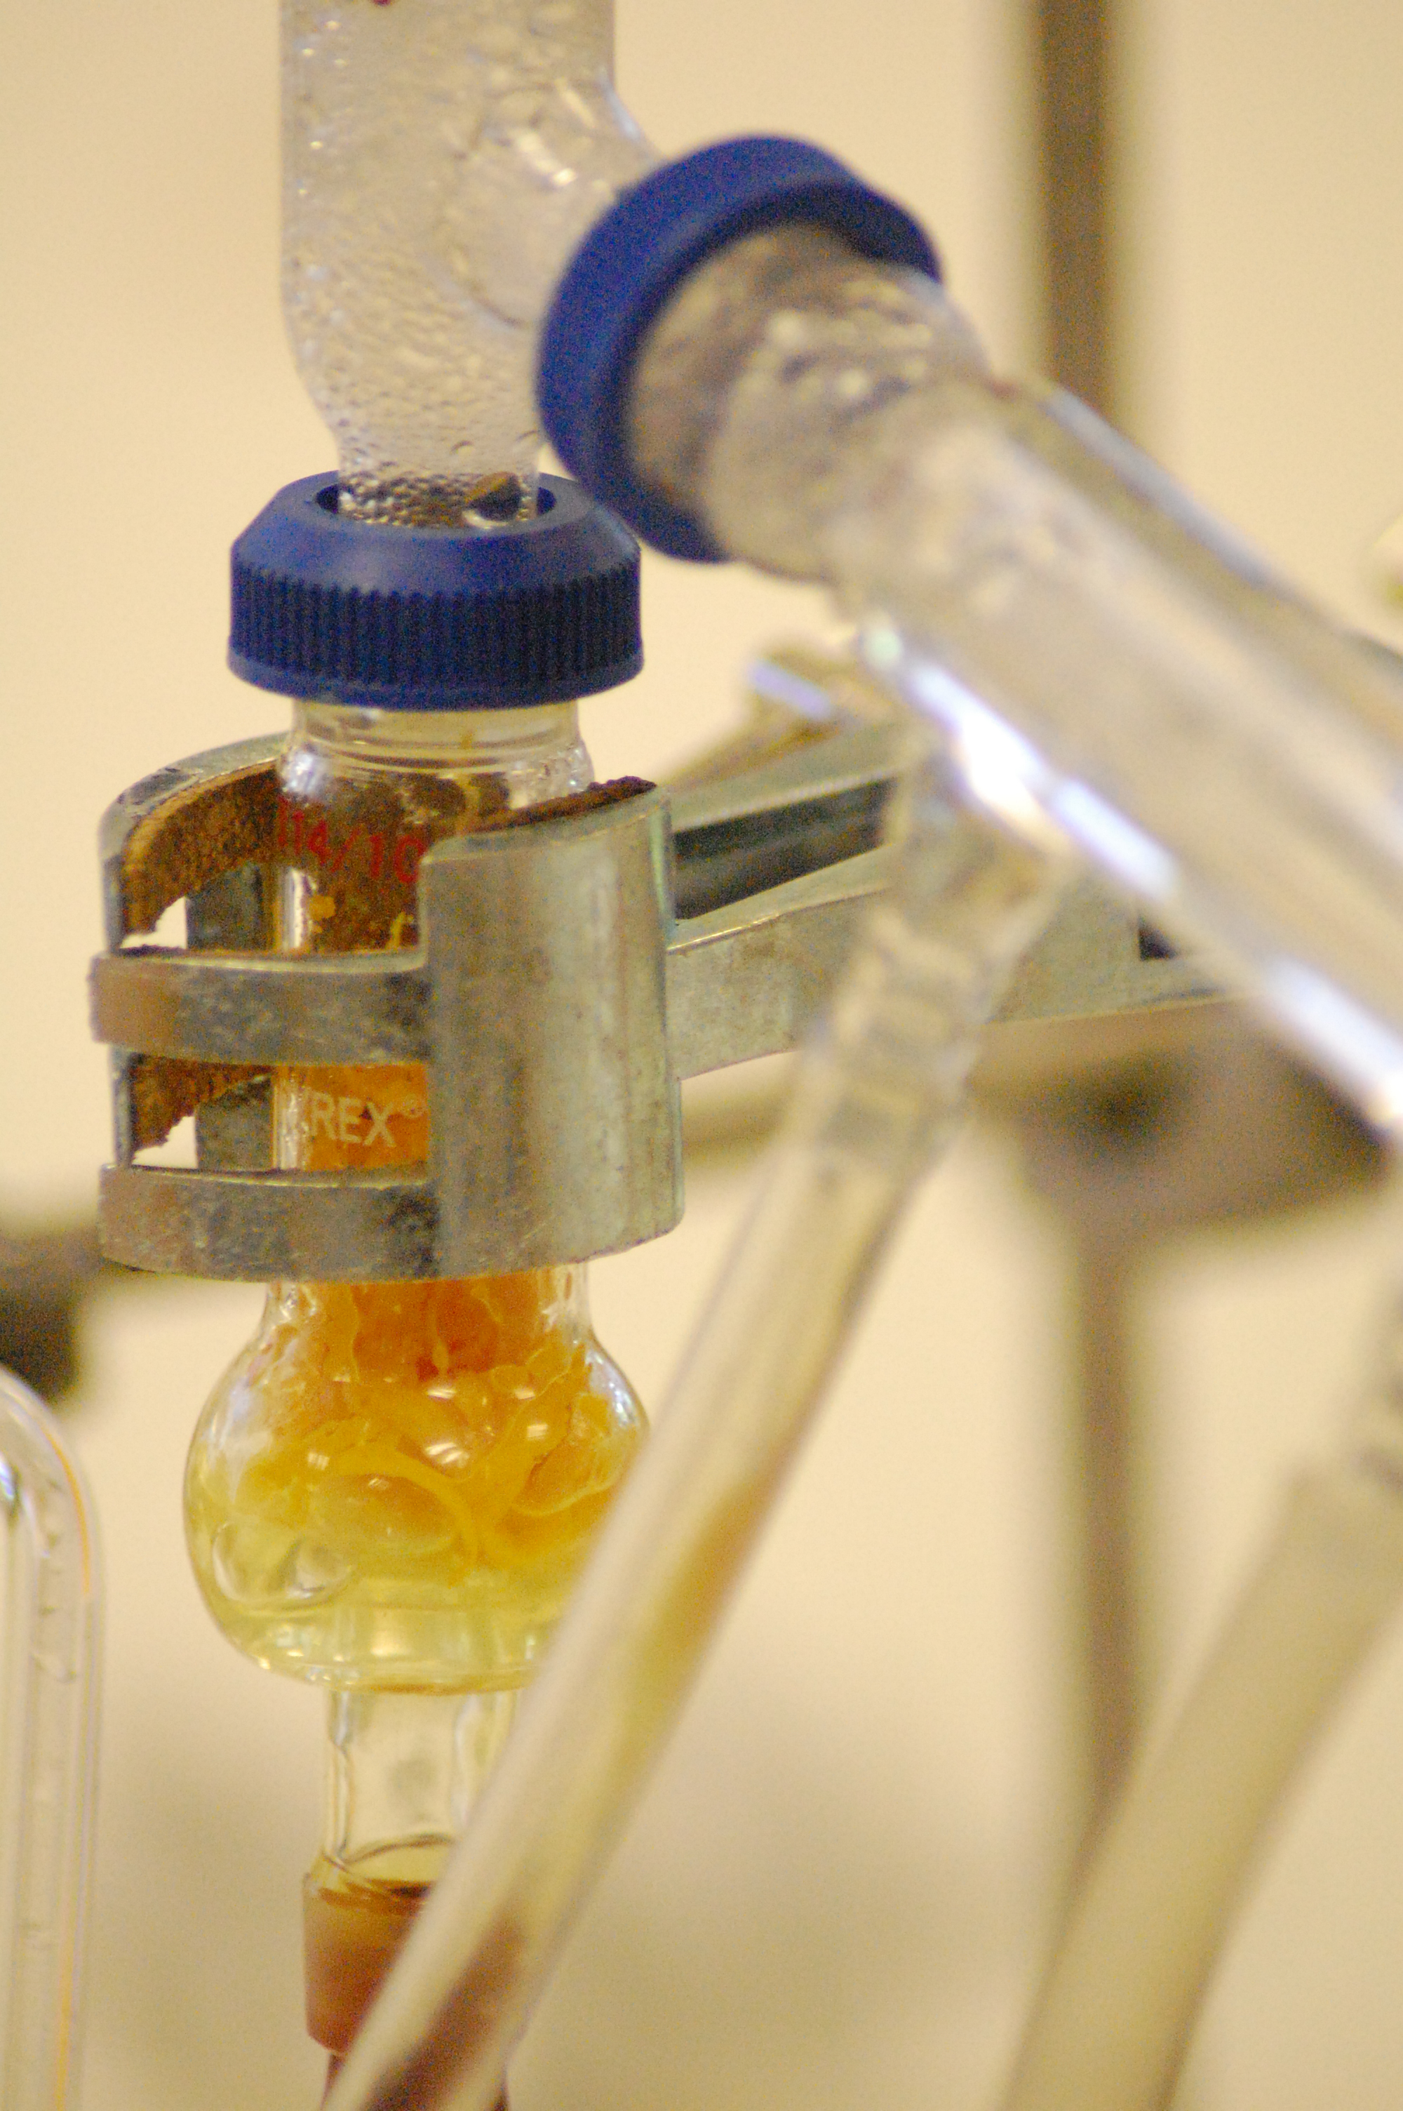
CfE Level 3
I can differentiate between pure substances and mixtures in common use and can select appropriate physical methods for separating mixtures into their components
SCN 3-16a
National 4 – Nature’s Chemistry
Plants to products

CfE Higher –
Nature’s Chemistry
Fragrances

Background
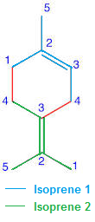
Limonene is a colourless liquid hydrocarbon which occurs as two optical isomers. The more common D-isomer possesses a strong smell of oranges and is the major component (94%) of the essential oil that can be extracted from orange zest. .It is used in chemical synthesis and more commonly as a more environmentally friendly solvent in cleaning products.
Limonene is a terpene, more specifically a cyclic diterpene.
L-limonene smells of pine and is not, contrary to several internet sources, a component of lemon zest.

You will need

2 oranges or 100 cm³ of blended orange zest | 1 zester or knife
Access to a balance | Access to blender (optional0
Tripod | Clamp, boss & stand
250 cm³ round-bottom flask | Leibig condenser
Still head | Thermometer holder
Adaptor (if needed for different sizes of glassware | Clip to secure condenser
Bunsen burner (or heating mantle) | Heatproof mat

- Use the zester or a knife to remove as much of the zest as possible off the peel of two oranges.
- Chop the zest into small pieces using scissors and weigh it. Record how much you have.
- If you have access to a blender, blend the pieces of orange zest with 100cm³ of distilled water.
- Place the blended mixture (or the zest and water) into a 250 cm³ round-bottom flask and add a few anti-bump granules).
(You can increase the yield a little by refluxing first but this (steps 5 – 9) is optional)
- Hold the flask firmly with a clamp.
- Attach a condenser vertically to the flask and turn on the water.
- Turn on the Bunsen burner and bring the mixture to the boil. (Take care it does not boil over)
- Boil the mixture gently under reflux for 15 minutes.
- Move the Bunsen burner from under the reflux apparatus, leave for a minute or so and then remove the condenser. You do not need to switch the water off but be careful not to drag the outflow pipe out of the sink.
- Assemble the apparatus for distillation
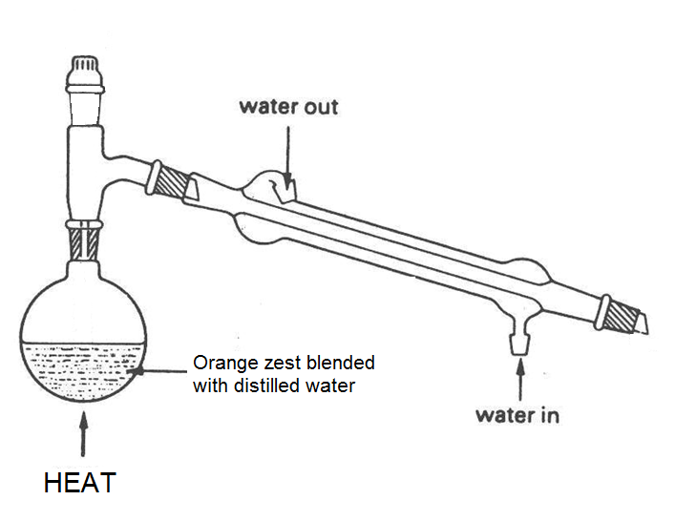
- Gently bring the mixture to the boil. If using a Bunsen burner, you will need to watch it carefully.
- Continue boiling until you have collected 5 – 10 cm³ of the distillate in a test tube. You should clearly see an oily layer on top of the water.
- Switch off the Bunsen burner to stop the distillation.

Safety
Wear eye protection.
It is the responsibility of teachers doing this demonstration to carry out an appropriate risk assessment.

