
Simple Chemical Reactions
Orange oxidation
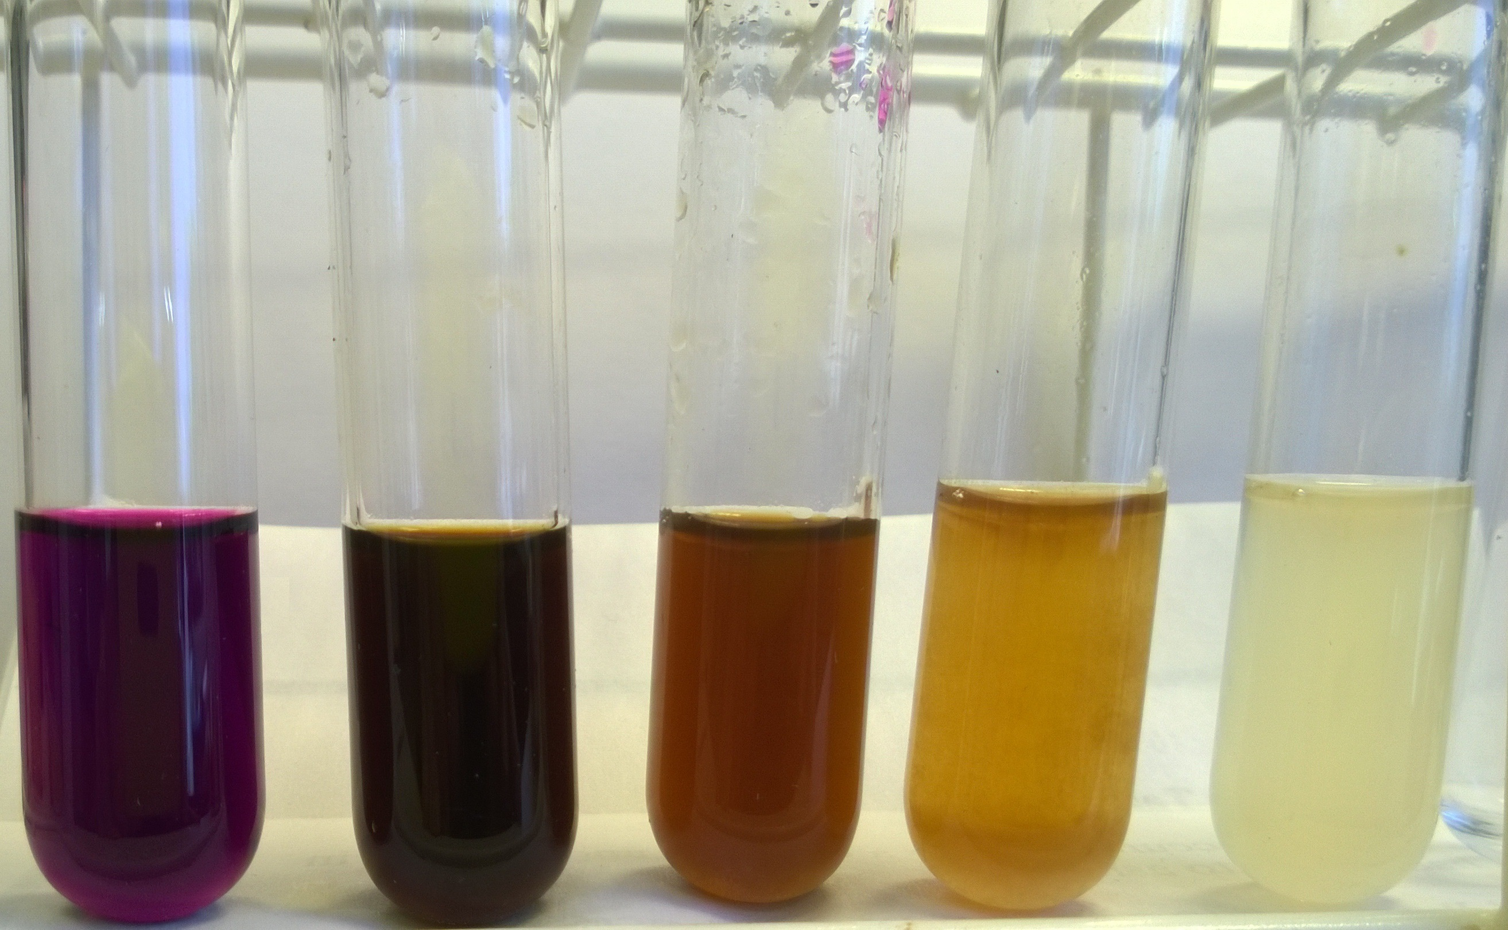
CfE Level 3
Through experimentation, I can identify indicators of chemical reactions having occurred. ...
SCN 3-19
CfE Advanced Higher –
Organic chemistry and Instrumental analysis
Spectroscopy
Absorption of visible light by organic molecules

Background
The colour of oranges is mainly due to the carotenoid, β-carotene, which is a tetraterpene, having 8 isoprene units.
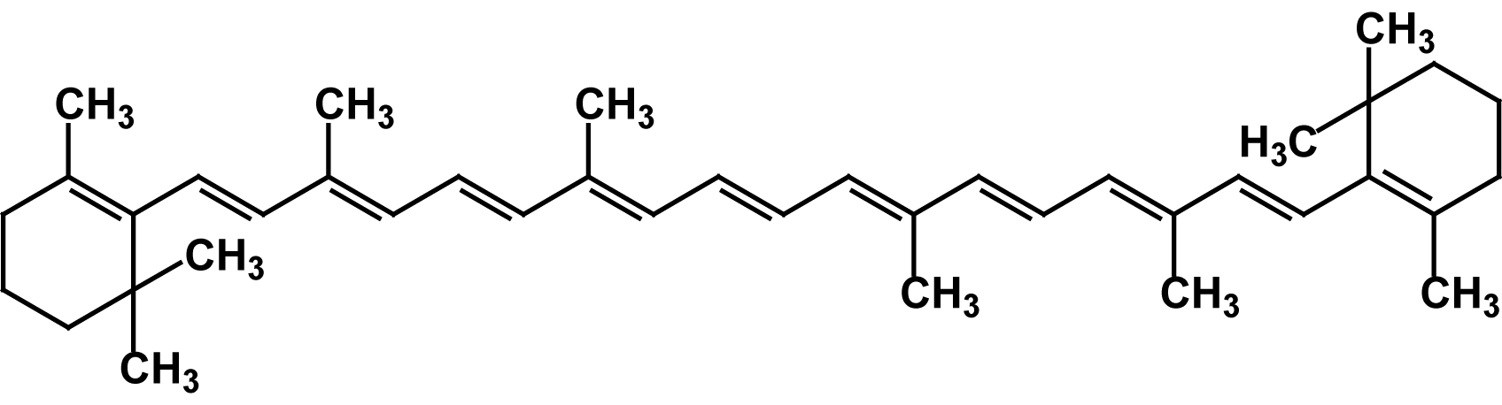
It is the length of the conjugated system in β-carotene that causes absorption in the blue region of the visible spectrum and gives them the characteristic yellow colour. If a double bond is attacked and removed by an agent like bromine, the length of conjugation shortens, the wavelength becomes smaller, and the absorption shifts to the ultraviolet region of the spectrum causing the compound to become colourless.
Potassium manganate VII is a powerful oxidising agent and breaks down the β-carotene into a range of compounds, mainly aldehydes and dialdehydes. In the process, it is reduces to manganese IV (usually manganese IV oxide, which is insoluble. The small particles remain in suspension for a while, giving a brown colour but will eventually settle to the bottom.

You will need

Test tube rack | Test tubes (5 or so)
0.01M potassium manganate VII | Orange juice
1 x 3 cm³ pasteur pipette | 1 x 1 cm³ pasteur pipette

What you do
- Place 3 cm³ of 0.01M potassium manganate VII into each test tube
- Leave the tube on the left as a control. Add orange juice water to the other tubes as follows:
5 drops to the first, 10 to the second, 15 to the third and 20 to the fourth.
- Swirl the tubes to mix thoroughly and let stand for a minute or so.

- The result will be a range of colours.
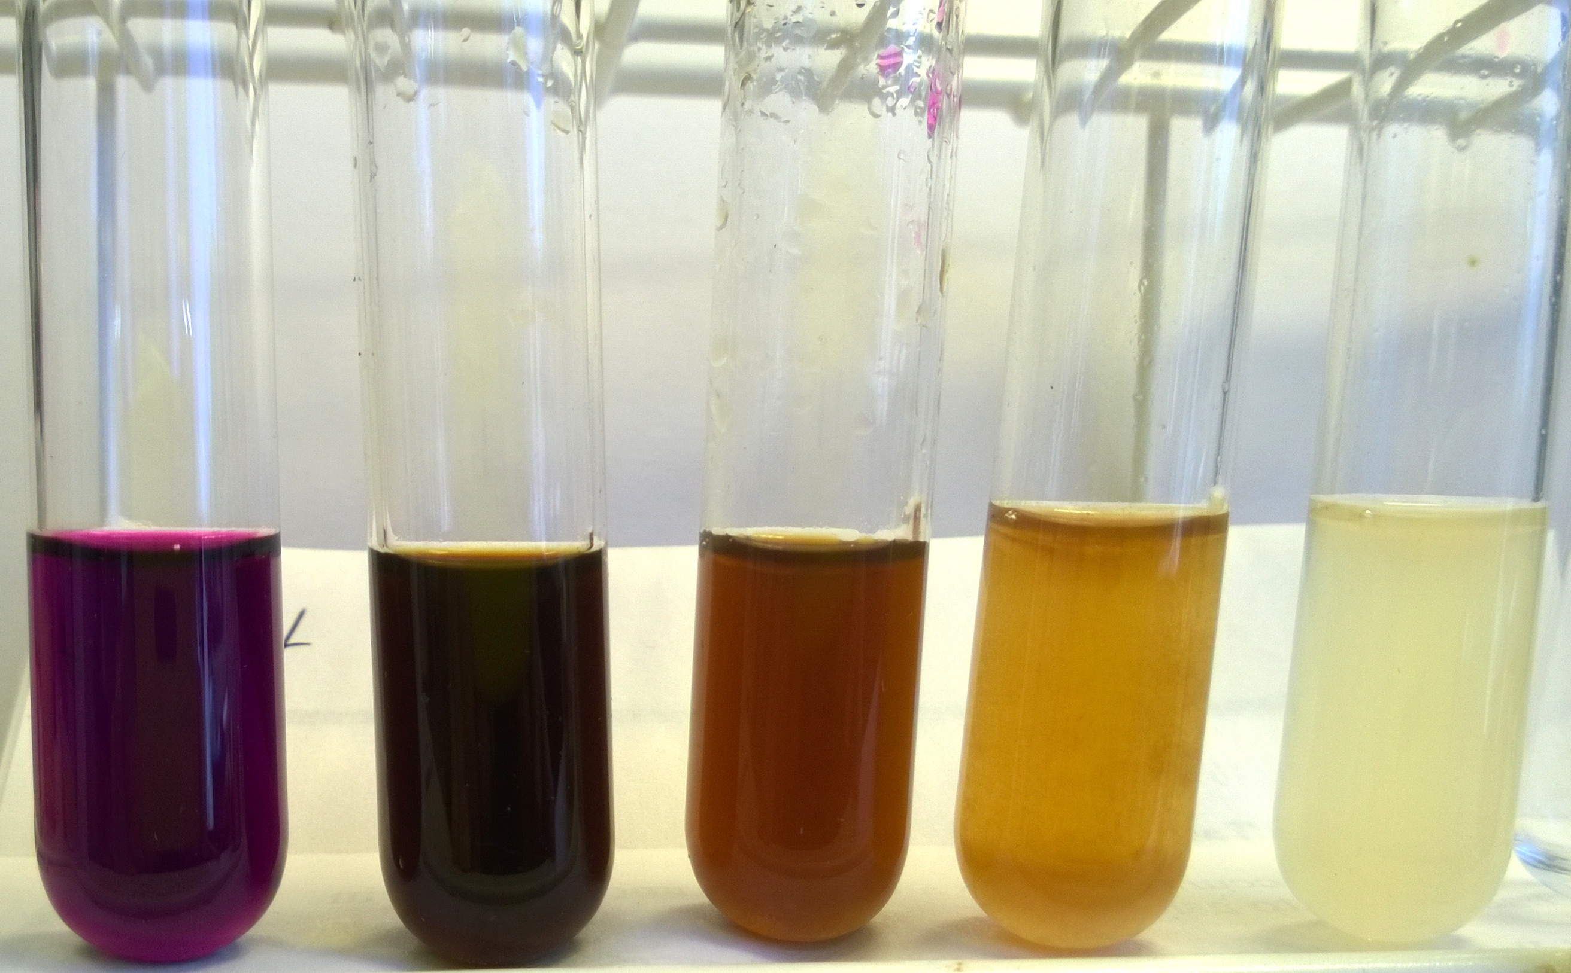
Amount of orange juice (drops)
0 | 5 | 10 | 15 | 20

Safety
Carry out in a well-ventilated area
Wear eye protection. Consider wearing gloves

It is the responsibility of teachers doing this demonstration to carry out an appropriate risk assessment.

