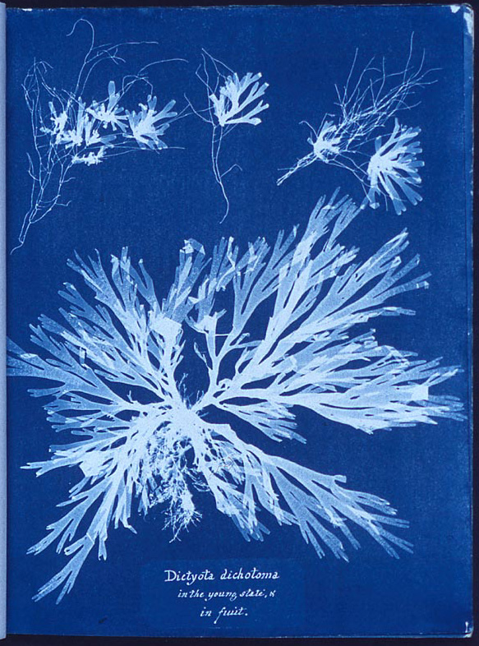
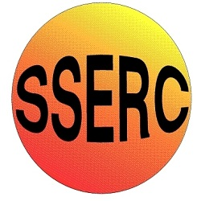

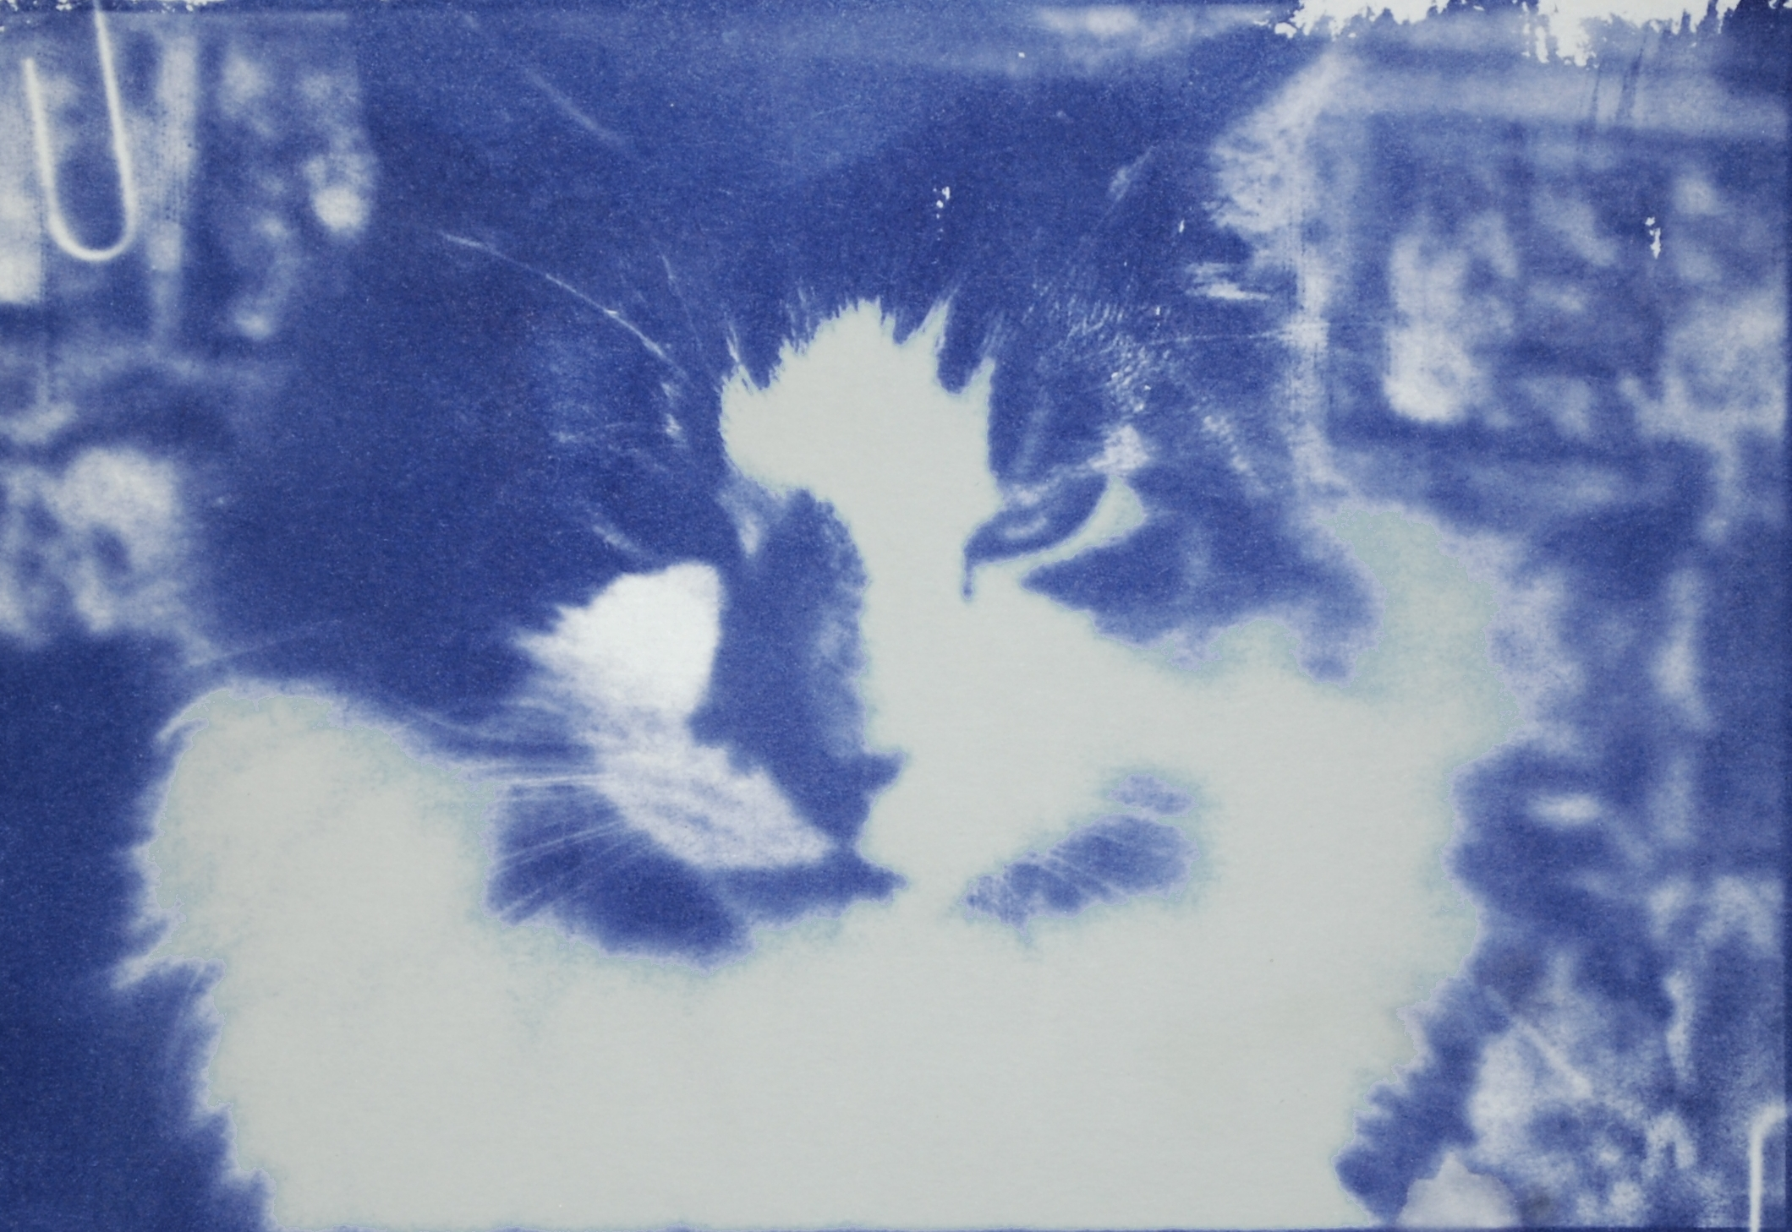
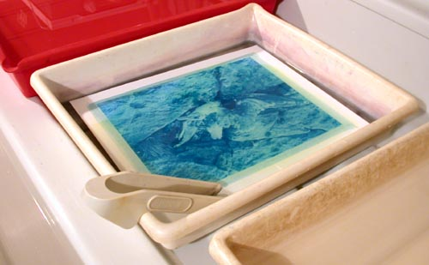

Background
This was one of the earliest photographic processes. Invented by William Herschel in 1842.
It uses iron compounds rather than silver, making it much cheaper, and the paper is not very sensitive to light which means it can be handled in a normal classroom, as long as the light is not too bright.

Curriculum links

This reaction can be applied to curriculum for excellence.
SCN 3-19a
Through experimentation, I can identify indicators of chemical reactions having occurred ...
CfE Higher – Nature’s Chemistry
Skin care (can be used in place of uv beads to assess sunscreens

The chemistry
Prussian Blue is essentially Iron(III) Hexacyanoferrate(II) but there is a whole range of similar iron blues, with compositions depending on their precise method of preparation. At the molecular level, they all have in common a characteristic cubic structure, but this lattice can accommodate variable amounts of water and metal ions within it, so formulae range from KFe[Fe(CN)₆].5H₂O (the so-called "soluble" Prussian Blue) to Fe₄[Fe(CN)₆]₃ .15H₂O ("insoluble" Prussian Blue).
In fact, all forms of Prussian Blue are highly insoluble in water; the "solubility" in the former case is an illusion caused by its easy dispersion as tiny (colloidal) particles which form a blue suspension in water, which looks like a true solution. Chemists call this process peptization, and it is responsible for some of the problems that beset the cyanotype process.
Exposure to UV light reduces a portion of the Fe³⁺ salt to the Fe²⁺ state, and a portion of the hexacyanoferrate III (Fe³⁺ in Fe(CN)₆³⁻ ) to hexacyanoferrate II (Fe²⁺ in Fe(CN)₆⁴⁻ ), resulting in the formation of a pale yellow-blue image consisting of iron II hexacyanoferrate II. Washing removes the soluble, unreduced (unexposed) salts, leaving behind a deep blue and white image. The image intensifies upon drying as Iron II hexacyanoferrate II is slowly oxidized to a deep blue colour that results from Iron III hexacyanoferrate II.
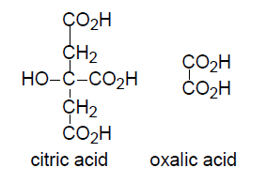
The two photoactive iron compounds most commonly used for photography are Iron III ammonium citrate, Fe(III)NH₄(C₆H₆O7²⁻)₂, and Iron III ammonium oxalate, Fe(III)(NH₄(C₂O₄²⁻)₂.
Citrate and oxalate are the anions generated by loss of two acidic protons from citric and oxalic acids, respectively.

Interaction of light with these anions leads to their oxidation and releases carbon dioxide and an electron which then reduces Fe(III) to Fe(II). Although the recipes here use Iron III ammonium citrate, the redox chemistry is more readily apparent in the reaction of oxalate rather than citrate
2 Fe ³⁺ + C₂O₄ ²⁻ + hν → 2 Fe ²⁺ + 2 CO₂

The Fe(II) formed in combines with CN⁻ present in the solution to form the complex[Fe(CN)₆]⁴⁻
Fe ²⁺ + 6CN⁻ → [Fe(CN)₆]⁴⁻
This, in turn, gives the insoluble blue Prussian blue, Fe(III)₄[Fe(CN)₆]₃, that sticks to the fibres of the cloth or paper on which the reagents had been coated
[Fe(CN)₆]⁴⁻ + 4 Fe ³⁺ → Fe(III)₄[Fe(CN)₆]₃

The blue colour results from interaction between the iron in two different oxidation states.
The intense blue colour of Prussian blue is associated with the energy of the transfer of electrons from Fe II to Fe III. Many such mixed-valence compounds absorb certain wavelengths of visible light resulting from intervalence charge transfer. In this case, orange-red light around 680 nanometers in wavelength is absorbed, and the transmitted light appears blue as a result.
In chemistry, intervalence charge transfer, often abbreviated IVCT or even IT, is an electron transfer (thermal or photoinduced) between two metal sites differing only in oxidation state. Quite often such electron transfer reverses the oxidation states of the sites. The term is frequently extended to the case of metal-to-metal charge transfer between non-equivalent metal centres.
Typically, such a process produces a characteristic absorption in the electromagnetic spectrum of the compound involved. The phenomenon is most often observed in mixed-valence bi- and polymetallic coordination complexes.

The reagents

Recipe 1
- Dissolve 5g of potassium hexacyanoferrate III in 50 cm³ of water.
- Dissolve 9g of ammonium iron III citrate in 50 cm³ of water.
- Mix the two solutions together
- Put the sensitiser in a dark bottle and keep out of the light until used. It will keep for a week or two (possibly longer)

Recipe 2
This is a variant called Fisch’s ferro-prussiate. It is a little more fiddly to prepare but has the advantage of using chemicals that are likely to be found in the chemistry lab already.
- Dissolve 145.5 g of iron(II) chloride in 100 cm³ of water. (This is close to being a saturated solution so will take some dissolving)
- Weigh 25 g of 2,3-dihydroxybutanedioic acid (tartaric acid) and dissolve in 100 cm³ of water
- Mix solutions 1 and 2.
- Add up to 47 cm³ ammonia (0.880), stirring constantly, until neutral – Health & Safety data from Hazardous Chemicals [2]
- Label this Solution A.
- Weigh 20 g of potassium hexacyanoferrate(III)-3-water (ferricyanide) and dissolve in 72 cm³ of water.
- Label this Solution B.
- Add all of solution B to solution A with constant stirring.
- When it is cool, pour into a dark bottle and store in the dark until use.
- This should give about 275 cm³ – enough for around 50 A4 sized sheets – depending on paper. If kept in the dark, the combined solution will keep for a few weeks.

Recipe 3
This is apparently the recipe that gives the best quality prints, according to AlternativePhotography.com. Probably not worthwhile unless you are looking for high quality prints; working with the art department on some IDL projects for instance.
- Measure 20 cm³ of distilled water into a 100 cm³ glass beaker, heat it to about 70°C, and completely dissolve 10 g of potassium hexacyanoferrate III in it, with stirring; keep the solution hot.
- Measure 30 cm³ of distilled water into a second beaker, heat to about 50 °C, and dissolve in it 30 g of ammonium iron(III) oxalate.
- Now add the hot potassium hexacyanoferrate III solution to the ammonium iron(III) oxalate solution, stir well, and set the mixture aside in a dark place to cool and crystallise, until it just reaches room temperature - about 20 °C (for this quantity of solution, the cooling will take an hour or two).
- Separate the liquid from the green crystals by decanting and filtration (Whatman grade 1 filter paper is adequate). The green crystals (potassium iron(III) oxalate) should be disposed of safely because they are poisonous. The volume of filtrate extracted should be ca. 55-60 cm³.
- Make up the filtered solution with distilled water to a final volume of 100 cm³. Mix well.
- Store the sensitizer solution in a well-stoppered, clearly labelled brown bottle. Kept in the dark, at room temperature, its shelf life should be at least six months.
This sensitizer solution is poisonous (much more so than traditional cyanotype) and it will obviously stain skin, wood, clothes, textiles, household pets and any other absorbent surfaces.
If your chemicals are of high purity, the sensitizer solution you obtain will be yellowish-green. But if there are significant amounts of iron(II) impurities in your chemicals, it may be coloured blue due to a trace of Prussian blue formed in suspension. A strongly blue-coloured sensitizer can stain the high values of your prints, so, before use, allow such a solution to stand in the dark for a day or two, after which time the Prussian blue should have flocculated and settled out as a dark blue precipitate, leaving a clear green solution above it. Now re-filter the sensitizer before use. Alternatively, you can make use of dichromate to prevent formation of the blue colour, as follows.
If the impurities in your chemicals are sufficient to cause a strong blue coloration in the mixed sensitizer, then this can be avoided by the addition of ammonium (or potassium) dichromate. However, the presence of this reagent will tend to increase the contrast of the sensitizer significantly. To the solution at stage 2 above, add 0.1 g of solid ammonium dichromate, and dissolve it. You should recognise that this does introduce a very toxic substance, albeit in very small amount. The addition of dichromate extends the shelf-life of the sensitizer almost indefinitely.

The paper

It is possible to produce cyanotype prints on almost any type of paper but if you are intending to make prints for artistic reasons as opposed to merely scientific ones, a better quality paper will help

Filter paper – can give reasonable images but absorbs a lot of sensitiser so they may be too dark.

A4 copier paper – again, images can be quite good but the paper is a bit flimsy and is easy to tear in the washing stage.

A4 copier card – decent images and is stronger than the plain copier paper.

Watercolour paper – this will give the best quality image but is quite expensive.

Coating the paper
If you are looking for a good, artistic print, it is best to apply two coats of emulsion.
You can get quite an attractive appearance if you can still see the brush strokes but this may not be to everyone’s taste. If you want to avoid this, make a spreader from some bent glass tubing and use that to spread the sensitiser over the paper.
A few drops of a surfactant such as Tween 20 can help with an even coating
The light source
The easiest light source is the sun. It does not always shine in Scotland, as you may have noticed, but even daylight on a cloudy day has quite a bit of uv in it.

It is possible to expose the paper indoors through a window but be aware that glass cuts down the amount of uv radiation quite a lot and this will slow the process. On a cloudy day, through glass, it can be quite slow.

It is possible to make a uv light box to expose the papers without too much trouble.

Creating a negative

If you want to produce silhouettes then it is easy to produce a simple shape.

If you want to print a photograph, thing are a little more difficult.

You will need access to a photo editing program. If you have photoshop or something similar in your school then that is fine. If not, two free programs that will do the job perfectly well are paint.net and gimp. Of these, gimp is a more powerful tool but paint.net is easier to use. Once you have loaded up your phot you will need to
- Convert it to black and white (if it is a colour photo)
- Invert the colours. i.e. convert it to a negative.
Then print it onto a transparency sheet. If you can’t print it directly, print onto paper and then photocopy onto the transparency sheet.
For use in a classroom, the negatives can be re-used many times so you could make a set and then keep them for the future.
Exposing the cyanotype
The exposure time will depend on the light source. Daylight is rather variable so it can be difficult to work out in advance how long it will take.
If you are using a uv light box, a bit of experimentation should give you a pretty good idea of the exposure time.
The uncovered regions of the sensitized paper first darken to blue, but then reverse back to a pale blue-grey. The image shadows should be distinctly reversed, giving it a solarized look, and the high values should be green (the effect of colour-mixing the Prussian blue image with the residual yellow sensitizer). UV

Possible uses
As well as being usable as a good example of a photochemical reaction, it is possible to use this as a means of looking at sunscreens, due to the fact that the cyanotype is exposed by uv light.
For this, instead of a negative that is a picture, use a sheet of acetate and coat some areas with sunscreen – you could have a series of lines of different dilutions for instance.
When exposed, you should see that the areas covered by sunscreen remain pale whereas the uncovered ones are dark.
Some practice will be needed to get the exposures right.

Instructions

What you will need
- Cyanotype sensitiser *
- Paper**
- Access to daylight (ideally sunshine) or a uv source
- Something to create an outline with.
- Access to a sink (or a large bowl of cold water)
- Hairdryer (optional)

* You can place solid objects on top of the paper or cut out a stencil from paper.
Alternatively, you can take a photo and use an image processing program to invert it to make a negative (having converted it to black and white first) and then print this onto an acetate sheet.

What you do
- Use a brush to coat the paper with the sensitiser solution.

- Leave it to dry. You can use a hairdryer to speed up the process.

- Take your negative or template and place it on top of the cyanotype paper. Place in the sun – or in bright daylight
The negative needs to be in close contact with the paper or the image will be fuzzy. A clip frame is ideal but if one is not available, paper clips should hold it firmly enough.

- Leave the paper for a few minutes. You will see it going dark blue black.
Exposure time will vary depending on the light intensity. In bright sunlight, 2 or 3 minutes should be enough. In duller conditions it could be 15 minutes or more.

- Once you can see little or no sign of the original greenish of the sensitiser, take your paper and wash it in plenty of cold water. This will wash away any of the unexposed yellow emulsion that was not exposed to light and leave you a picture that is monochrome in shades of dark blue.

What is happening?
The two iron salts do not react with each other in the dark, but when they are exposed to ultraviolet light the iron(III) ammonium citrate becomes an iron(II) salt. The iron(II) ion reacts with the potassium ferricyanide to form an insoluble blue compound, blue iron(III) ferrocyanide, also known as Prussian blue.

Safety
Potassium hexacyanoferrate(III) is a skin, eye irritant and respiratory irritant
Ammonium iron(III) citrate – is a skin and eye irritant
Wear eye protection and possibly gloves when making up the solutions

The solutions themselves are of low hazard.

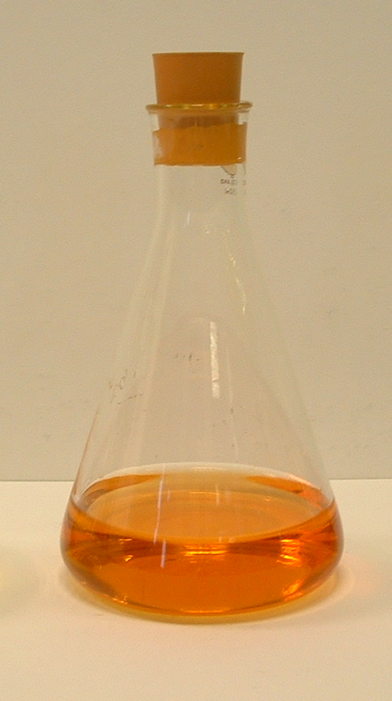
It is the responsibility of teachers doing this demonstration to carry out an appropriate risk assessment.
Technician’s Guide
Each group will need
50 cm³ Cyanotype sensitiser (or pre-sensitised paper) or the chemicals to make up the sensitiser, depending on how the activity is being carried out and with what age group.
Alternatively, pupils may only need access to a beaker of sensitiser placed centrally for them to use.
Use of 1 Paintbrush for coating the paper
1 sheet of paper (each or per group)
Access to daylight (ideally sunshine) or a uv source
Something to create an outline with. (either objects such as leaves or fridge letters or card to cut out a template)
Access to a sink (or a large bowl of cold water)
Access to Hairdryer (optional)

The quantities are a little vague as a lot depends on precisely how the teacher would like to carry out the activity.

