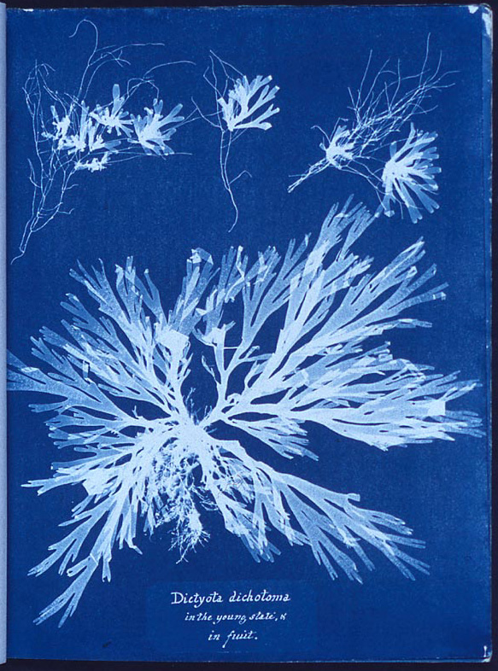
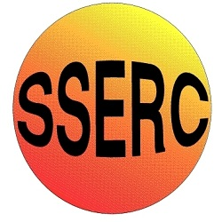

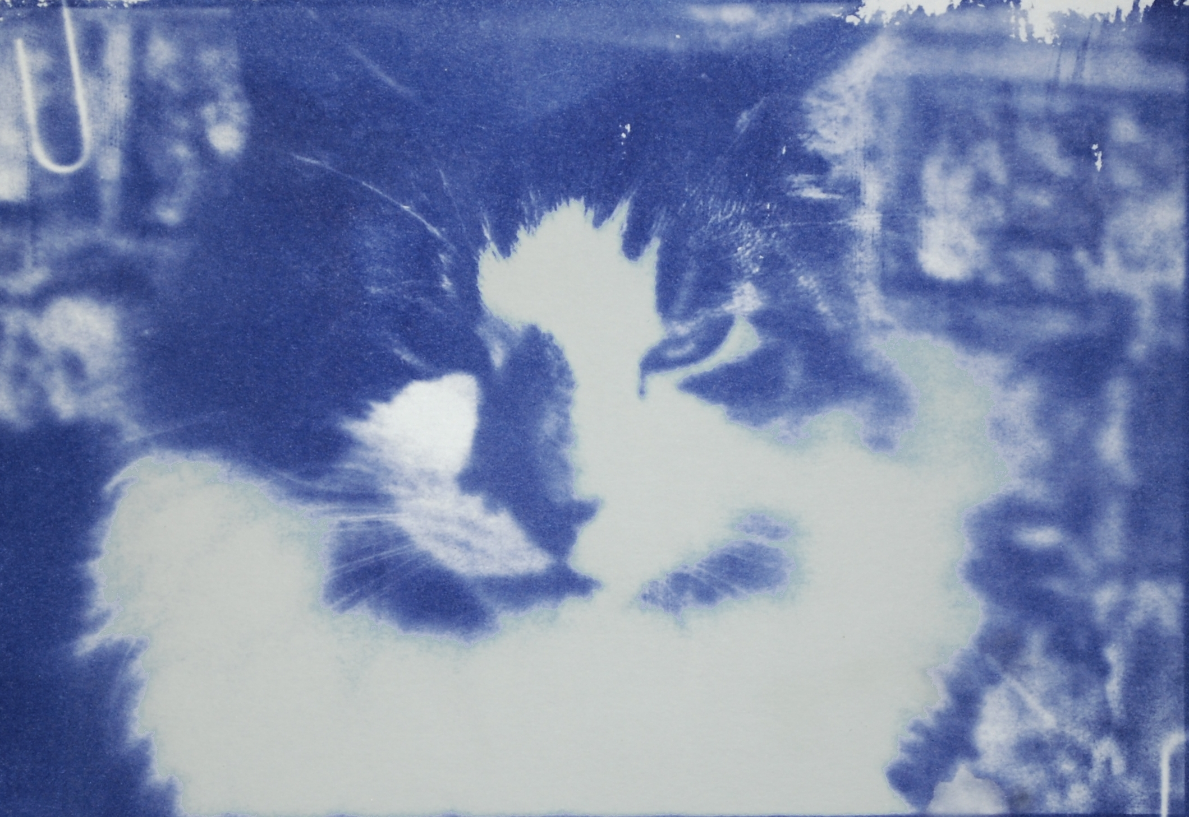
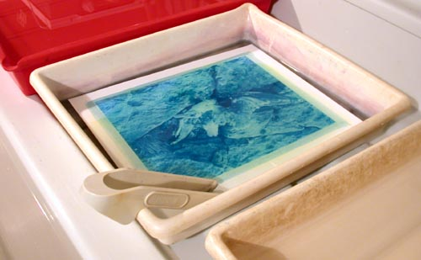

Background
This was one of the earliest photographic processes. Invented by William Herschel in 1842.
It uses iron compounds rather than silver, making it much cheaper, and the paper is not very sensitive to light which means it can be handled in a normal classroom, as long as the light is not too bright.

What you will need
- Cyanotype sensitiser *
- Paper**
- Access to daylight (ideally sunshine) or a uv source
- Something to create an outline with.*
- Access to a sink (or a large bowl of cold water)
- Hairdryer (optional)

* You can place solid objects on top of the paper or cut out a stencil from paper.
Alternatively, you can take a photo and use an image processing program to invert it to make a negative (having converted it to black and white first) and then print this onto an acetate sheet.

What you do
- Use a brush to coat the paper with the sensitiser solution.

- Leave it to dry. You can use a hairdryer to speed up the process.

- Take your negative or template and place it on top of the cyanotype paper. Place in the sun – or in bright daylight
The negative needs to be in close contact with the paper or the image will be fuzzy. A clip frame is ideal but if one is not available, paper clips should hold it firmly enough.

- Leave the paper for a few minutes. You will see it going dark blue black.
Exposure time will vary depending on the light intensity. In bright sunlight, 2 or 3 minutes should be enough. In duller conditions it could be 15 minutes or more.

- Once you can see little or no sign of the original greenish of the sensitiser, take your paper and wash it in plenty of cold water. This will wash away any of the unexposed yellow emulsion that was not exposed to light and leave you a picture that is monochrome in shades of dark blue.

What is happening?
The two iron salts do not react with each other in the dark, but when they are exposed to ultraviolet light the iron(III) ammonium citrate becomes an iron(II) salt. The iron(II) ion reacts with the potassium ferricyanide to form an insoluble blue compound, blue iron(III) ferrocyanide, also known as Prussian blue.

Safety
Potassium hexacyanoferrate(III) is a skin, eye irritant and respiratory irritant
Ammonium iron(III) citrate – is a skin and eye irritant
Wear eye protection and possibly gloves when making up the solutions

The solutions themselves are of low hazard.

