
Chemical Demonstrations
Cyanotypes
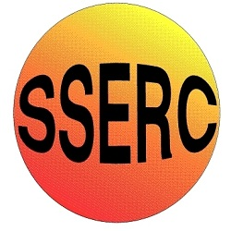
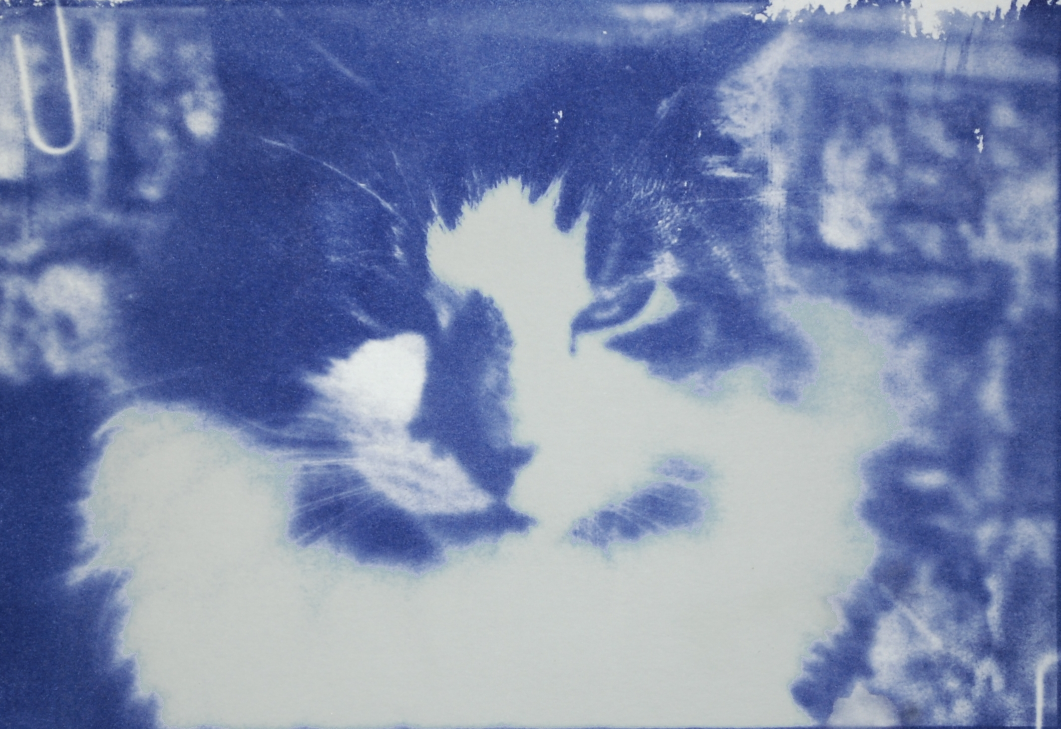
This reaction can be applied to curriculum for excellence.
SCN 3-19a
Through experimentation, I can identify indicators of chemical reactions having occurred ...
CfE Higher – Nature’s Chemistry
Skin care (can be used in place of uv beads to assess sunscreens

Background
This was one of the earliest photographic processes. Invented by William Herschel in 1842.
It uses iron compounds rather than silver, making it much cheaper, and the paper is not very sensitive to light which means it can be handled in a normal classroom, as long as the light is not too bright.

What you will need
- Cyanotype sensitiser *
- Paper**
- Access to daylight (ideally sunshine) or a uv source
- Something to create an outline with. 
- Access to a sink (or a large bowl of cold water)
- Hairdryer (optional)

* Dissolve 5g of potassium hexacyanoferrate III in 50 cm³ of water.
Dissolve 9g of ammonium iron III citrate in 50 cm³ of water.
Mix the two solutions together
Put the sensitiser in a dark bottle and keep out of the light until used. It will keep for a week or two (possibly longer)
** photocopier card is probably the best compromise. If the paper is too absorbent (like filter paper) the pattern will be rather fuzzy. Ordinary A4 paper will work but is a bit flimsy when washed.
The best option, if you are trying to produce a good picture is watercolour paper which you may be able to get from the art department.
 You can place solid objects on top of the paper or cut out a stencil from paper.
Alternatively, you can take a photo and use an image processing program to invert it to make a negative (having converted it to black and white first) and then print this onto an acetate sheet.

What you do
- Use a brush to coat the paper with the sensitiser

- Leave it to dry. You can use a hairdryer to speed up the process.

- Take your negative or template and place it on top of the cyanotype paper. Place in the sun – or in bright daylight

- Leave the paper for a few minutes. You will see it going dark blue black.

- Once you can see little or no sign of the original greenish of the sensitiser, take your paper and wash it in plenty of cold water. This will wash away any of the unexposed yellow emulsion that was not exposed to light and leave you a picture that is monochrome in shades of dark blue.

What is happening?
The two iron salts do not react with each other in the dark, but when they are exposed to ultraviolet light the iron(III) ammonium citrate becomes an iron(II) salt. The iron(II) ion reacts with the potassium ferricyanide to form an insoluble blue compound, blue iron(III) ferrocyanide, also known as Prussian blue.

Safety
Potassium hexacyanoferrate(III) is a skin, eye irritant and respiratory irritant. And should NOT be mixed with a strong mineral acid.
Ammonium iron(III) citrate – is a skin and eye irritant
Wear eye protection and possibly gloves when making up the solutions

The solutions themselves are of low hazard.

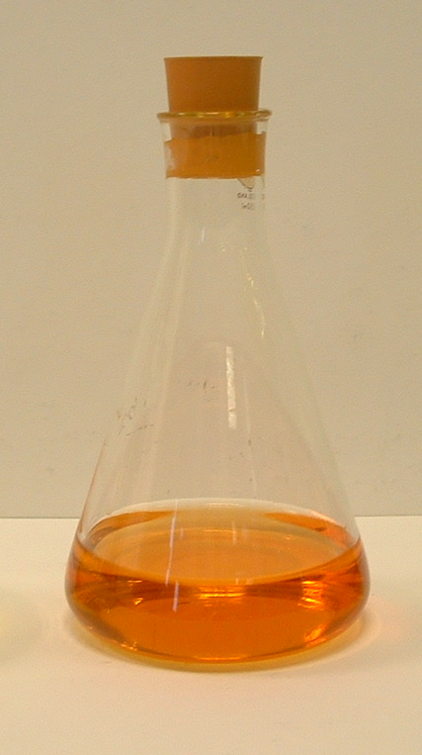
It is the responsibility of teachers doing this demonstration to carry out an appropriate risk assessment.

