Turning a webcam into a USB microscope
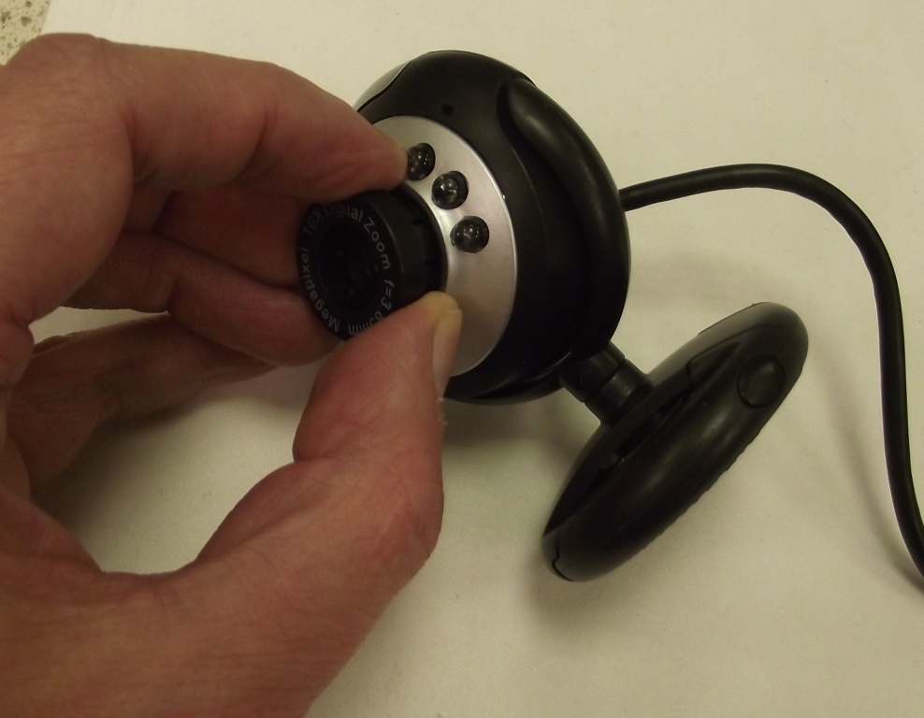
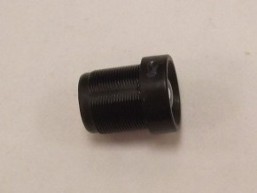
Pull off the ring around the lens, then unscrew the lens.

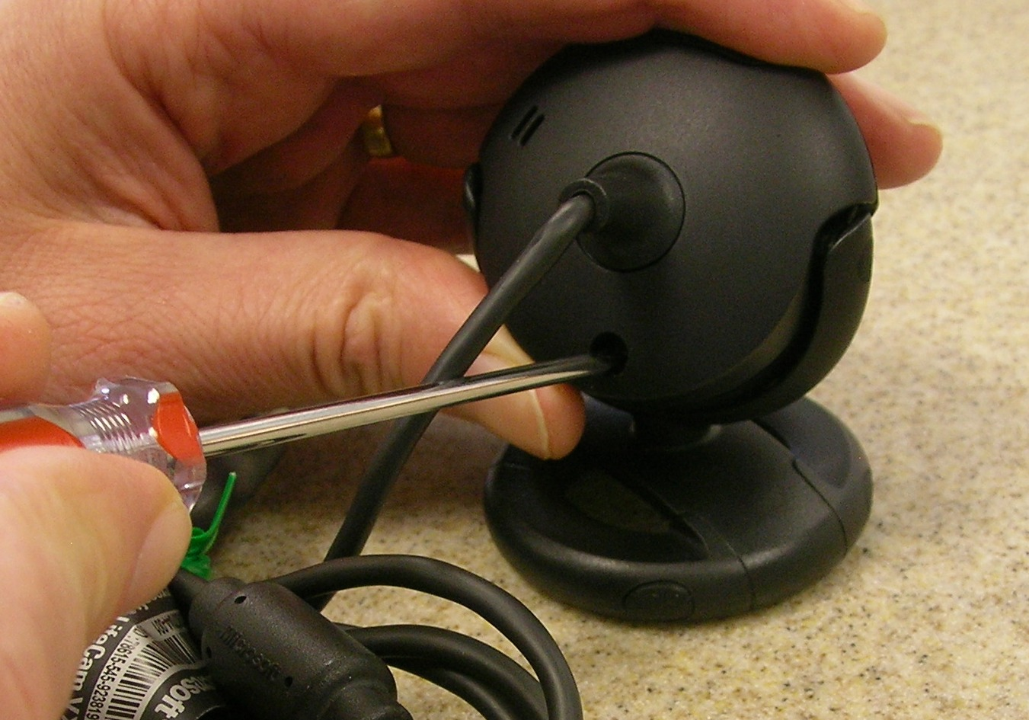
Remove the screws holding the casing together, then remove the casing itself. Looking down the black threaded lens holder, you can see the camera’s sensor.
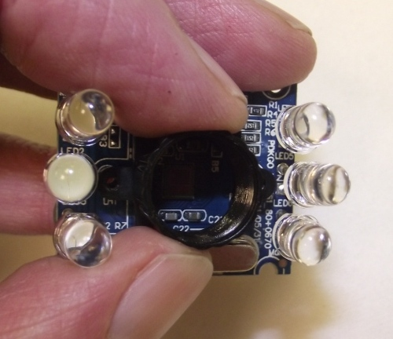

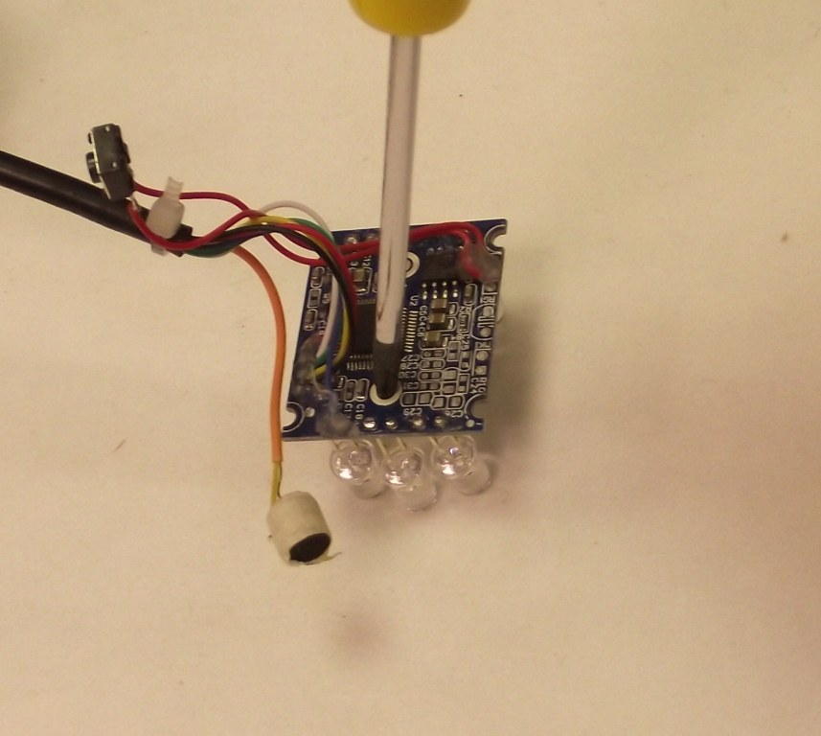

Remove the two screws at the back of the circuit board that secure the lens holder. Remove the lens holder.
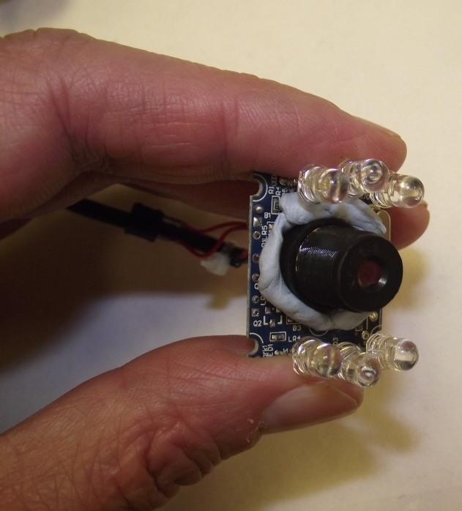

Stick the lens backwards on to the circuit board, directly above the camera sensor.

