

Simple Chemical Experiments
Toothpaste and orange juice
CfE
I have explored the structure and function of sensory organs to develop my understanding of body actions in response to outside conditions.
SCN 2-12b
CfE Higher – Nature’s Chemistry
Soaps, detergents and emulsions

Taste and Aroma
You will need:
•Toothpaste
• mint (sweets)
• orange juice
Procedure:
- After discussing the horrible taste, get the pupils to such a mint and then take a sip of orange juice.
- To their surprise, the orange will taste quite normal.
- Now get them to put a dab of toothpaste in their mouths and swirl it round for a minute or two.
- Then repeat the orange juice tasting and it will taste horrible

What is happening?
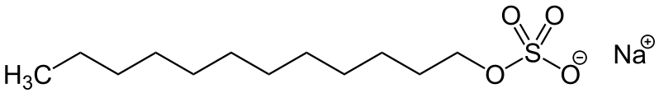
Contrary to popular opinion, the guilty party in the toothpaste is not the mint flavouring, it is a surfactant called sodium dodecyl sulphate (sodium lauryl sulphate - SLS) that is used to make the toothpaste foam when you brush your teeth.
In the mouth, the SLS suppresses the working of the taste buds that detect sweetness.
In addition, SLS destroys phospholipids. These fatty compounds act as inhibitors on your bitterness receptors.
So by inhibiting sweet receptors and destroying phospholipids, SLS dulls the sweetness and promotes the bitter taste in orange juice.
Health & Safety
Other than the normal requirements of hygiene, there are no issues here.

