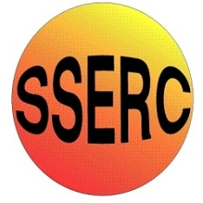

Simple Chemical Experiments
Taste and Aroma
CfE
I have explored the structure and function of sensory organs to develop my understanding of body actions in response to outside conditions.
SCN 2-12b
CfE Higher – Nature’s Chemistry
Chemistry of cooking
Taste and Aroma

You will need:
•Strawberry jam (or similar)
• teaspoon

Procedure:
- Either hold your own nose or get someone to do it for you.
- Place some jam in your mouth, swirl it round with your tongue and describe the taste.
- Let go of your nose.
- Now describe the taste.

What is happening?
The tongue can detect only 5 tastes: sweet, sour, salt, bitter and umami. When the nose is held, the jam only really registers as sweet.
The vast majority of what makes up the taste of a food is in fact the aroma molecules detected by the nose. When you let go of your nose, the molecules can make their way there and the unmistakable ‘strawberry-ness’ comes through.
This explains why food tastes bland when you have a bad cold.

Health & Safety
Other than the normal requirements of hygiene, there are no issues here.

