

Simple Chemical Experiments
Structural subtlety
CfE
I have explored the structure and function of sensory organs to develop my understanding of body actions in response to outside conditions.
SCN 2-12b
CfE Higher – Nature’s Chemistry
Fragrances - terpenes

CfE Advanced Higher – Organic Chemistry and Instrumental Analysis
Stereochemistry

Taste and Aroma

You will need:
•2 small bottles/jars with lids
• pestle and mortar
• Caraway seeds
• Spearmint (or spearmint sweets such as tic-tacs)

Procedure:
- Crush a teaspoon of caraway seeds in a pestle and mortar and place in one of the jars.
- Do the same with the mint (or mint sweets) and place in the other jar.
- Allow pupils to smell the two jars and try to identifiy the odours.

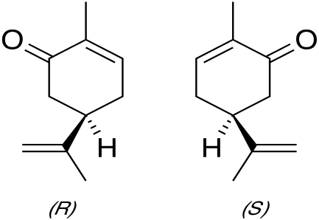
What is happening?
The main odour molecules in spearmint and caraway are different optical isomers of a terpene called carvone.
Caraway contains the S – Isomer
Spearmint contains the R isomer
It is a simple demonstration of how the human senses can detect substances that are structurally very similar.

It is possible to isolate essential oils from spearmint and caraway whicn contain around 50 – 80% carvone.
Health & Safety
Other than the normal requirements of hygiene, there are no issues here.

