

Simple Chemical Experiments
Esters

CfE Higher – Nature’s Chemistry
Esters
Taste and Aroma

You will need:
• ethanol
• 3-methyl butanol
• Ethanoic acid (c) (corrosive)
• Sulphuric acid (c) (corrosive)
• 1M sodium carbonate
• Test tubes (with bungs) or small bottles
• warm water bath (beaker of warm water)

Procedure:
- Put 1 cm³ of ethanol and 3-methyl butanol in each of two test tubes/bottles.
- Add 1 cm³ of ethanoic acid.
- Add 4-5 drops of concentrated sulphuric acid.
- Stopper the test tubes and place in the warm water bath for 5 minutes.
- Add 10 cm³ of 1M sodium carbonate ( to neutralise the acid)
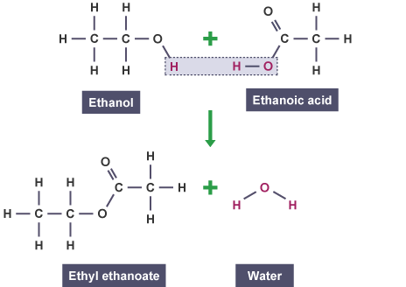
- Smell the tubes, cautiously.

What is happening?
Sulphuric acid is a powerful dehydrating agent and this encourages the condensation reaction between the acid and the alcohols.
Eg
Esters are widely found as aromas in a variety of foods, both naturally-occurring and added artificially.
Pear drops contain a mixture of the two esters being made here. They are known in the industry as ethyl acetate and iso-amyl acetate
Health & Safety
If being carried out by pupils, it may be sensible for the teacher to add the sulphuric acid drops, and perhaps the ethanoic acid.
Sulphuric acid is corrosive. Wear goggles (BS EN166 3) and gloves.
Ethanoic acid is corrosive. Wear goggles (BS EN166 3) and gloves.
Ethanoic acid vapour is irritating. Keep container stoppered as much as possible. Work in a well-ventilated area. If ventilation is a problem, dispense ethanoic acid in a fume cupboard.

