

Chemical Demonstrations
Oxidation states of Vanadium
CfE Advanced Higher – Inorganic chemistry and Instrumental Analysis
Oxidation states of transition metals

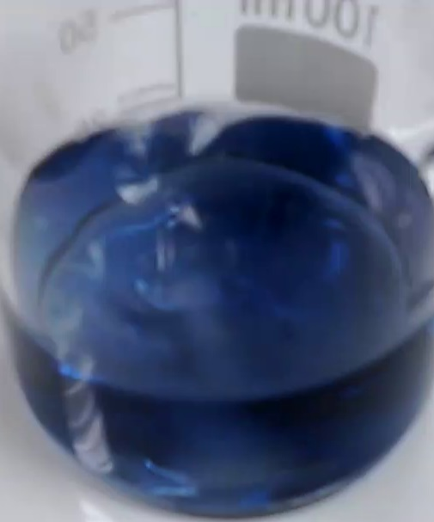
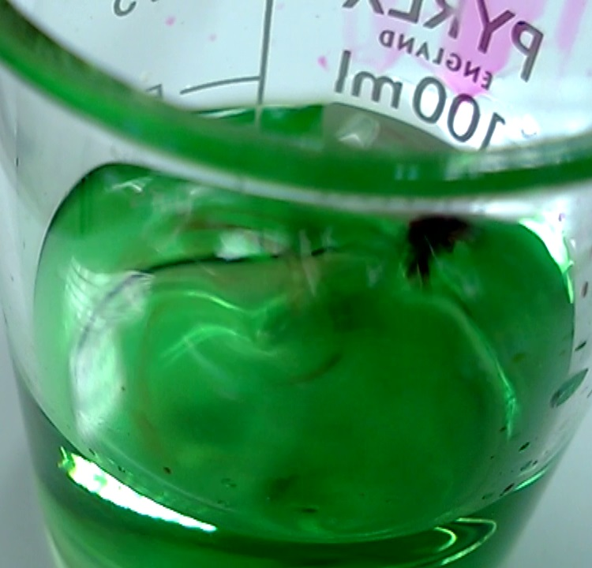
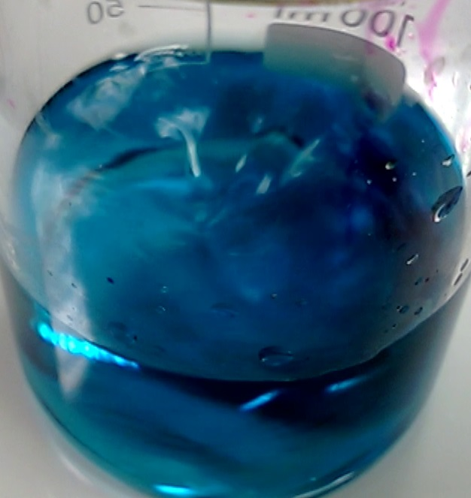
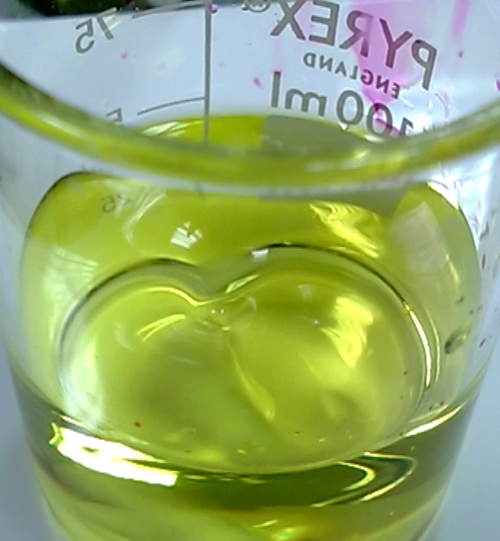
Oxidation states of Vanadium
Background
Vanadium, like many transition metals, has several different oxidation states. Also like other transition metals, these oxidation states are coloured.
Oxidation State | Colour | Ion
+5 | yellow | VO₂ ⁺ (aq)
+4 | Blue | VO ²⁺ (aq)
+3 | Green | V ³⁺ (aq)
+2 | Lavender blue | V ²⁺ (aq)

What you will need
- Ammonium vanadate V
- 1M sulphuric acid
- burette
- 0.1M potassium manganate VII
- Spatula
- Zinc powder
- 250cm³ beaker
- 100cm³ beaker

Preparation of the solutions
Sulphur dioxide
add about 0.5 g of a sulphite to a test tube and cover with 1M hydrochloric acid
dilute this further with water - do not heat.
Ammonium vanadate V
Wear goggles (BS EN 166 3)
Dissolve 1.17 g of ammonium vanadate (V) in 80 cm³ of 1M sulphuric acid.
Make up to 100 cm³ with distilled water.

The demonstration

Take a beaker containing 60 cm3 of yellow vanadate V solution and pour 10 cm³ into each of two test tubes

Place one of the tubes in a rack as a sample of the 5+ oxidation state.

To the other tube, add 3cm³ of sulphur dioxide solution and mix. It will go blue as it is reduced to the 4+ oxidation state. Place this test tube in a rack also.

Take the rest of your vanadate V solution and add a spatula full of zinc powder. It will immediately go green and then blue (the green is a mixture of the yellow and blue)

It continues to change and in a few minutes will turn green again. Pour about 10cm³ through a filter paper (to remove zinc and thus stop the reaction) into a test tube and place in the test tube rack. This is the 3+ oxidation state.

The remainder of the solution in the beaker will continue to change over the next few minutes until it is a lavender blue colour (almost violet). Pour 10cm³ into a test tube and place in the rack. This is the 2+ oxidation state.
- Take your beaker with the remaining vanadium 2+ and zinc powder and filter it into a 100cm³ beaker or flask.
- Place on a magnetic stirrer (if available)
- Fill a burette with 0.1M potassium manganate VII.
- Place the beaker/flask under the burette and let the manganate VII run into the beaker of the vanadium solution, stirring/swirling all the time.
- Watch the colour changes as they progress back through green (V3+) and blue (V4+) to yellow (V5+)

Safety
It is the responsibility of teachers doing this demonstration to carry out an appropriate risk assessment.

