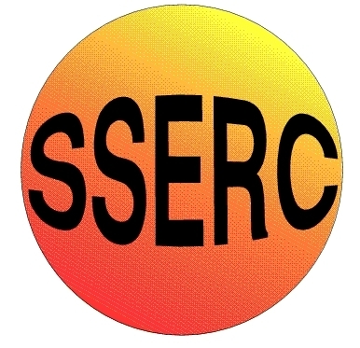
SSERC Risk Assessment (revised version November 2009)
(based on HSE ‘5 steps to risk assessment’)

2 Pitreavie Court, South Pitreavie Business Park, Dunfermline KY11 8UB
tel : 01383 626070 fax : 01383 842793
e-mail : sts@sserc.org.uk web : www.sserc.org.uk

Activity assessed
Date of assessment | 7/28/2026
Date of review (Step 5)
School
Department

Step 1 | Step 2 | Step 3 |  | Step 4
List Significant hazards here: | Who might be harmed and how? | What are you already doing? | What further action is needed? | Action by whom? | Action by when? | Done
Experiment A – sugars in alcopops  Ethanol is highly flammable | Pupils, teacher, technicians while pupil is preparing dilutions by burning | Keep ethanol well away from any sources of ignition.  Use a heating mantle to heat the alcoholic solution  Add a boiling chip to the round-bottomed flask to prevent bumping of the mixture
Experiment B – Alcohol %  Ethanol is highly flammable  Sodium hydroxide (solid and 2M solution) is corrosive | Pupils, teacher, technicians while pupil is preparing dilutions by burning  Technician making up solution and pupil/teacher using solution by splashing. | Keep ethanol well away from any sources of ignition.  Use a heating mantle to heat the alcoholic solution  Add a boiling chip to the round-bottomed flask to prevent bumping of the mixture  Wear gloves and goggles (BS EN166 3). Handle with care.
Experiments C, D & E – Sulphur dioxide levels  Sulphuric acid (concentrated and 2M solution) is corrosive.  Sodium hydroxide (solid and 1M solution) is corrosive  Iodine is harmful to the respiratory system and irritating to skin and eyes.  (The iodine solutions used here are of low hazard) | Technician making up solution and pupil/teacher using solution by splashing.  Technician making up solution and pupil/teacher using solution by splashing.  Technician preparing solutions by inhaling vapour or getting iodine on skin or in eyes | Wear gloves and goggles (BS EN166 3). Technician should take care making dilute solution – see SSERC website for details.  Wear gloves and goggles (BS EN166 3). Handle with care.  Wear gloves and eye protection.  Work in a well-ventilated area.

Description of activity:

Experiment A involves determining the sugar content of alcopops by measuring the density of the solution and comparing it to a graph of densities of sugar/alcohol solutions.

Experiment B involves distilling off the alcohol from a sample of wine, measuring its density and comparing it with a reference graph to determine the % ethanol.

Experiments C, D & E involve titrating aliquots of wine (or other drinks) against iodine solution to determine the amount of free and combined sulphur.

Additional comments:

The sodium thiosulphate and starch solutions used in Experiments C, D & E are of low hazard.

