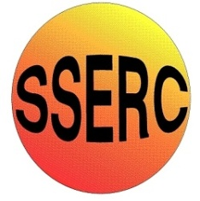

|  |
| --- |
| **Chemical Demonstrations** |
| The Photochemical Blue Bottle |

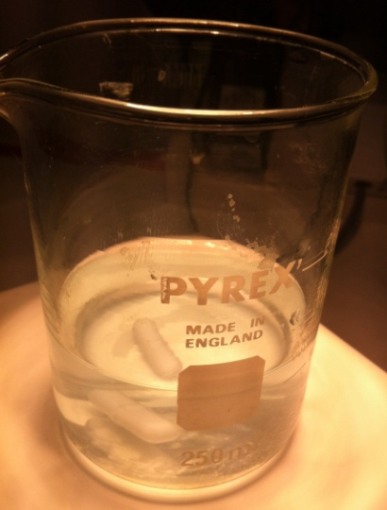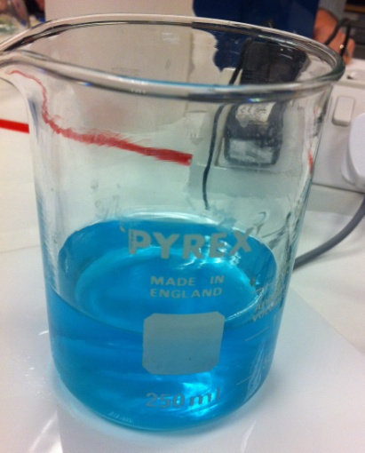

This reaction can be applied to curriculum for excellence.

*Through experimentation, I can identify indicators of chemical reactions having occurred ...* SCN 3-19a

*By contributing to experiments and investigations, I can develop my understanding of models of matter and can apply this to changes of state and the energy involved as they occur in nature.* SCN 3-05a

National 4 – Chemical changes and structure

*Energy changes of chemical reactions*

**Introduction**

You may well be familiar with the classic blue bottle experiment.  Methylene blue is reduced to its colourless leuco form by glucose and then re-oxidised by oxygen when the bottle is shaken.

This version has methylene blue being reduced photochemically by light and iron II, which presumably is oxidised to iron III in the process. In the presence of bright light, the blue solution bleaches in a few seconds. When the light is turned off, the blue colour re-appears.

**You will need**

|  |  |
| --- | --- |
| 1 x 250 cm3 beaker | 100 cm3 0.2M sulphuric acid |
| 2g iron II sulphate | Methylene blue |
| High intensity light (eg a slide projector) | Magnetic stirrer (optional) |

**The demonstration**

Dissolve 2g of iron II sulphate in 100 cm3 of 0.2M sulphuric acid.

Add 1 drop of methylene blue (2 at the most)

Place the solution close to the high intensity light source and switch the light on.

When the colour has gone, switch the light off and watch it reappear.

**H&S**

0.2M sulphuric acid is an irritant. The ionn sulphate solution and methylene blue are of low hazard.

**Notes**

Unlike the original blue bottle demonstration the mechanism for this demonstration is not yet clear.

It doesn't seem to involve O2, because the photochemical reduction occurs equally well in solutions that have been degassed via repeated freeze/pump/thaw cycles.

The equation is presumably something like

Fe2+ + methylene blue + light == Fe 3+ + reduced methylene blue

The rate of reaction is controlled by light and is **independent** of reaction concentrations.

If you have too much methylene blue, the solution may fade but it will not go colourless. Try again with less methylene blue.

So it is 0th order with respect to concentration.

The light needs to be very bright. I tried an OHP with no success – though different ones may work.

A slide projector worked and this allowed the possibility of holding a test tube of the solution such that only half of it was illuminated enabling the audience to clearly see the tube was half clear and half blue – for a few seconds – after it was taken out of the light.

Originally from A Demo A Day, p. 234 via [www.wikieducator.org](http://www.wikieducator.org)