Crumple Zones – a New Mindset
As physics teachers begin to tie together Outcome One investigations with N4 Added value units and N5 Assignments, the interest in reliable experiments suitable for these course elements has increased. We know that our friends at Road Safety Scotland have been lending out their “Pimp my Trolley” kits, as the exemplars in SQA course documentation on N4 and N5 relates to vehicle safety. However, we heard of another piece of apparatus that might be suitable, one that had the advantage of being relatively inexpensive. We refer to the USB accelerometer from Mindsets [1] which at the time of writing, costs £24.95 before VAT (Figure 1).
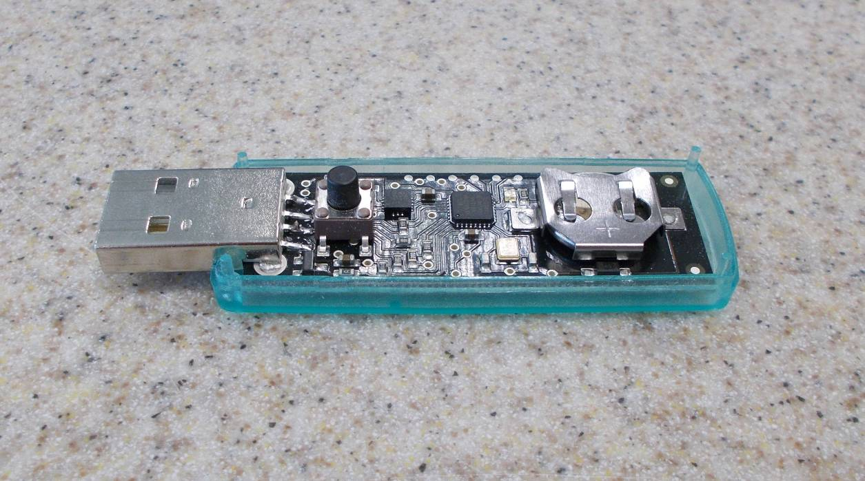
Figure 1 – USB accelerometer with lid removed to show circuitry. Because we’re physicists.
The device uses standard Windows drivers and the software to configure it and download data is free. We will suggest a number of activities you could carry out using the accelerometer later in this article but, for now, we will concentrate on collision investigation.
Once the software is installed, the accelerometer has to be configured. This is done by inserting it into a USB port, loading the application and selecting Configure. This displays the pop-up shown in Figure 2.
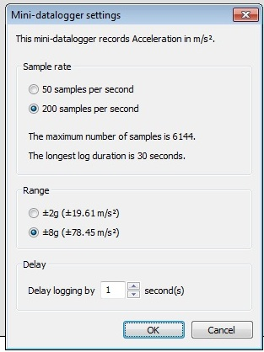
Figure 2 - Configuration
For collisions, the maximum sampling rate (200 per second) and the maximum range (±8 g) should be selected. A delay between the logger being activated and the beginning of data capture can be set too. Note that the logger can only collect 30 seconds of data at this rate.
Prior to this, we prepared a set of stick-on crumple zones 1, 2, 3... up to 8 strips of paper (Figure 3).
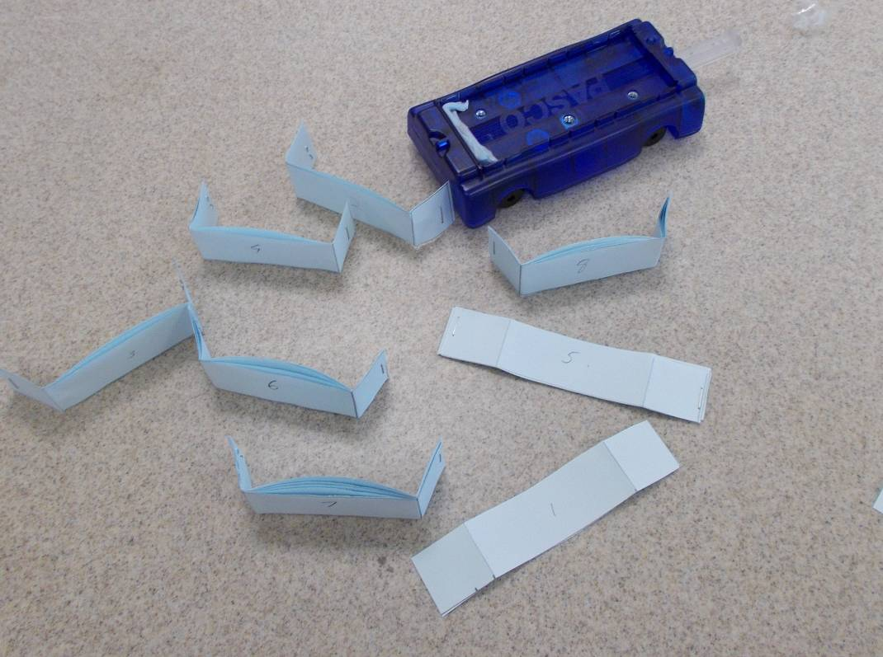
Figure 3 – Trolley with crumple zones of varying thickness
These zones did not protrude in front of the trolley sufficiently for good results. A new set, one example of which is shown attached to a trolley in Figure 4, was created.
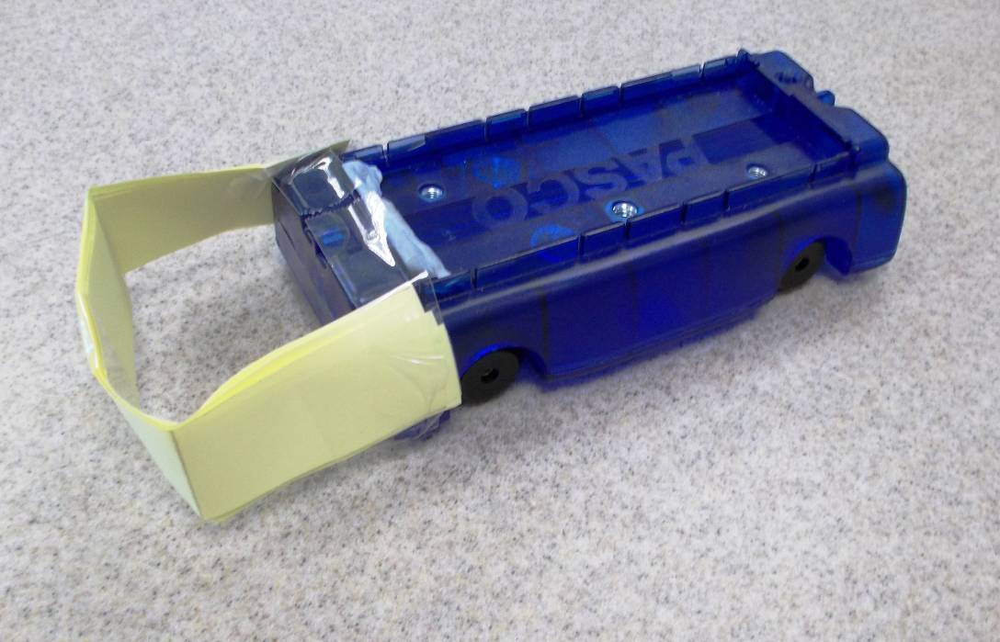
Figure 4 – Trolley with longer crumple zone
The accelerometer was removed from the computer and mounted on a trolley. The trolley was placed on a gentle slope around 40 cm from a wooden block placed at the ramp’s end (Figure 5). The button on the accelerometer was pressed and the trolley was released, allowing for the delay before logging was due to begin.
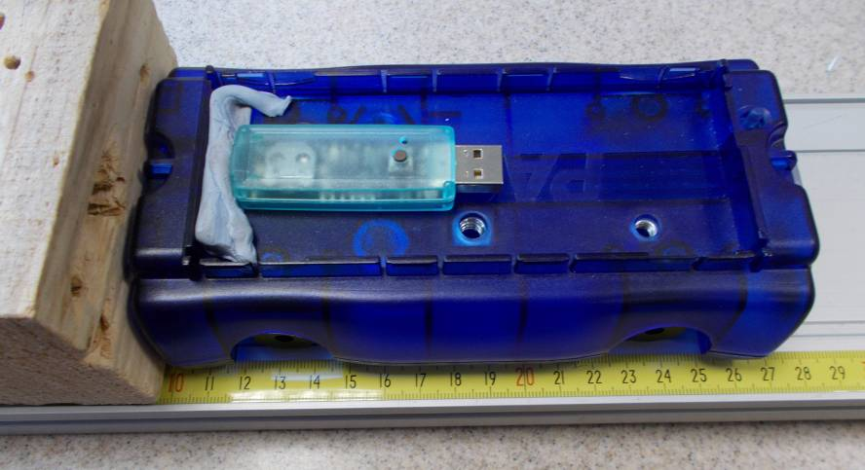
Figure 5 – Trolley with accelerometer
Note that fairly wimpy collisions can produce large accelerations. Although the students are expected to contribute extensively to the design of the experiment, it is worth doing a few test runs to have some sort of idea of the angle of slope and the distance run by the trolley that will yield accelerations that consistently remain within the device’s range. The data capture rate is good, but it could still miss a sharp, short-lived spike or perhaps take a misleadingly small measurement corresponding to a point on the shoulder of the peak. We felt pupils would find data easier to understand if we mounted the accelerometer such that accelerations in collisions would be positive. Some of you may disagree with this.
After the collision occurred, the logging button was pressed to stop data collection. The accelerometer was inserted once more into a USB port on the computer and the “Add data” option chosen (Figure 6).
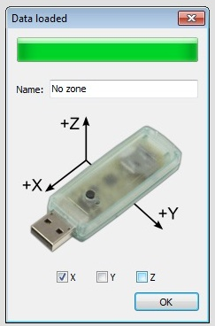
Figure 6 – Add data
You can at this point name your data run. You can also specify which axes you are interested in. For our collisions, we were only interested in X.
Several runs of data can be overlaid, making comparisons very easy.
Figure 7 shows (1) an unprotected collision, (2) a collision with a balloon “airbag” and (3) a collision with a paper crumple zone attached to the trolley.
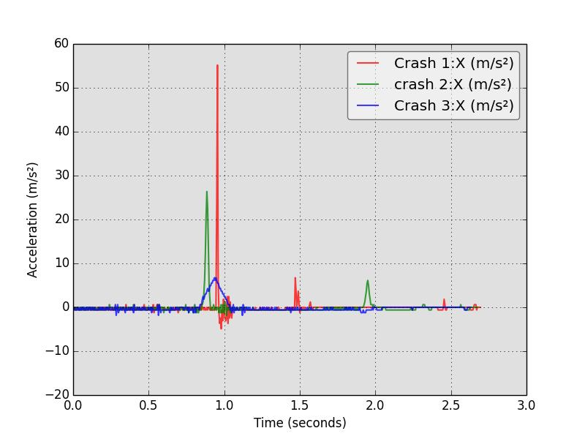
Figure 7 – Three collisions on the same graph
As can be seen from Figure 7, some judgement was needed in taking readings from the graph. Data can be saved in a spreadsheet-compatible format. For more sophisticated investigations, for example at Advanced Higher, this technique should be used.

Here are some sample results. See also Figure 8.
Thickness (units) | acceleration (ms⁻²)
0 | 39
1 | 16
2 | 9
3 | 5
4 | 6
5 | 12

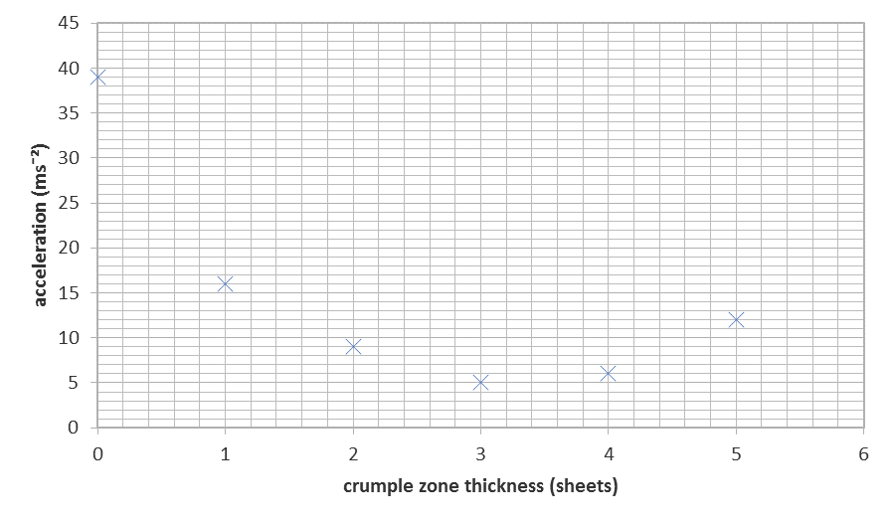
Figure 8 – Acceleration versus thickness
The results of our investigation are shown in Figure 8. Are these suitable for pupils studying Nationals? Each time we did the investigation, we found that the trend was for increasing thickness to reduce acceleration, up to a point when it began to increase again. The data was “messy”. There were results that were higher or lower than expected, for example the last two on Figure 8. Repeating the experiment in order to take an average would be time consuming. When a collision occurs, the crumple zone may lose some of its effectiveness. New crumple zones would have to be made each time. Indeed, we carried out an investigation that showed that the crumple zone became less effective with each bump. Nevertheless, we conclude that this is a valid investigation. Interestingly, it mimics a particularly sophisticated form of accident investigation. “Black boxes” in some vehicle systems, for example the control circuitry for seat belt pre-tensioners, continuously log information about the car’s motion. In some cases, the police have applied for permission to access this data to determine what happened in a crash.
We tried other activities with the accelerometer such as mounting it on a mass suspended on a spring to study acceleration during simple harmonic motion. We also placed it in the nose cone of a model rocket, though the initial acceleration was off the scale. As with other accelerometers, the Mindsets unit will sense an acceleration of 1 g even when at rest. This can cause confusion for freefall experiments. To their great credit, the developers have been willing to enter into a dialogue with us about their product and may include a “zeroing” feature in a future software release.
We acknowledge the work of the teachers in Highland schools whose “acceleration versus thickness” experiments gave us the idea for this article.
[1] www.mindsetsonline.co.uk

