NATIONAL QUALIFICATIONS CURRICULUM SUPPORT

Chemistry

Antioxidants

Teacher’s Guide
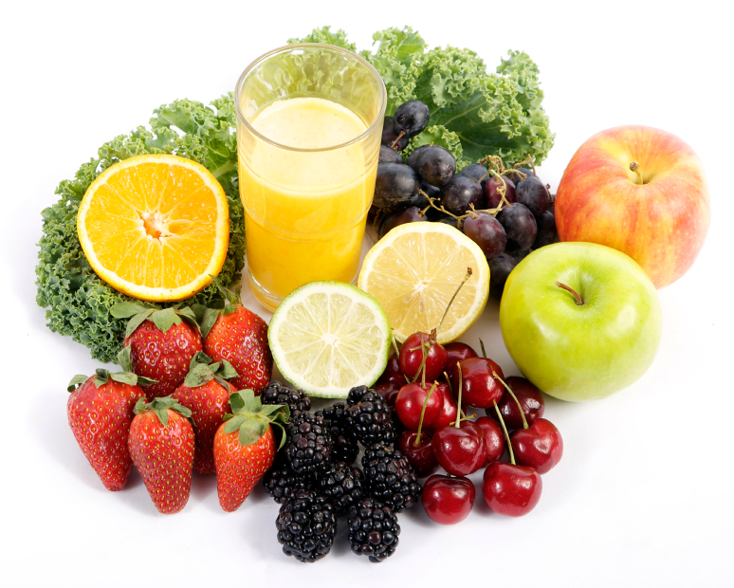

[HIGHER]




The Scottish Qualifications Authority regularly reviews the arrangements for National Qualifications. Users of all NQ support materials, whether published by Learning and Teaching Scotland or others, are reminded that it is their responsibility to check that the support materials correspond to the requirements of the current arrangements.

Acknowledgement
Learning and Teaching Scotland gratefully acknowledges this contribution to the National Qualifications support programme for Chemistry.

© Learning and Teaching Scotland 2011

This resource may be reproduced in whole or in part for educational purposes by educational establishments in Scotland provided that no profit accrues at any stage.

Contents

Introduction 4

Why is this topical? 5

Technician notes for the investigations 12

SSERC risk assessment 19

Teacher’s notes

Introduction

The Antioxidants support pack for the Researching Chemistry unit contains a selection of five possible investigations, labelled A to E.

Investigation | Title
A | Which fruit contains the most antioxidants?
B | Which tea contains the most antioxidants?
C | Does cooking destroy antioxidants in food?
D | Can we boil all the goodness out of food?
E | Is it best to buy frozen or fresh?

Teachers should feel free to edit these investigations to suit the needs of their own students. For example, some teachers may wish to remove some of the experimental instructions from the Student guide to make the planning process more challenging for able students.
Additionally, the list of investigations is by no means exhaustive; teachers are free to develop their own alternative investigation topics to enhance the experience for students.

What are antioxidants?

Many of the oxidation reactions that occur in the human body are harmful and can lead to disease. It is believed that antioxidants (chemicals that can help prevent oxidation) help to keep the body healthy and can also treat disease. Examples of antioxidants include vitamins A, C and E, and the hormone melatonin.

Why is this topical?

The media is full of reports of scientific studies relating to the benefits or otherwise of antioxidants. Ever since the famous chemist Linus Pauling attracted the scientific and media spotlight by claiming that high doses of certain antioxidants can protect against disease and treat ailments, scientists have been debating the merits of antioxidants in food and of antioxidants as food supplements.

It is worth noting that a significant number of the clinical trials carried out in this area have looked at the effect of antioxidant supplements on health, rather than the effect of consuming food rich in antioxidants.

This investigation pack allows students to investigate the relative concentrations of antioxidants in a variety of foods and drinks, and also encourages students to research some of the antioxidant-related claims made by the food and medical industries.

Examples of antioxidants

Melatonin

Melatonin is a hormone that helps to regulate sleep in our bodies. This compound can be termed a terminal or suicidal antioxidant as once it has removed harmful free radicals it has to be replaced.

α-tocopherol

α-tocopherol is a form of the antioxidant vitamin E that is found in vegetable oil, nuts and seeds. There have been claims that it is good for the skin.

Ascorbic acid

Ascorbic acid is also known as vitamin C and is commonly found in fruit and vegetables. It is one of the essential vitamins and cannot be synthesised by the human body. It can be easily oxidised and acts as a hydroxyl or superoxide anion radical scavenger.

β-carotene

β-carotene is a precursor to vitamin A. It is a red–orange pigment found in plants and fruits. In particular it gives carrots their orange colour. It helps human cells to absorb vitamin A.

Determining antioxidant concentration in ‘superfoods’

A wide range of engaging media items are available on the role of so-called ‘superfoods’ in healthy diets and their subsequent impact on modern life.

The Briggs–Rauscher reaction, an oscillating chemical reaction that exhibits a vivid colour change from colourless to amber to a sudden dark blue, is used to determine relative antioxidant concentration in this practical investigation.

Briggs–Rauscher reaction

This hybrid of the Bray–Liebhafski and Belousov–Zhabotinsky [1] reactions was developed by Thomas S. Briggs and Warren C. Rauscher [2] of Galileo High School, San Francisco, as an oscillating chemical reaction.

The reaction is very complex and involves both iodide (I–) ions and iodine (I₂) molecules. It is thought that a colourless solution is formed when I₂ concentration is low and I– concentration is high, a yellow solution is formed when I₂ concentration is high and I– concentration is low, and a blue colour is formed when the I₂ and I– concentrations are both high (due to the formation of pentaiodide ions, which give a blue complex with starch). The changes in the relative concentrations of the I₂ and I– are brought about by the presence of HOI. As the HOI concentration rises and falls, it triggers oscillations in the I– and I₂ concentrations.

Using this reaction, it is possible to determine the level of antioxidants present in everyday foods and drinks by starting a timer when the reaction mixture is blue and noting how long it takes for the reaction mixture to go through one full cycle (stopping the stopwatch when the mixture is blue again). The addition of antioxidants increases the time taken for this reaction. The longer the time taken for the reaction cycle, the more antioxidants the food contains. [3]

Apparatus

To simplify this process, students are supplied with the three solutions labelled A, B and C (see Technician’s guide). Adding the three solutions together produces the oscillating reaction. Students note the time taken for the first full blue-to-blue cycle of the oscillating reaction, and record this as the reference time.

Students investigate the effect of antioxidants on the reaction time by adding selected foodstuffs to the mixture.

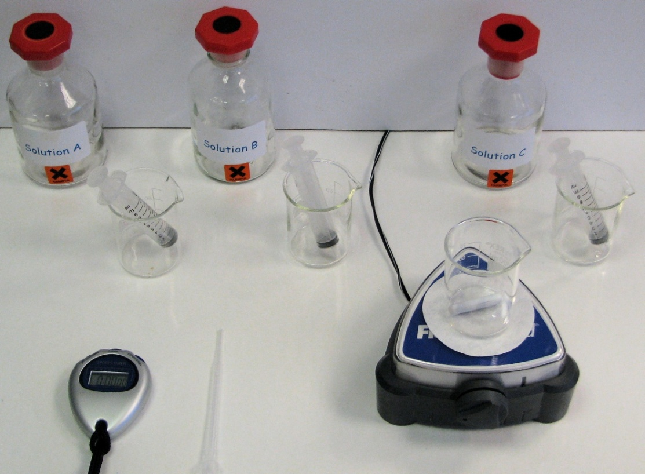

The colour cycle

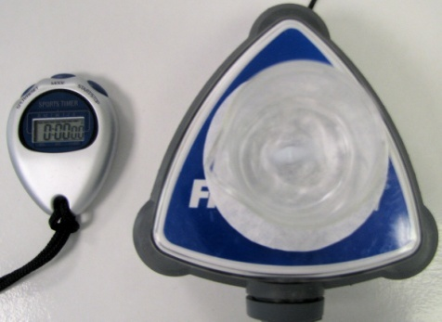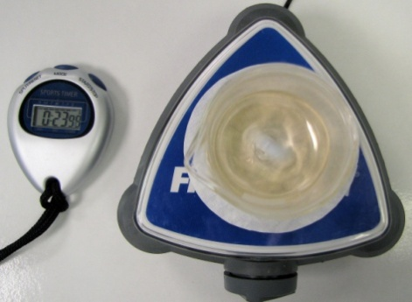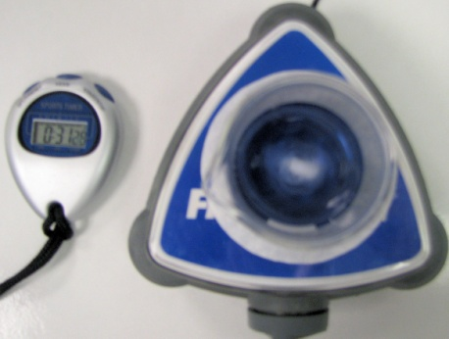
Amber
Colourless
Blue

References

- B.Z. Shakhashiri, Chemical Demonstrations: A Handbook for Teachers of Chemistry, Volume 2, The University of Wisconsin Press, 1985, pp. 248–256.
- T.S. Briggs and W.C. Rauscher, J. Chem. Educ., 1973, 50, 496.
3. www.scienceinschool.org/2009/issue13/antioxidants

Media items

A simple search for antioxidants on the BBC website throws up stories that show both sides of the coin. Teachers may wish to use some of these news clips/websites to introduce the topic:
http://search.bbc.co.uk/search?go=toolbar&uri=%2F&q=antioxidants

A wealth of resources and background chemistry for common antioxidants can be found on the Linus Pauling Institute website:
http://lpi.oregonstate.edu/

The following websites may also be of interest:

http://www.nutraingredients.com/Research/New-Scientist-slams-antioxidant-supplement-benefits
An overview of some trials which studied the effects of antioxidants on people’s health (mainly through supplements rather than from food sources).

http://www.youtube.com/watch?v=s3lX67swZWk
This video is 2 minutes long and explains how free radicals can damage cells, using a cut apple as a demonstration.

http://www.youtube.com/watch?v=T_Xo5AaTH8U
This video is just over 1 minute long and is a light-hearted approach to explaining how free radicals are formed using a group of people eating dessert at the dinner table as a demonstration.

http://www.youtube.com/watch?v=fTBz9ipkWhE
This video is 4½ minutes long and gives a more detailed explanation of how radicals are formed, lifestyles that encourage their formation and how antioxidants help to remove the free radicals. It mentions oxidative stress and oxygen radical absorbency testing (ORAC) and places examples of fruits or vegetables in order of their ORAC ranking (their ability to remove free radicals).

www.youtube.com/watch?v=yNsCU-_V0oM
This video is about 5 minutes long and shows the preparation for the Briggs–Rauscher reaction, the actual visual changes of the oscillating reaction and finally how to dispose of the product mixture. Text accompanies the video.

http://www.scienceinschool.org/2009/issue13/antioxidants
This website provides further reading on how a tutor and his students were able to detect the levels of antioxidants found in food and drink samples.

Technician notes for the investigations

This section contains details of the chemicals and apparatus needed for each experiment together with safety information and advice on common problems encountered by students.

Investigations A, B, C, D and E

Requirements (per group).

The following recipe assumes five groups per class of 20 students.

Chemicals | Apparatus
50 cm³ 0.2 M potassium iodate and 0.07 M sulphuric acid (solution A, see below)  50 cm³ 0.15 M malonic acid and 0.02 M manganese sulphate (solution B, see below)  50 cm³ 4 M hydrogen peroxide (solution C, see below)  Distilled water as required | Eye protection – indirect vent goggles  Gloves (latex free)  Bench cover/mat  Top-pan balance  Waste disposal bottle, 250 cm³  Mortar and pestle  2 × 250 cm³ beakers  Stirring rod  Filter paper  Filter funnel  100 cm³ plastic sample bottles as required  4 × 100-cm³ glass beakers  3 cm³ Pasteur pipettes as required  3 × 10-cm³ syringes  Timer  Magnet stirrer

Investigation | Additional requirements
A: Which fruit contains the most antioxidants? | A selection of fruits/drinks, eg blueberries, cranberry juice, etc
B: Which tea contains the most antioxidants? | A selection of teas, eg Tetley, peppermint, green, etc
C: Does cooking destroy antioxidants in food? | Samples of food that can be cooked by different methods  Access to a kitchen if a student wishes to fry or microwave their foods
D: Can we boil all the goodness out of food? | Samples of food, eg blueberries, carrots, broccoli
E: Is it best to buy frozen or fresh? | Samples of frozen and fresh foods, eg frozen and fresh carrots; frozen and fresh broccoli

Preparation of solutions A, B and C

Potassium iodate and sulphuric acid (250 cm³)

Dissolve 10.75 g of potassium iodate (oxidising and harmful) in 100 cm³ of distilled water and add 1.08 cm³ concentrated sulphuric acid (corrosive). Make up to 250 cm³ with deionised water and stir using a magnetic stirrer on a gentle heat setting until dissolved.

Place into five bottles and label with harmful pictograms. Label as solution A.

B. Malonic acid and manganese sulphate (250 cm³)

Take 2.5 g of starch and mix with distilled water to make a slurry. Boil distilled water and pour it into the slurry until the slurry has completely dissolved.

Dissolve 4.0 g of malonic acid (harmful) and 0.85 g of manganese sulphate (harmful) in 100 cm³ of distilled water. Add the starch solution and make up to 250 cm³ with distilled water.

Place into five bottles and label with harmful pictograms. Label as solution B.

C. Hydrogen peroxide (250cm³)

Pipette 75 cm³ of 100 vol hydrogen peroxide (corrosive and powerful oxidising agent) into a measuring flask and make up to 250 cm³ with distilled water.

Place into five bottles and label with harmful pictograms. Label as solution C.

Disposal of waste

In a fume cupboard, slowly add solid sodium thiosulphate (irritant) to the waste. Wait until the iodine molecules (blue/black) turn into iodide ions (colourless) and dispose of down the sink with excess water. Beware that this reaction is exothermic.

Specimen answers for superfoods – Investigation A

Type of food/drink | Time 1 (s) | Time 2 (s) | Time 3 (s) | Average time (s)
Blueberries | 289 | 296 | 227 | 271
Cranberry juice | 99 | 100 | 96 | 98
Raisins | 80 | 85 | 81 | 82
Carrots | 73 | 70 | 77 | 73
Reference sample | 48 | 62 | 58 | 56

By plotting a bar graph students will be able to easily rank the foods in order of level of antioxidants. Note that it is purely a qualitative not a quantitative result that is sought.

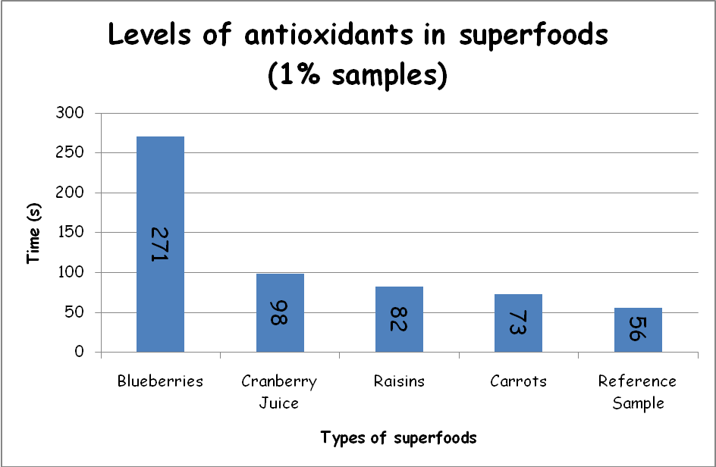
Students can discuss why the colour cycle takes significantly longer with certain samples and indeed why the cycle then returns to its reference sample time interval.

Investigation B involves students investigating the antioxidant levels in tea. Note, however, that to complete the reaction for each sample within a class period (53 minutes) you need to weigh 0.01 g of the tea leaves and stir/brew them for 2 minutes in cold distilled water. This would need to be done prior to the lesson if a single period is being used.

Green teas or any tea claiming to be high in antioxidants will take considerably longer to complete the colour cycle (between 10 and 20 minutes).

Specimen answers for tea leaves – Investigation B

Type of tea | Time 1 (s) | Time 2 (s) | Time 3 (s) | Average time (s)
Twining’s Pure Peppermint | 171 | 168 | 168 | 169
Twining’s Classic Traditional | 132 | 116 | 122 | 123
Tetley Green Tea Lemon | 116 | 102 | 102 | 107
Tetley Tea | 98 | 103 | 95 | 99
Tetley Peppermint Punch | 83 | 83 | 87 | 84
Twining’s Pure Camomile | 86 | 84 | 80 | 83
Twining’s Aromatic Earl Grey | 80 | 77 | 79 | 79
Twining’s Assam | 67 | 75 | 72 | 71
Tetley Sweet Cranberry | 66 | 69 | 68 | 68
Reference sample | 40 | 45 | 49 | 45

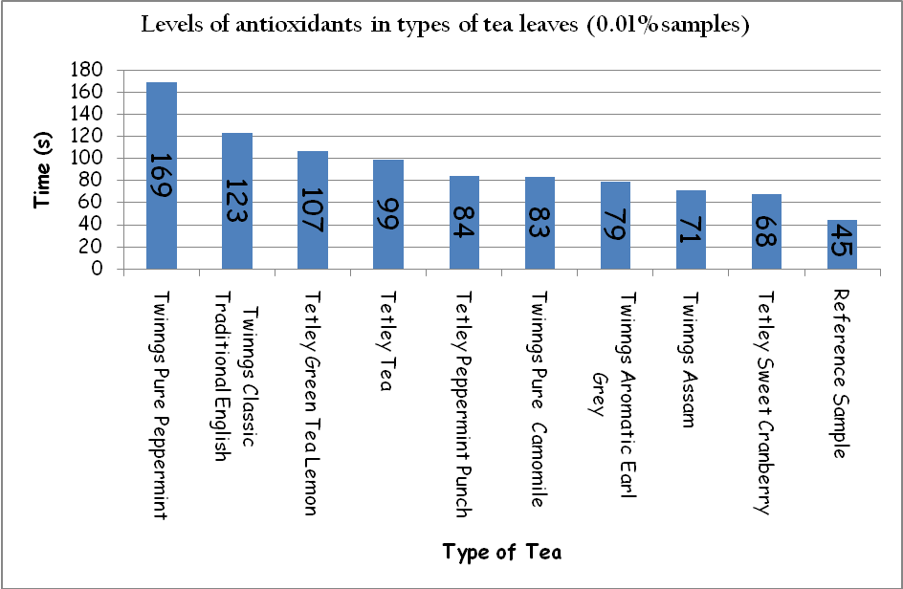

Students can discuss why the colour cycle takes significantly longer for certain samples and indeed why the cycle then returns to its reference sample time interval.

Alternatives and trouble shooting

If there are insufficient mortar and pestles to crush all the samples, allow more time for uncrushed samples when stirring vigorously with distilled water in the 250-cm³ beaker.

If there are insufficient magnetic stirrers, use a stirring rod inside the glass beaker. This will require some team work to co-ordinate the stirring, adding the sample and recording the time.

If students are finding that no colour change is occurring within 10 minutes it is most likely that they have added two lots of one of the colourless solutions A, B or C. Discard the mixture and start again.

A Buchner funnel could be used when filtering off any residue. Note that although this will be quicker it will take up significant space if 10 pairs of students are completing the practical activity at the same time.

Sample sources

Some examples of foodstuffs containing a range of the antioxidants are small red beans (dried), red kidney beans, pinto beans, cranberries, artichokes, blackberries, prunes, raspberries, strawberries, Red Delicious apples, Granny
Smith apples, pecans, sweet cherries, black plums, Russet potatoes, black beans (dried), plums or Gala apples.

This list is not exhaustive.

The table below lists food samples that are rich in each type of antioxidant.

Type of antioxidant | Sample
β-carotene | Carrots, sweet potatoes, pumpkin, apricots, mangoes, spinach, kale
α-tocopherol (vitamin E) | Almonds, mangoes, broccoli, wheat germ oil, soybean oil
Ascorbic acid (vitamin C) | Fruits and their juices, beef, poultry, fish and cereals
Vitamin A | Sweet potatoes, mozzarella cheese, milk, egg yolks

Note: Be aware of food allergies and issues with raw meats, poultry and fish.

SSERC Risk Assessment (revised version November 2009)
(based on HSE 5 steps to risk assessment)

Activity assessed | Antioxidants in superfoods and types of tea
Date of assessment | 16 March 2010
Date of review (Step 5)
School
Department

Step 1 | Step 2 | Step 3 |  | Step 4
List significant hazards here: | Who might be harmed and how? | What are you already doing? | What further action is needed? | Action by whom? | Action by when? | Done
Potassium iodate is harmful, irritant and powerful oxidising agent | Technician, teacher by inhalation and splashes | See SSERC Hazchem  Avoid breathing in any dust  Wear indirect vent goggles  If spilt on skin, wash off with copious amounts of water  Wear gloves  Keep away from combustible materials
Concentrated sulphuric acid is very corrosive | Technician, teacher by inhalation and splashes | See SSERC Hazchem
Malonic acid | Technician, teacher by inhalation and splashes | Avoid breathing in any dust  Wear indirect vent goggles (BSN 1663)  If spilt on skin, wash off with copious amounts of water  Wear gloves

Solutions A, B and C | Teacher and student by splashes | Wear indirect vent goggles (BNS 1663)  Wear gloves  If spilt on skin, wash off with copious amounts of water
Hydrogen peroxide 100 volume is corrosive and powerful oxidising agent | Technician, teacher by inhalation and splashes | See SSERC Hazchem  Use indirect vent goggles (BSN 1663)  Wear gloves  If spilt on skin, wash off with copious amounts of water
Manganese sulphate is harmful | Technician, teacher by inhalation and splashes | Avoid breathing in any dust  Wear indirect vent goggles (BSN 1663)  Wear gloves
Starch | Technician, teacher by inhalation | Avoid breathing in any dust
Foods and drinks | Teacher, student | Awareness of food allergies  Wear gloves and wash hands after use

Cooking foods | Teacher, student  Risk of burns | Students should wear indirect vent goggles (BSN 1663) and handle hot containers with heat proof gloves  Cooking methods should be approved and supervised by a teacher
Hydrogen peroxide 30 volume is irritant | Technician, teacher and students by splashes | See SSERC Hazchem  Use indirect vent goggles (BSN 1663)  Wear gloves  If spilt on skin, wash off with copious amounts of water
Sodium thiosulphate is irritant | Technician, teacher by inhalation and splashes | Avoid breathing in any dust  Wear indirect vent goggles (BSN 1663)  Wear gloves

Description of activity

Preparing superfood solution samples by crushing and diluting with distilled water.

Determining levels of antioxidants by mixing solutions A, B and C, then adding sample solutions and recording the time interval for the colour cycle of colourless to amber to blue.

Waste is collected in the disposal bottle and then disposed of as described in the additional comments.

Additional comments

Disposal of waste will be exothermic, especially in large quantities. Wear indirect vent goggles (BS EN 1663) and gloves, and complete procedure in fume cupboard. Once the solution remains colourless dispose down the sink with excess water.

