NATIONAL QUALIFICATIONS CURRICULUM SUPPORT

Chemistry

Antioxidants

Student’s Guide

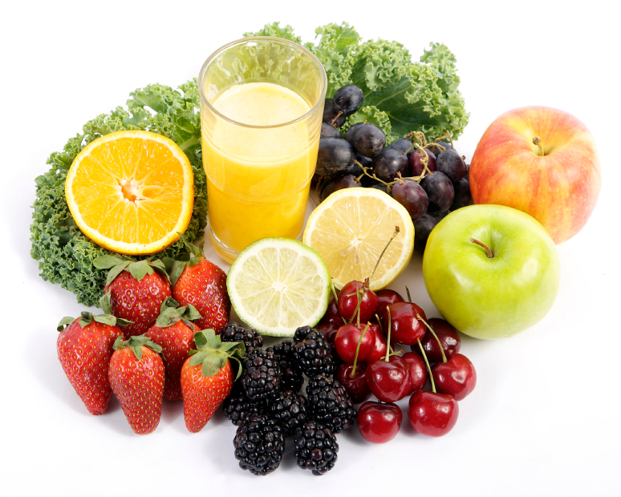
[HIGHER]




The Scottish Qualifications Authority regularly reviews the arrangements for National Qualifications. Users of all NQ support materials, whether published by Learning and Teaching Scotland or others, are reminded that it is their responsibility to check that the support materials correspond to the requirements of the current arrangements.

Acknowledgement
Learning and Teaching Scotland gratefully acknowledges this contribution to the National Qualifications support programme for Chemistry.

Every effort has been made to trace all the copyright holders but if any have been inadvertently overlooked, the publishers will be pleased to make the necessary arrangements at the first opportunity.

© Learning and Teaching Scotland 2011

This resource may be reproduced in whole or in part for educational purposes by educational establishments in Scotland provided that no profit accrues at any stage.

Contents

Investigation A 4

Investigation B 11

Investigation C 18

Investigation D 26

Investigation E 33

Investigation A

Which fruit contains the most antioxidants?

Introduction

Many of the oxidation reactions that occur in the human body are harmful and can lead to disease. It is believed that antioxidants (chemicals that can help prevent oxidation) help to keep the body healthy and even treat disease. Examples of antioxidants include vitamins A, C and E as well as the hormone melatonin.

Food manufacturers are keen to advertise the presence of antioxidants in their products in the hope that the potential health benefits will lead to an increase in sales. In addition, there is a lucrative market in antioxidant supplements sold to promote good health. Medical scientists continue to investigate how beneficial antioxidants really are and what effects they can have on the human body.

Your task in this investigation is to find out which of a range of fruits contains the most antioxidants.

Background research

The first stage of carrying out research in chemistry is to review what is already known about the topic of interest. Chemists use books, scientific papers, journals and the internet to carry out background research.
Your first task in the Researching Chemistry unit is to independently carry out background research into one of the focus questions listed below, which will be assigned to you by your teacher. In school it is likely that you will carry out your background research on the internet.

Once you have completed your background research, you must then complete the unit assessment tasks and store your research evidence in a safe place.
Assessment tasks

- Record at least two sources of information relevant to your focus question. Sufficient detail should be given to allow someone else to find your sources easily. For a website, the URL shown here is perfectly adequate: http://www.biodieselfillingstations.co.uk/.

- Write a brief summary of the information of relevance contained in each of the sources you have identified.

Focus questions

A1 Explain why the human body requires antioxidants.

A2 Many foods and drinks which contain antioxidants are known as ‘superfoods’. What requirements must be met for a food to be labelled as a superfood?

A3 What evidence is there to suggest that eating superfoods is good for human health?

A4 Many people make fruit smoothies to get their daily allowance of vitamins from fruits. It is thought that smoothies can be harmful to health. What evidence is there to support this?

A5 Vitamin E is a powerful antioxidant. State some sources of vitamin E and briefly explain the role it plays in the human body.

A6 The concentration of antioxidants in food and drink can be affected by storage conditions. How should food be stored to maintain the maximum concentration of antioxidants?

Advice on using the internet for background research

The web allows you to access a huge amount of information – don’t get side-tracked! Promising sites should be bookmarked so that you can return to them later. Tables, graphs and pictures can be copied into a folder. It is worthwhile spending a few moments considering which keywords may be the best to enter into your search engine. For more advice on effective web-based research see the LTS resource on http://www.ltscotland.org.uk/nationalqualifications/resources/r/nqresource_tcm4629006.asp.

Planning your investigation

The next stage in your investigation is to plan and carry out an appropriate experimental procedure that will allow you to determine how much antioxidant is contained in a range of fruits.

Whilst planning your experimental work you must consider:

- which fruits or fruit juices will you use
- how to find out the expected antioxidant concentration by reading labels and/or carrying out internet research
- what apparatus will be required
- which chemicals will be required
- the hazards that might be involved and how you will minimise risk.

Procedure: Determining the concentration of antioxidants in fruits

The concentration of antioxidant in a fruit can be determined using a reaction known as the Briggs–Rauscher reaction. In this reaction, a colour change takes place from colourless to amber to blue The interesting thing is that the reaction repeats itself over and over. It is an example of an oscillating reaction.

The reaction is very complex and involves both iodide (I–) ions and iodine (I₂) molecules. It is thought that a colourless solution is formed when I₂ concentration is low and I– concentration is high, a yellow solution is formed when I₂ concentration is high and I– concentration is low, and a blue colour is formed when the I₂ and I– concentrations are both high (due to the formation of the iodine-starch complex).

The method requires a timer to be started when the reaction mixture is blue and stopped once one cycle of the reaction is complete and the mixture has returned to blue again. Adding antioxidants increases the time taken to complete one cycle of the Briggs–Rauscher reaction. The larger the increase in time when a particular fruit is added, the more antioxidants the food contains.

Preparation of the food/drink sample

- Weigh 1 g of fruit sample on a balance then place it in the mortar and pestle.
- Crush the sample and transfer it to a 250 cm³ beaker using 100 cm³ of distilled water.
- Stir for between 2 and 4 minutes.
- Filter off the excess solid and pour the remaining liquid into a plastic sample bottle.

Note: For a liquid sample use a volume of 1 cm³ (1 cm³ = 1 g).

Safety! Wear goggles throughout the practical.
Wear gloves when handling solutions A, B and C. If spilt on skin, wash off with copious amounts of water.
Wash hands after handling food and drink.

Determining the concentration of antioxidant

- Place a heatproof mat on the bench to prevent any iodine formed staining the work surface.

- Place a blank piece of filter paper on top of a magnetic stirrer device.

- Using a syringe, place 5 cm³ of solution A into a 100-cm³ beaker.

- Using a second syringe, add 5 cm³ of solution B to the same beaker.

- Place the beaker on top of the magnetic stirrer and turn on the stirrer.

- Add 5 cm³ of solution C to the beaker using a third syringe.

- Record the time taken from the start of the second appearance of blue colour to the start of the third appearance. This is your reference sample time. Be aware that the time interval for the first colour cycle from colourless to amber to blue will be significantly longer than the time intervals for the second and third cycles.

- Using a clean beaker, repeat steps 3 and 4.

- Shake the bottle containing the fruit sample. Using a Pasteur pipette collect 1.5 cm³ of fruit sample, ready to add to the beaker.

- Turn on the stirrer and add 5 cm³ of solution C to the beaker using a syringe.

- Wait for the blue colour to appear for the second time, add the food sample from the Pasteur pipette and start the timer.

- Wait for the blue colour to appear and stop the timer. Record the time.

- Empty the contents of the beaker into the waste disposal bottle.

Repeat steps 8 to 13 for the other fruit samples.

Apparatus

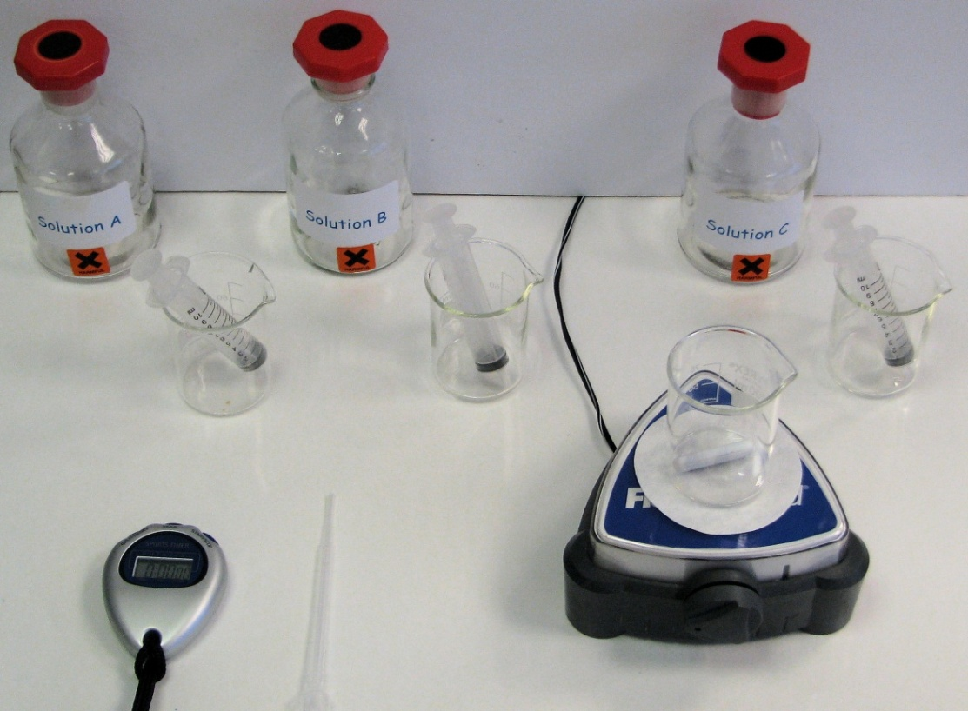

The colour cycle

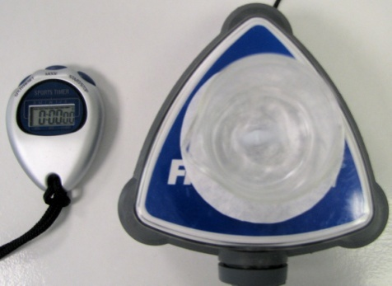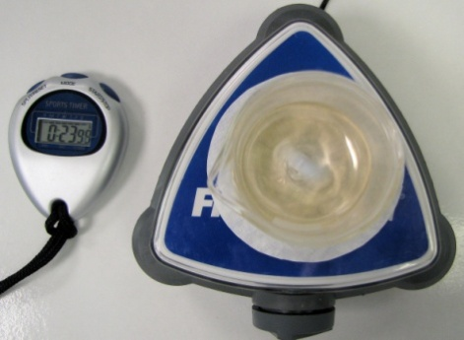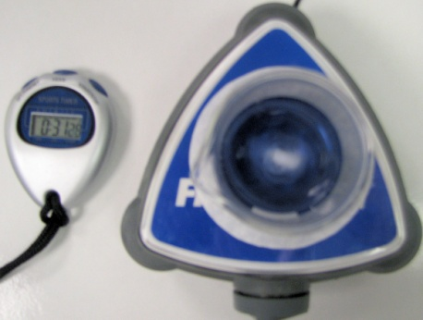
Amber
Colourless
Blue

Reporting your results

The final stage of any scientific investigation involves reporting the results. Scientists use a wide range of communication methods to report their results, including scientific papers, laboratory reports, blogs, videos, scientific posters, podcasts, PowerPoints, web pages, etc.

Assessment task

Once you have agreed the format of your scientific communication with your teacher, you should produce a report on your investigation containing the following key features:

- a clear statement of the aim of your investigation
- a description of what antioxidants are and why they are required
- a brief explanation of how the Briggs–Rauscher reaction can be used to measure the level of antioxidants in a food/drink
- your experimental observations and results, including bar graphs
- a comparison of the actual and theoretical antioxidant concentrations in your fruits
- reasons why the experimental results are different from the actual results (if they are different)
- a description of any ways in which the results could be improved
- a valid conclusion, based on the evidence in your report, which relates to your aim.

Investigation B

Which tea contains the most antioxidants?

Introduction

Many of the oxidation reactions that occur in the human body are harmful and can lead to disease. It is believed that antioxidants (chemicals that can help prevent oxidation) help keep the body healthy and even treat disease. Examples of antioxidants include vitamins A, C and E as well as the hormone melatonin.

Food manufacturers are keen to advertise the presence of antioxidants in their products in the hope that the potential health benefits will lead to an increase in sales. In addition, there is a lucrative market in antioxidant supplements sold to promote good health. Medical scientists continue to investigate how beneficial antioxidants really are and what effects they can have on the human body.

Your task in this investigation is to find out which of a variety of teas contains the most antioxidants.

Background research

The first stage of carrying out research in chemistry is to review what is already known about the topic of interest. Chemists use books, scientific papers, journals and the internet to carry out background research.

Your first task in the Researching Chemistry unit is to independently carry out background research into one of the focus questions listed below, which will be assigned to you by your teacher. In school it is likely that you will carry out your background research on the internet.

Once you have completed your background research, you must then complete the unit assessment tasks and store your research evidence in a safe place.

Assessment tasks

- Record at least two sources of information relevant to your focus question. Sufficient detail should be given to allow someone else to find your sources easily. For a website, the URL shown here is perfectly adequate: http://www.biodieselfillingstations.co.uk/.

- Write a brief summary of the information of relevance contained in each of the sources you have identified.

Focus questions

B1 Is there any evidence to suggest that drinking tea leads to better health?

B2 Why do different types of tea contain different concentrations of antioxidants?

B3 Tea contains many other compounds, such as caffeine. What effects does caffeine have on the human body?

B4 Tea and other drinks, such as wine, contain compounds known as tannins. What are tannins?

B5 How can tea affect the body’s ability to absorb iron?

B6 Green tea is recognised to be very beneficial to health. Describe the health benefits of drinking green tea.

Advice on using the internet for background research

The web allows you to access a huge amount of information – don’t get side-tracked! Promising sites should be bookmarked so that you can return to them later. Tables, graphs and pictures can be copied into a folder. It is worthwhile spending a few moments considering which keywords may be the best to enter into your search engine. For more advice on effective web-based research see the LTS resource on http://www.ltscotland.org.uk/nationalqualifications/resources/r/nqresource_tcm4629006.asp.

Planning your investigation

The next stage in your investigation is to plan and carry out an appropriate experimental procedure that will allow you to find out which tea contains the most antioxidant.

Whilst planning your experimental work you must consider:

- which teas will you use
- how to find out the expected antioxidant concentration by reading labels and/or carrying out internet research
- what apparatus will be required
- which chemicals will be required
- the hazards that might be involved and how you will minimise risk.

The concentration of antioxidant in a tea can be determined using a reaction known as the Briggs–Rauscher reaction. This reaction undergoes a colour change from colourless to amber to blue. The interesting thing is that the reaction repeats itself over and over. It is an example of an oscillating reaction.

The reaction is very complex and involves both iodide (I–) ions and iodine (I₂) molecules. It is thought that a colourless solution is formed when I₂ concentration is low and I– concentration is high, a yellow solution is formed when I₂ concentration is high and I– concentration is low, and a blue colour is formed when the I₂ and I– concentrations are both high (due to the formation of the iodine-starch complex).

The method requires a timer to be started when the reaction mixture is blue and stopped once one cycle of the reaction is complete and the mixture has returned to blue again. Adding antioxidants increases the time taken for one cycle of the Briggs–Rauscher reaction. The larger the increase in time when a particular tea is added, the more antioxidants the tea contains.

Preparation of the tea leaf sample

- Weigh 0.01 g of tea leaves on a balance.

- Using 100 cm³ of distilled water, transfer the sample to a 250-cm³ beaker.

- Stir vigorously for 1 minute and then allow ‘brewing’ for a further minute.

- Filter off the excess solid and pour the remaining liquid into a plastic sample bottle.

Safety! Wear goggles throughout the practical.
Wear gloves when handling solutions A, B and C. Wash off with copious amounts of water if spilt on skin.

Determining the concentration of antioxidants in tea

- Place a heatproof mat on the bench to prevent any iodine formed staining the work surface.

- Place a blank piece of filter paper on top of a magnetic stirrer device.

- Using a syringe, place 5 cm³ of solution A into a 100-cm³ beaker.

- Using a second syringe, add 5 cm³ of solution B to the same beaker.

- Place the beaker on top of the magnetic stirrer and turn on the stirrer.

- Add 5 cm³ of solution C to the beaker using a third syringe.

- Record the time taken from the start of the second appearance of blue colour to the start of the third appearance. This is your reference sample time. Be aware that the time interval for the first colour cycle from colourless to amber to blue will be significantly longer than the time intervals for the second and third cycles.

- Using a clean beaker, repeat steps 3 and 4.

- Shake the bottle containing the tea sample. Using a Pasteur pipette collect 1.5 cm³ of tea sample, ready to add to the beaker.

- Turn on the stirrer and add 5 cm³ of solution C to the beaker using a syringe.

- Wait for the blue colour to appear for the second time, add the tea sample from the Pasteur pipette and start the timer.

- Wait for the blue colour to appear again and stop the timer. Record the time.

- Empty the contents of the beaker into the waste disposal bottle.

Repeat steps 8 to 13 for the other tea samples.

Apparatus

The colour cycle

Amber
Colourless
Blue

Reporting your results

The final stage of any scientific investigation involves reporting the results. Scientists use a wide range of communication methods to report their results, including scientific papers, laboratory reports, blogs, videos, scientific posters, podcasts, PowerPoints, web pages, etc.

Assessment task

Once you have agreed the format of your scientific communication with your teacher, you should produce a report on your investigation containing the following key features:

- a clear statement of the aims of your investigation
- a description of what antioxidants are and why they are required
- a brief explanation of how the Briggs–Rauscher reaction can be used to measure the level of antioxidants in tea
- your experimental observations and results, including bar graphs
- a comparison of the actual and the theoretical antioxidant concentrations in the teas
- reasons why your experimental results are different from the actual results (if they are different)
- a description of any ways in which the results could be improved
- a valid conclusion, based on the evidence in your report, which relates to your aim.

Investigation C

Does cooking destroy antioxidants in food?

Introduction

Many of the oxidation reactions that occur in the human body are harmful and can lead to disease. It is believed that antioxidants (chemicals that can help prevent oxidation) help keep the body healthy and even treat disease. Examples of antioxidants include vitamins A, C and E as well as the hormone melatonin.

Food manufacturers are keen to advertise the presence of antioxidants in their products in the hope that the potential health benefits will lead to an increase in sales. However, concern has recently been expressed that cooking may destroy the antioxidants in foods.

Medical scientists continue to investigate how beneficial these antioxidants really are and what effects they can have on the human body.

Your task in this investigation is to find out if cooking affects the concentration of antioxidants in food.

Background research

The first stage of carrying out research in chemistry is to review what is already known about the topic of interest. Chemists use books, scientific papers, journals and the internet to carry out background research.

Your first task in the Researching Chemistry unit is to independently carry out background research into one of the focus questions listed below, which will be assigned to you by your teacher. In school it is likely that you will carry out your background research on the internet.

Once you have completed your background research, you must then complete the unit assessment tasks and store your research evidence in a safe place.

Assessment tasks

- Record at least two sources of information relevant to your focus question. Sufficient detail should be given to allow someone else to find your sources easily. For a website, the URL shown here is perfectly adequate: http://www.biodieselfillingstations.co.uk/.

- Write a brief summary of the information of relevance contained in each of the sources you have identified.

Focus questions

C1 Vitamin C is a powerful antioxidant. What evidence is there to suggest that there is very little vitamin C in fruits that have been on display for many weeks?

C2 β-carotene is an antioxidant found in carrots. Describe the function of β-carotene in the diet.

C3 Foods can be cooked by many methods, such as steaming, boiling and frying. Explain which method of cooking is considered to be the healthiest.

C4 Cooking causes chemical reactions that change the taste, texture and appearance of food. Recent concern has focused on compounds known as acrylamides, which are formed when carbohydrates are cooked. What are acrylamides and why are people concerned about them?

C5 Find out which food contains the highest level of antioxidant per gram of food.

C6 Many people take supplements which contain antioxidants. Explain the pros and cons of taking antioxidant supplements.

Advice on using the internet for background research

The web allows you to access a huge amount of information – don’t get side-tracked! Promising sites should be bookmarked so that you can return to them later. Tables, graphs and pictures can be copied into a folder. It is worthwhile spending a few moments considering which keywords may be the best to enter into your search engine. For more advice on effective web-based research see the LTS resource on http://www.ltscotland.org.uk/nationalqualifications/resources/r/nqresource_tcm4629006.asp.

Planning your investigation

The next stage in your investigation is to plan and carry out an appropriate experimental procedure that will allow you to find out how different methods of cooking affect antioxidant levels.

Whilst planning your experimental work you must consider:

- which food(s) will you use in this experiment
- how to find out the concentration of antioxidants by reading labels and/ or carrying out internet research
- how to find out the effect of different types of cooking on antioxidants (boiling, steaming, frying, microwaving, etc) from other people’s research
- what apparatus will be required
- which chemicals will be required
- the hazards that might be involved and how you will minimise risk

Determining the effect of different cooking methods on antioxidant concentration

The concentration of antioxidants in a foodstuff can be determined using a reaction known as the Briggs–Rauscher reaction. This reaction undergoes a colour change from colourless to amber to blue. The interesting thing is that the reaction repeats itself over and over. It is an example of an oscillating reaction.

The reaction is very complex and involves both iodide (I–) ions and iodine (I₂) molecules. It is thought that a colourless solution is formed when I₂ concentration is low and I– concentration is high, a yellow solution is formed when I₂ concentration is high and I– concentration is low, and a blue colour is
formed when the I₂ and I– concentrations are both high (due to the formation of the iodine-starch complex).

The method requires a timer to be started when the reaction mixture is blue and stopped once one cycle of the reaction is complete and the mixture has returned to blue again. Adding antioxidants increases the time taken for one cycle of the Briggs–Rauscher reaction. The larger the increase in time when a particular foodstuff is added, the more antioxidants the foodstuff contains.

Safety!
Wear goggles throughout the practical.
Wear gloves when handling solutions A, B and C. Wash off with copious amounts of water if spilt on skin.
Wash hands after handling food and drink.

Preparation of the food sample

- Prepare samples of the selected foodstuff using several different cooking methods (eg raw, steamed, fried, boiled, microwaved, etc).

- Weigh 1 g of the sample on a top-pan balance and place it in a mortar and pestle.

- Crush the sample and transfer it to a 250-cm³ beaker using 100 cm³ of distilled water.

- Stir vigorously for about 4 minutes.

- Filter off the excess solid and pour the remaining liquid into a plastic sample bottle.

Determination of antioxidant concentration

- Place a heat-proof mat on the bench to prevent any iodine formed staining the work surface.

- Place a blank piece of filter paper on top of a magnetic stirrer device.

- Using a syringe, place 5 cm³ of solution A into a 100-cm³ beaker.

- Using a second syringe, add 5 cm³ of solution B to the same beaker.

- Place the beaker on top of the magnetic stirrer and turn on the stirrer.

- Add 5 cm³ of solution C to the beaker using a third syringe.

- Record the time taken from the start of the second appearance of blue colour to the start of the third appearance. This is your reference sample time. Be aware that the time interval for the first colour cycle from colourless to amber to blue will be significantly longer than the time intervals for the second and third cycles.

- Using a clean beaker, repeat steps 3 and 4.

- Shake the bottle containing the food sample. Using a Pasteur pipette collect 1.5 cm³ of food sample ready to add to the beaker.

- Turn on the stirrer and add 5 cm³ of solution C from a syringe to the beaker.

- Wait for the blue colour to appear for the second time, add the food sample from the Pasteur pipette and start the timer.

- Wait for the blue colour to appear and stop the timer. Record the time taken.

- Empty the contents of the beaker into the waste disposal bottle.

Repeat steps 8 to 13 for the other food samples.

Apparatus

The colour cycle

Amber
Colourless
Blue

Reporting your results

The final stage of any scientific investigation involves reporting the results. Scientists use a wide range of communication methods to report their results, including scientific papers, laboratory reports, blogs, videos, scientific posters, podcasts, PowerPoints, web pages, etc.

Assessment task

Once you have agreed the format of your scientific communication with your teacher, you should produce a report on your investigation containing the following key features:

- a clear statement of the aim of the investigation
- a description of what antioxidants are and why they are required in the diet
- a brief explanation of how the Briggs–Rauscher reaction can be used to measure the level of antioxidants in foods
- your experimental observations and results, including bar graphs
- a comparison of the actual and the theoretical antioxidant concentrations in the foodstuff
- reasons why your experimental results are different from the actual results (if they are different )
- a description of any ways in which the results could be improved
- a valid conclusion, based on the evidence in your report, which relates to your aim.

Investigation D

Can we boil all the goodness out of food?

Introduction

Many of the oxidation reactions that occur in the human body are harmful and can lead to disease. It is believed that antioxidants (chemicals that can help prevent oxidation) help keep the body healthy and even treat disease. Examples of antioxidants include vitamins A, C and E as well as the hormone melatonin.

Food manufacturers are keen to advertise the presence of antioxidants in their products in the hope that the potential health benefits will lead to an increase in sales. However, concern has recently been expressed that cooking may destroy the antioxidants in foods.

Many people claim that boiling a vegetable for too long destroys the antioxidants in the vegetable. Your task in this investigation is to find out if the length of time a food is cooked in boiling water affects the concentration of antioxidants.

Background research

The first stage of carrying out research in chemistry is to review what is already known about the topic of interest. Chemists use books, scientific papers, journals and the internet to carry out background research.

Your first task in the Researching Chemistry unit is to independently carry out background research into one of the focus questions listed below, which will be assigned to you by your teacher. In school it is likely that you will carry out your background research on the internet.

Once you have completed your background research, you must then complete the unit assessment tasks and store your research evidence in a safe place.

Assessment tasks

- Record at least two sources of information relevant to your focus question. Sufficient detail should be given to allow someone else to find your sources easily. For a website, the URL shown here is perfectly adequate: http://www.biodieselfillingstations.co.uk/.

- Write a brief summary of the information of relevance contained in each of the sources you have identified.

Focus questions

D1 Broccoli is an example of a vegetable that contains a high concentration of antioxidants. State some of the health benefits claimed for eating broccoli and explain whether there is evidence to support these claims.

D2 Melatonin is an antioxidant that has many functions in the human body. Explain why melatonin is essential for us to live a healthy life.

D3 Find out why the US Department for Health recommends that smokers should consume a higher level of the antioxidant vitamin C than non-smokers.

D4 Which method of cooking vegetables is reported to have the least effect on the concentration of antioxidants in the food?

D5 Is there any evidence to support the view that eating too much fruit or drinking too much fruit juice is harmful to health?

D6 Many beauty creams claim to prevent ageing of the skin as they contain antioxidants. Is there any evidence to support this claim?

Advice on using the internet for background research

The web allows you to access a huge amount of information – don’t get side-tracked! Promising sites should be bookmarked so that you can return to them later. Tables, graphs and pictures can be copied into a folder. It is worthwhile spending a few moments considering which keywords may be the best to enter into your search engine. For more advice on effective web-based research see the LTS resource on http://www.ltscotland.org.uk/nationalqualifications/resources/r/nqresource_tcm4629006.asp.

Planning your investigation

The next stage in your investigation is to plan and carry out an appropriate experimental procedure that will allow you to find out how the length of time a food is boiled affects antioxidant levels.

Whilst planning your experimental work you must consider:

- which foodstuffs you will use
- how to find out the antioxidant concentration in the raw food by reading labels and/or carrying out internet research
- how to find out the effect of cooking in boiling water on antioxidants from other people’s research
- which apparatus is required
- what chemicals are required
- what hazards might be involved and how you will minimise risk.

Procedure: Determining antioxidant concentration

The concentration of antioxidant in a foodstuff can be determined using a reaction known as the Briggs–Rauscher reaction. This reaction undergoes a colour change from colourless to amber to blue. The interesting thing is that the reaction repeats itself over and over. It is an example of an oscillating reaction.

The reaction is very complex and involves both iodide (I–) ions and iodine (I₂) molecules. It is thought that a colourless solution is formed when I₂ concentration is low and I– concentration is high, a yellow solution is formed when I₂ concentration is high and I– concentration is low, and a blue colour is formed when the I₂ and I– concentrations are both high (due to the formation of the iodine-starch complex).
The method requires a timer to be started when the reaction mixture is blue and stopped once one cycle of the reaction is complete and the mixture has returned to blue again. Adding antioxidants increases the time taken for one cycle of the Briggs–Rauscher reaction. The larger the increase in time when a particular foodstuff is added, the more antioxidants the foodstuff contains.

Safety!
Wear goggles throughout the practical.
Wear gloves when handling solutions A, B and C. Wash off with copious amounts of water if spilt on skin.
Wash hands after handling food and drink.

Preparation of the food sample

1. Prepare samples of the selected foodstuff by cooking it in boiling water for different lengths of time.

2. Weigh 1 g of sample on a top-pan balance and place it in the mortar and pestle.

3. Crush the sample and using 100 cm³ of distilled water transfer it into a 250-cm³ beaker.

4. Stir vigorously for about 4 minutes.

5. Filter off the excess solid and pour the remaining liquid sample into a plastic sample bottle.

Determining the concentration of antioxidant

- Place a heat-proof mat on the bench to prevent the any iodine formed staining the work surface.

- Place a blank piece of filter paper on top of a magnetic stirrer device.

- Using a syringe, place 5 cm³ of solution A into a 100-cm³ beaker.

- Using a second syringe, add 5 cm³ of solution B to the same beaker.

- Place the beaker on top of the magnetic stirrer and turn on the stirrer.

- Add 5 cm³ of solution C to the beaker using a third syringe.
- Record the time taken from the start of the second appearance of blue colour to the start of the third appearance. This is your reference sample time. Be aware that the time interval for the first colour cycle from colourless to amber to blue will be significantly longer than the time intervals for the second and third cycles.

- Using a clean beaker, repeat steps 3 and 4.

- Shake the bottle containing the food sample. Using a Pasteur pipette collect 1.5 cm³ of food sample ready to add to the beaker.

- Turn on the stirrer and add 5 cm³ of solution C from a syringe to the beaker.

- Wait for the blue colour to appear for the second time, add the food sample from the Pasteur pipette and start the timer.

- Wait for the blue colour to appear and stop the timer. Record the time taken.

- Empty the contents of the beaker into the waste disposal bottle.

Repeat steps 8 to 13 for the other food samples.

Apparatus

The colour cycle

Amber
Colourless
Blue

Reporting your results

The final stage of any scientific investigation involves reporting the results. Scientists use a wide range of communication methods to report their results, including scientific papers, laboratory reports, blogs, videos, scientific posters, podcasts, PowerPoints, web pages, etc.

Assessment task

Once you have agreed the format of your scientific communication with your teacher, you should produce a report on your investigation containing the following key features:

- a clear statement of the aim of your investigation
- a description of what antioxidants are and why they are required in the diet
- a brief explanation of how the Briggs–Rauscher reaction can be used to measure the level of antioxidants in foods
- your experimental observations and results, including bar graphs
- a comparison of the actual and the theoretical antioxidant concentrations in the raw foodstuff
- reasons why your experimental results are different from the actual results (if they are different)
- a description of any ways in which the results could be improved
- a valid conclusion, based on the evidence in your report, which relates to your aim.

Investigation E

Is it best to buy frozen or fresh?

Introduction

Many of the oxidation reactions that occur in the human body are harmful and can lead to disease. It is believed that antioxidants (chemicals that can help prevent oxidation) help keep the body healthy and even treat disease. Examples of antioxidants include vitamins A, C and E as well as the hormone melatonin.

Food manufacturers are keen to advertise the presence of antioxidants in their products in the hope that the potential health benefits will lead to an increase in sales.

However, many people claim that frozen fruit and vegetables lack the ‘goodness’ found in fresh fruit and vegetables. Your task in this investigation is to determine if the antioxidant concentration in frozen fruit andr vegetables is any different from that in fresh fruit and vegetables.

Background research

The first stage of carrying out research in chemistry is to review what is already known about the topic of interest. Chemists use books, scientific papers, journals and the internet to carry out background research.

Your first task in the Researching Chemistry unit is to independently carry out background research into one of the focus questions listed below, which will be assigned to you by your teacher. In school it is likely that you will carry out your background research on the internet.

Once you have completed your background research, you must then complete the unit assessment tasks and store your research evidence in a safe place.

Assessment tasks

- Record at least two sources of information relevant to your focus question. Sufficient detail should be given to allow someone else to find your sources easily. For a website, the URL shown here is perfectly adequate: http://www.biodieselfillingstations.co.uk/.

- Write a brief summary of the information of relevance contained in each of the sources you have identified.

Focus questions

E1 Blueberries contain a high concentration of antioxidants. State the names of some of the antioxidants found in blueberries and explain whether or not there is evidence to support the claim that blueberries are beneficial to human health.

E2 Selenium is an antioxidant that has many functions in the human body. State the recommended daily allowance (RDA) for selenium and explain why it is important that people do not ingest high doses of selenium.

E3 Freezing food is a popular method for preserving food. How does freezing food help to preserve the food?

E4 Explain why rapid freezing of food is preferred to slow freezing of food.

E5 Frozen food is often much cheaper than fresh food. Find out the cost per gram of the following foods: (a) fresh broccoli and frozen broccoli, (b) fresh raspberries and frozen raspberries.

E6 Linus Pauling was a famous Nobel Prize winner who was convinced of the benefits of consuming high levels of antioxidants such as vitamin C. Find out why Linus Pauling’s ideas about vitamins were controversial.

Planning your investigation

The next stage in your investigation is to plan and carry out an appropriate experimental procedure that will allow you to determine whether there is a difference in antioxidant levels between fresh and frozen food.

Whilst planning your experimental work you should think about:

- which food(s) will you use
- how to find out the concentration of antioxidants by reading labels and doing some internet research
- how to find out the effect of freezing on antioxidants from other people’s research
- what apparatus will be required
- which chemicals will be required
- what hazards might be involved and how you will minimise risk.

Procedure: Determining the antioxidant concentration of fresh and frozen food

The concentration of antioxidant in a foodstuff can be determined using a reaction known as the Briggs–Rauscher reaction. This reaction undergoes a colour change from colourless to amber to blue. The interesting thing is that the reaction repeats itself over and over. It is an example of an oscillating reaction.

The reaction is very complex and involves both iodide (I–) ions and iodine (I₂) molecules. It is thought that a colourless solution is formed when I₂ concentration is low and I– concentration is high, a yellow solution is formed when I₂ concentration is high and I– concentration is low, and a blue colour is formed when the I₂ and I– concentrations are both high (due to the formation of the iodine-starch complex).

The method requires a timer to be started when the reaction mixture is blue and stopped once one cycle of the reaction is complete and the mixture has returned to blue again. Adding antioxidants increases the time taken for one cycle of the Briggs–Rauscher reaction. The larger the increase in time when a particular foodstuff is added, the more antioxidants the foodstuff contains.

Preparation of the food sample

1. Weigh 1 g of the sample on a top-pan balance and place it in the mortar and pestle.

2. Crush the sample and transfer it to a 250-cm³ beaker using 100 cm³ of distilled water.

3. Stir vigorously for about 4 minutes.

4. Filter off the excess solid and pour the remaining liquid into a plastic sample bottle.

Safety!
Wear goggles throughout the practical.
Wear gloves when handling solutions A, B and C. Wash off with copious amounts of water if spilt on skin.
Wash hands after handling food and drink.

Determination of antioxidant concentration

- Place a heat-proof mat on the bench to prevent any iodine formed staining the work surface.

- Place a blank piece of filter paper on top of a magnetic stirrer device.

- Using a syringe, place 5 cm³ of solution A into a 100-cm³ beaker.

- Using a second syringe, add 5 cm³ of solution B to the same beaker.

- Place the beaker on top of the magnetic stirrer and turn on the stirrer.

- Add 5 cm³ of solution C to the beaker using a third syringe.

- Record the time taken from the start of the second appearance of blue colour to the start of the third appearance. This is your reference sample time. Be aware that the time interval for the first colour cycle from colourless to amber to blue will be significantly longer than the time intervals for the second and third cycles.
- Using a clean beaker, repeat steps 3 and 4.

- Shake the bottle containing the food sample. Using a Pasteur pipette collect 1.5 cm³ of food sample ready to add to the beaker.

- Turn on the stirrer and add 5 cm³ of solution C from a syringe to the beaker.

- Wait for the blue colour to appear for the second time, add the food sample from the Pasteur pipette and start the timer.

- Wait for the blue colour to appear and stop the timer. Record the time taken.

- Empty the contents of the beaker into the waste disposal bottle.

Repeat steps 8 to 13 for the other food samples.

Apparatus

The colour cycle

Amber
Colourless
Blue

Reporting your results

The final stage of any scientific investigation involves reporting the results. Scientists use a wide range of communication methods to report their results, including scientific papers, laboratory reports, blogs, videos, scientific posters, podcasts, PowerPoints, web pages, etc.

Assessment task

Once you have agreed the format of your scientific communication with your teacher, you should produce a report on your investigation containing the following key features:

- a clear statement of the aim of your investigation
- a description of what antioxidants are and why they are required in the diet
- a brief explanation of how the Briggs–Rauscher reaction can be used to measure the level of antioxidants in foods
- your experimental observations and results, including bar graphs
- a comparison of the actual and the theoretical antioxidant concentrations in the fresh and frozen foodstuffs
- reasons why your experimental results are different from the actual results (if they are different)
- a description of any ways in which the results could be improved
- a valid conclusion, based on the evidence in your report, which relates to your aim.

