

**Curriculum links**

**CfE Level 3**

Through experimentation, I can identify indicators of chemical reactions having occurred. I can describe ways of controlling the rate of reactions and can relate my findings to the world around me.

SCN 3-19a

*(possible links elsewhere for some of the reactions)*

**National 3 -** Chemistry in Society

The Properties of Materials

**CfE Higher** - Chemistry in Society

Oxidising or reducing agents

|  |
| --- |
| Microscale Chemistry |
| Microelectrolysis |

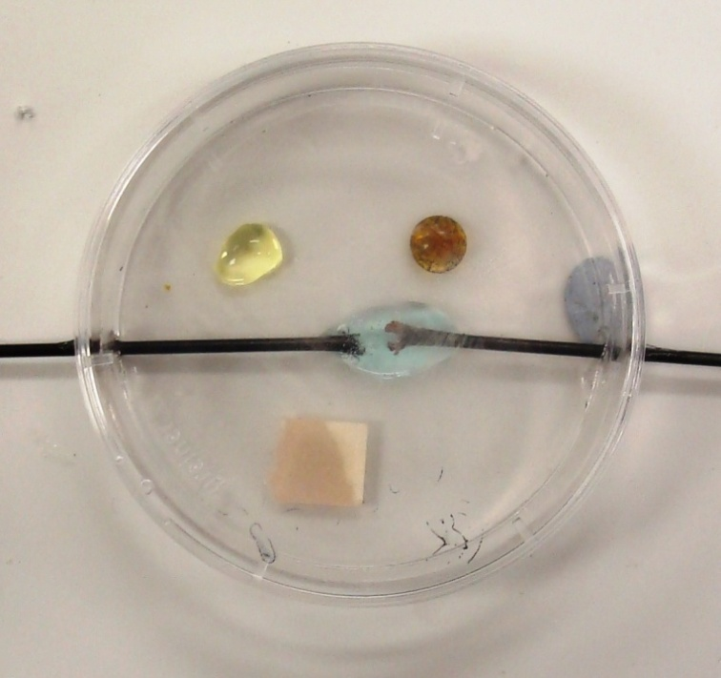

**Introduction**

**Health & Safety**

Chlorine is toxic.

To avoid inhaling chlorine gas (which could trigger breathing difficulties in those who are susceptible), do not remove the Petri dish cover **and** at the same time lean close to the dish.

The chlorine can be quickly diffused away with a waft of the hand. The chlorine levels are, on average, well below the workplace exposure levels.

In this procedure, 4 drops (i.e. 0.2 cm3) of 0.5 M copper(II) chloride solution are used. The maximum amount of chlorine that could be produced is ~ 7.1 mg (i.e. ~ 2.4 cm3 at room temperature).

If 10 sets of equipment were all working at the same time, the Workplace Exposure Limit (WEL) of 1.5 mg m-3 (averaged over the whole room) would not be reached.

However, it would very probably be exceeded in localised areas, i.e., just above the Petri dish when the lid is removed. Hence, great care must be taken to avoid inhaling the chlorine gas when removing the lid.

**You will need**

|  |  |
| --- | --- |
| 1 petri dish fitted with carbon fibre electrodes* | Copper II chloride solution 0.5M |
| Potassium iodide solution (1M) | Potassium bromide solution (2M) |
| Power supply and connecting leads |  |

* It is possible to use graphite electrodes but they are very likely to break. Carbon fibre rods can be obtained from online suppliers of kite materials. 2mm is the best size to use. As sometimes the smaller diameters are a bit temperamental regarding conductivity.

The electrodes are fitted through holes made in the sides of the petri dish (either drilled or made with a hot object)

They can be moved closer together or further apart to speed up or slow down the rate of electrolysis

**To Do**

1. Place the following in the Petri dish (see diagram below) in the following order:
   1. 1-2 drops of potassium bromide solution (~ 0.5 M – 2 M);
   2. 1-2 drops of potassium iodide solution (~ 0.1 M – 0.5 M);
   3. a piece of damp blue litmus paper;
   4. a few drops of 0.5 M copper(II) chloride solution . … until the ‘merged’ drop just touches both electrodes.

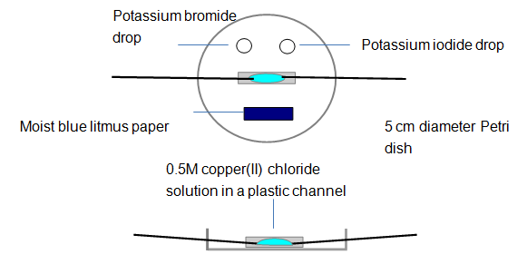

1. Place the lid on the Petri dish and then connect the electrodes to a DC source (~ 6 to 9 volts).
2. Switch on and observe what happens: (i) at the electrodes, (ii) to the test solutions & indicator.
3. Look carefully at the electrode regions (using the digital microscope gives a clearer view).

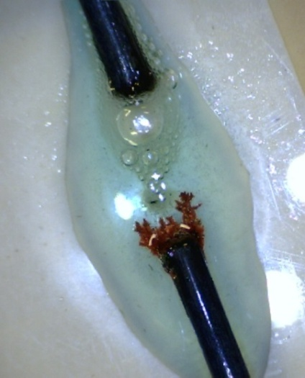**During the electrolysis**:

* Metallic copper is produced at the cathode (see right).
* You will see bubbles of chlorine gas being formed at the anode
* The Cl2 reacts with the salt solutions to form bromine, Br2, and iodine, I2 (in solution).
* moist blue litmus paper turns red due to formation of hydrochloric acid, HCl(aq), and chloric(I) acid, HClO(aq). The latter then oxidises the litmus dye to give colourless products.
* The results are even more effective if the procedure is viewed via a visualizer/digital microscope.

## Possible extensions

Find out what happens with other salt solutions.

|  |  |
| --- | --- |
| Potassium bromide | Place 1 drop of 2M potassium bromide in a Petri dish and add 9 drops of water. Place this mixture between the electrodes. Based on the experiment with copper(II) chloride solution, design some additional investigations. |
| Iron(II) sulphate(VI) | Place iron(II) sulphate(VI) solution between the electrodes.  If iron is produced at an electrode, it ought to be *magnetic*. Is it? |
| Zinc sulphate(VI) | Place 0.1M zinc sulphate(VI) solution between the electrodes. Follow the electrolysis using a digital microscope. Further dilution will slow down the rate of electrolysis but will this make the appearance of any metal crystals easier to see? Investigate. |
| Lead nitrate(V) | Place 0.1 M lead nitrate(V) solution between the electrodes and follow the electrolysis using a digital microscope. |
| Silver nitrate(V) | Place 0.05M silver nitrate(V)solution between the electrodes and follow the electrolysis using a digital microscope. |