

|  |
| --- |
| Microscale Chemistry |
| Microelectrolysis |

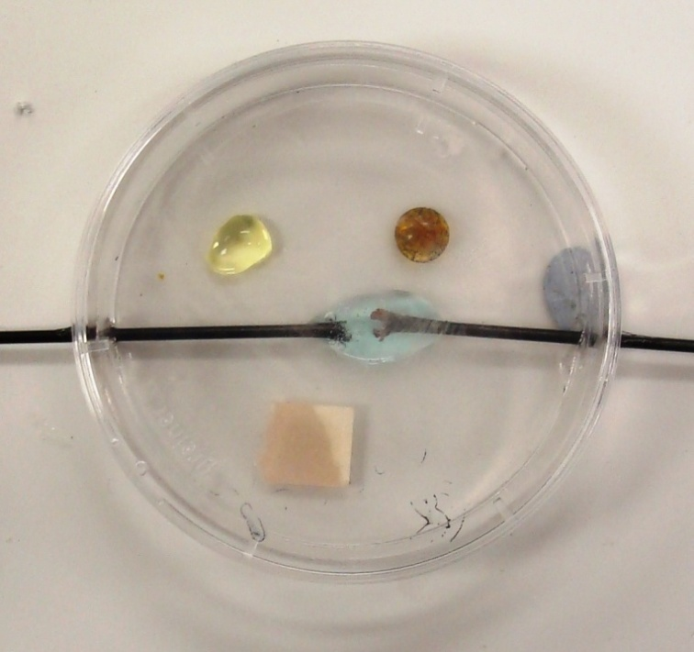

**Introduction**

Electrolysis of ionic solutions is an important part of electrochemistry.

This experiment combines that with a look at some of the properties of chlorine, such as bleaching and displacement reactions with other halogens.

**Health & Safety**

Chlorine is toxic.

To avoid inhaling chlorine gas (which could trigger breathing difficulties in those who are susceptible), do not remove the Petri dish cover **and** at the same time lean close to the dish.

**You will need**

|  |  |
| --- | --- |
| 1 petri dish fitted with carbon fibre electrodes* | Copper II chloride solution 0.5M |
| Potassium iodide solution (1M) | Potassium bromide solution (2M) |
| Power supply and connecting leads |  |

* It is possible to use graphite electrodes but they are very likely to break. They can be moved closer together or further apart to speed up or slow down the rate of electrolysis

**To Do**

1. Place the following in the Petri dish (see diagram below) in the following order:
   1. 1-2 drops of potassium bromide solution (~ 0.5 M – 2 M);
   2. 1-2 drops of potassium iodide solution (~ 0.1 M – 0.5 M);
   3. a piece of damp blue litmus paper;
   4. a few drops of 0.5 M copper(II) chloride solution … until the ‘merged’ drop just touches both electrodes.

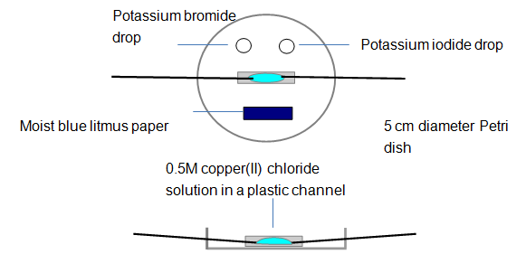

1. Place the lid on the Petri dish and then connect the electrodes to a DC source (~ 6 to 9 volts).
2. Switch on and observe what happens: (i) at the electrodes, (ii) to the test solutions & indicator.
3. Look carefully at the electrode regions (using the digital microscope gives a clearer view).

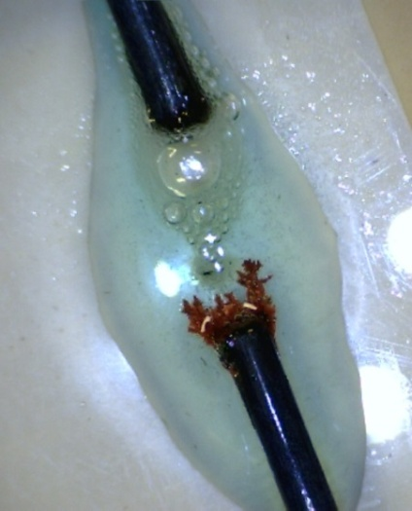**During the electrolysis**:

* Metallic copper is produced at the cathode (see right).
* You will see bubbles of chlorine gas being formed at the anode
* The Cl2 reacts with the salt solutions to form bromine, Br2, and iodine, I2 (in solution).
* moist blue litmus paper turns red due to formation of hydrochloric acid, HCl(aq), and chloric(I) acid, HClO(aq). The latter then oxidises the litmus dye to give colourless products.
* The results are even more effective if the procedure is viewed via a visualizer/digital microscope.

## Possible extensions

Find out what happens with other salt solutions.

|  |  |
| --- | --- |
| Potassium bromide | Place 1 drop of 2M potassium bromide in a Petri dish and add 9 drops of water. Place this mixture between the electrodes. Based on the experiment with copper(II) chloride solution, design some additional investigations. |
| Iron(II) sulphate(VI) | Place iron(II) sulphate(VI) solution between the electrodes.  If iron is produced at an electrode, it ought to be *magnetic*. Is it? |
| Zinc sulphate(VI) | Place 0.1M zinc sulphate(VI) solution between the electrodes. Follow the electrolysis using a digital microscope. Further dilution will slow down the rate of electrolysis but will this make the appearance of any metal crystals easier to see? Investigate. |
| Lead nitrate(V) | Place 0.1 M lead nitrate(V) solution between the electrodes and follow the electrolysis using a digital microscope. |
| Silver nitrate(V) | Place 0.05M silver nitrate(V)solution between the electrodes and follow the electrolysis using a digital microscope. |