

Chemical Demonstrations
Colourful catalysis
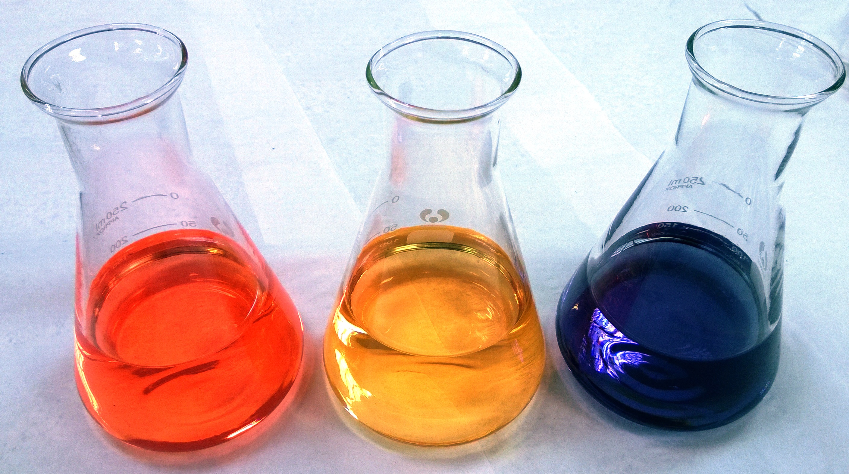
This reaction can be applied to curriculum for excellence.
Through experimentation, I can identify indicators of chemical reactions having occurred ...
SCN 3-19a
CfE Higher: Chemical Changes and Structure.
Controlling the rate. Catalysts, Reaction pathway, activation energy.

Background
Hydrogen peroxide oxidises sodium thiosulphate to sulphuric acid. Starting from an alkaline solution, the resulting pH change can be followed using universal indicator which changes from blue to green to yellow to orange-red. Adding an ammonium molybdate catalyst significantly speeds up the colour change.
Na₂S₂O₃(aq) + 4H₂O₂(aq) → Na₂SO₄(aq) + H₂SO₄(aq) + 3H₂O(l)
The sulphuric acid produced by the reaction neutralises the sodium hydroxide (buffered by the sodium ethanoate) and gives the observed colour changes.

Apparatus you will need
1 x 500 cm³ beaker / flask to make the mixture up in
3 x 250 cm³ flasks

Chemicals you will use

4.2 g of sodium thiosulphate-5-water.

1.9 g of sodium ethanoate-3-water (or 1.15 g of anhydrous sodium ethanoate).

0.25 g of sodium hydroxide.

0.08 g of ammonium molybdate(VI).

14 cm³ of 100 volume hydrogen peroxide.

A few cm³ of universal indicator solution.

deionised water

Before the demonstration
- In the 500 cm³ beaker/flask, dissolve the thiosulphate, ethanoate and hydroxide in distilled water and make up to 500 cm³.
- Add universal indicator to give a clearly visible blue colour.
- Divide equally between the 3 250 cm³ flasks. (Label them catalyst, no catalyst and control)
- Take 14 cm³ of hydrogen peroxide and make up to 40 cm³ with deionised water. Divide this into 2 portions of 20 cm³.
- Weigh out 0.08g of ammonium molybdate

Carrying out the demonstration
- Place the 3 flasks with the blue solution in on the bench, if possible on a white background.
- Add the ammonium moybdate to one of the flasks and swirl to dissolve.
- Add the 20 cm³ samples of hydrogen peroxide to the catalyst and no catalyst flasks.
- Observe the colour changes

Over a few minutes, the solution with the catalyst changes from blue through green, yellow and orange to orange-red.
The solution without the catalyst follows the same sequence, but more slowly. It will not have reached the same red-orange colour of the first solution after an hour.
The control solution, obviously, remains blue.

Notes
This demonstration can also be carried out as an investigation by varying factors such as concentration, temperature and amount of catalyst.
20 vol hydrogen peroxide will also work but a little more slowly, the concentration here is equivalent to 35 vol.

Safety


Wear eye protection
Care with peroxide - Corrosive and harmful
Wear gloves

It is the responsibility of teachers doing this demonstration to carry out an appropriate risk assessment.

(This is the same experiment as that in the RSC Classic Demonstrations – with the quantities slightly altered)

